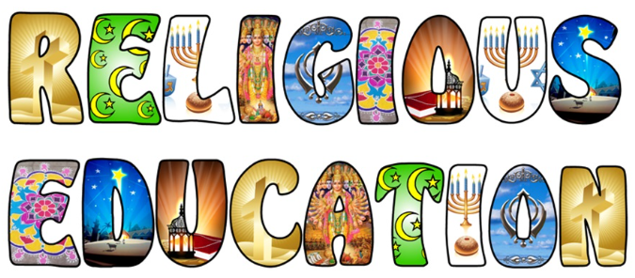

Marlfields Primary School
INTENT Our Marlfields children will be prepared and equipped for life to be accepting in the diverse communities we live in. They will become respectful citizens in today’s Britain, through fostering a depth of knowledge and understanding of religious literacy.
To reflect on examples of care and concern shown by believers and religious communities and explore reasons for these actions.
To identify symbolic actions, gestures and rituals and talk about how they are used as part of worship and ceremonies.
To find out about how and when people worship and ask questions about why this is important to believers.
To engage with stories and extracts from religious literature and talk about their meanings.
To reflect and respond to stories about belonging and relating to religious communities.

