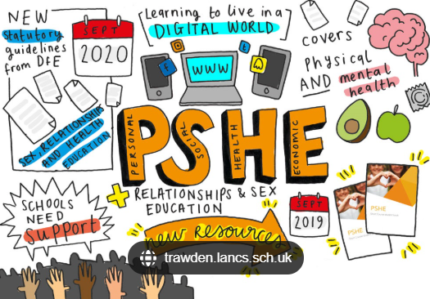

INTENT Our Marlfields children will develop an understanding of PSHE and be provided with a foundation of life skills across all contexts (home, school, community) and time spans (primary, secondary, later life).
To empathise, understand and respect the beliefs and values of different groups of people. To be a citizen within my school and within the local and wider community.
To be able to talk about how I am feeling and know who to talk to in different situations. To know how to deal with emotions, be open and honest about how I am feeling and use a range of strategies to deal with feelings.
To know what is right and wrong. To respect the laws and understanding the consequences of breaking laws. To be able to follow the rules appropriately in different social settings.
To be able to understand the importance of British values and what these represent. To begin to understand the importance of democracy.
To be able to work as a member of a team. To listen to others, communicate effectively, co-operate well and respect the views of others.
Marlfields Primary School
To be able to keep safe through different situations and learning including: E-Safety, Stranger Danger and Personal Safety.
To be able to talk about how I keep healthy and how exercise can help me maintain my fitness.

