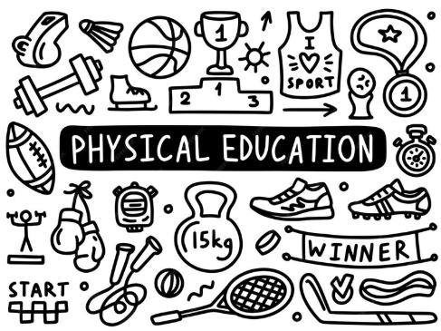

INTENT Our Marlfields athletes will have a breadth of opportunities (in school, across Congleton and the wider Trust of schools) that will enable them to enjoy a range of sporting experiences. The school will promote a healthy lifestyle. Our children will be inspired to achieve personal success, develop the appropriate skills and confidence to participate in a range of sports.
To develop knowledge of PE and use the correct language to improve the performance of themselves and other. Use this knowledge to lead others in sporting activities.
To be able to take part in a range of activities as individuals, groups and teams. Achieve this by applying skills, being creative, communicating and choosing tactics effectively.
To show an understanding of how to lead a healthy and happy lifestyle through a correct diet, physical activity and the knowledge of how substances can harm us.
To take part in all areas of PE, showing a positive attitude to join in each lesson and develop a love of physical activity. Taking part in clubs both in and outside of school.
Physical Education
Marlfields Primary School
To be able to take part in regular physical activity for at least 60 minutes per day (inside and outside of school).
To be organised and ready for PE by having the correct clothing and footwear.
To swim at least 25 metres before the end of Year 6 and show an understanding of how to be safe in and around water.

