
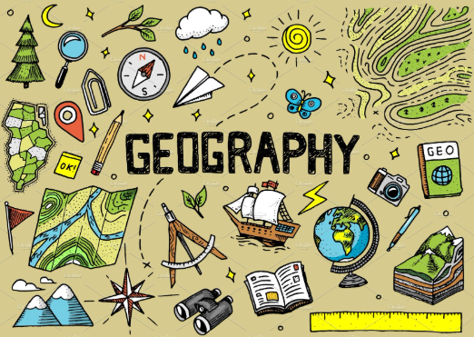
Marlfields Primary School
INTENT Our Marlfields Geographers show a curiosity for exploring the world around them and a sense of belonging in their community. They are keen to learn and respect the diverse environments in the world they live in. They have a deep sense of protection for their planet and strive to look after the world they live in and protect its future.
To have opinions that are justified through understanding issues in society and the environment.
To give views on places, fieldwork and features of the world. To compare these features from their own environment, with that of the wider world they live in
To develop a passion and sense of curiosity for the world and the people who live there in the modern and diverse world we live in today.
To be able to research information and present what they have learnt in Geography, including both human and physical geography features.
To use Geographical skills and techniques through field work e.g. map skills.
To understand where they live in relation to their community, their country and the wider world around them.
To compare their findings and reach an answer to a question.

