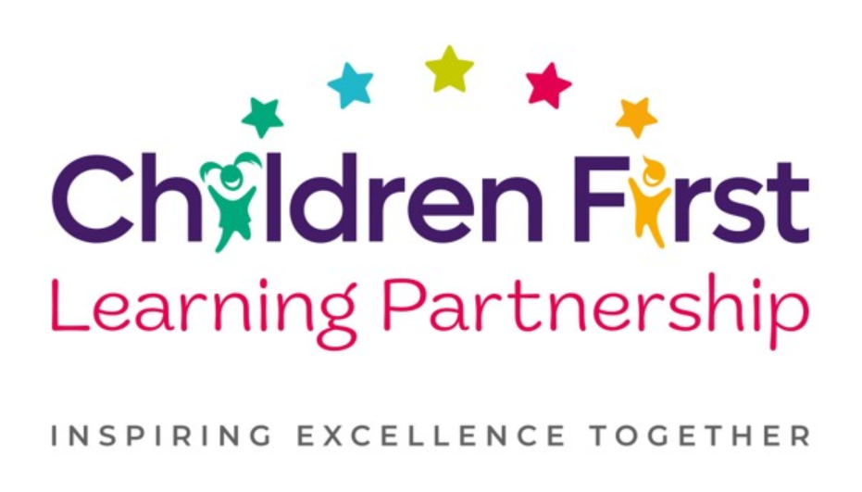

Music Policy 2026

July 2029
To be reviewed:
July 2026
Agreed and ratified by the Local Advisory Board on:
Headteacher – Mrs C Sleath

Responsible Officer:
Mr Gary Provis
Chair of Local Advisory Board:
The CFLP Music Policy in respect of the Children First Learning Partnership has been discussed and adopted by the Local Advisory Board.

Marlfields Primary School
Music Policy 2026
Intent
At Marlfields Primary school we recognise the importance Music plays in the curriculum and beyond. We understand that Music provides opportunity for personal expression and growth and theintegral part it can play in developing the whole child. This vibrant subject transcends different cultures, abilities and generations and facilitates the bringing together of communities.We value the subject a as unique way of communicating which can both inspire and motivatechildren with a love of music which they can carry with them for the rest of their lives.
Music lessons at Marlfields encourage children to be creative, imaginative and confident learners.
Our objectives in the teaching of Music align with the National Curriculum in that we aim to ensure all pupils:
- Perform, listen to, review and evaluate music across a range of historical periods, genres, stylesand traditions, including the works of the great composers and musicians;
- Learn to sing and to use their voices, to create and compose music on their own and withothers, have the opportunity to learn a musical instrument, use technology appropriately andhave the opportunity to progress to the next level of musical excellence;
- Understand and explore how music is created, produced and communicated, including throughthe inter-related dimensions: pitch, duration, dynamics, tempo, timbre, texture, structure andappropriate musical notations.
Implementation
At Marlfields Primary school music is delivered through the Get Set 4 Music scheme, which provides a structured, progressive curriculum aligned with the EYFS Development Matters and National Curriculum for Music. The scheme ensures full coverage of the statutory requirements and is sequenced to build knowledge, skills and understanding over time.
The curriculum is organised into units for each year group from EYFS to Year 6. Each unit is centred around a key musical focus such as rhythm, pitch, pulse, tempo, dynamics, notation or performance. These units are carefully sequenced to enable pupils to revisit and deepen prior learning while introducing new musical concepts.
Each unit incorporates the three interrelated strands of musical learning:
- Listening and Appraising
- Musical Activities (including singing, playing instruments, improvisation and composition)
- Performing and Sharing
Our bespoke curriculum progression maps ensure clear progression in:
- Musical vocabulary
- Instrumental skills
- Notation understanding
- Composition and improvisation techniques
- Critical listening skills
The curriculum also provides opportunities to explore a diverse range of musical styles, genres and traditions, promoting cultural awareness and appreciation. Where possible, pupils are given opportunities to work with both tuned and untuned instruments, as well as develop their voices as instruments.

Curriculum Delivery
Music is taught in discrete lessons in all year groups. The Get Set 4 Music scheme supports non-specialist teachers through high-quality, step-by-step lesson plans, audio resources and demonstration materials, ensuring consistency and confidence in delivery.
A Unit of Work (Pathway)
A unit of work typically incorporates the following:
- National Curriculum Programmes of Study are used, alongside our subject specific progression documents, for long term, medium term and short term planning.
- Currently, we follow Get Set 4 Music’s schemes of work for each year group to develop understanding and skill sets across exploring (listening and appraising), teach (call and response), design (improvisation), create and apply (composition) share and evaluate (perform and critique)
- Prior Learning/Listening and Appraising - this is achieved through targeted questioning, listening activities and the analysis of a prior learning activity which demonstrates the children’s strengths and areas for development.
- Vocabulary - a wide range of Music vocabulary is to be modelled and used in context to demonstrate understanding. The vocabulary documents set out clear expectations for each year group.
- Teach/Call and Response - model specific instrumental and compositional techniques based on the elements of music, that the children are given time to refine before applying them to their own performance or composition
- Application to a composite – children’s knowledge and skills of the unit to be applied in a final performance/composition
- Evaluate – children take part in ongoing self-reflection throughout the unit culminating in a final performance of a composition or rehearsed piece to an audience.

Lessons follow a consistent structure:
A Lesson (Pathway)
Lessons are planned from the correct Key Stage Programmes of Study from The National Curriculum and our progression documents. Teachers will be aware of the prior learning that needs to be secure from previous year groups to ensure new content can be understood. Lessons are planned sequentially, to ensure knowledge and skills are built upon.

A lesson would typically consist of the following:
- Retrieve - used to revisit and retrieve previously taught knowledge/skills.
- Shared learning objective, success criteria and unit specific vocabulary - help to set the context for a lesson.
- Teaching exposition - a variety of strategies are used to model and explore new concepts following the I do we do you do model which is knowledge-rich, with explicit teaching of musical terminology
- Opportunities to discuss learning - children are encouraged to speak in full sentences and reinforce vocabulary in context.
- On going assessment for learning (AfL) questions - used to extend and/or support learning.
- Practise/Apply – Repetitive and progressive opportunities allowing for consolidation and mastery of planned knowledge and skill content.
- Scaffolded learning activities - linked to the learning objective to ensure all children achieve the learning outcome.
- Reflection – a range of techniques are employed to encourage children to think about and discuss their own learning.
- Evaluate – refer back to learning objective and success criteria. This could be at any point throughout the lesson.
These elements could be used flexibly throughout each session.

Inclusion and Adaptation
Our inclusive approach ensures that every pupil can access learning meaningfully through thoughtful planning, targeted support, and high-quality adaptive teaching.

Adaptive Teaching
- Lessons are designed using high levels of AfL and a consistent I do we do you delievery model offering multiple ways to access, engage with and respond to content.
- Teachers break content into smaller, manageable steps with clear, concise language and visuals.
- Key vocabulary is pre-taught, reinforced and revisited frequently.
- Concepts may be repeated or revisited across longer periods to support retention.
- SEND pupils may be provided with scaffolded resources such as sentence starters, sorting activities, matching tasks, or visual prompts.

Performance Opportunities
Performance is an integral part of the music curriculum. Pupils have regular opportunities to:
- Perform within lessons
- Share outcomes with peers
- Participate in assemblies and school events
- Engage in concerts and productions
These experiences build confidence, resilience and a sense of achievement.

Enrichment
The school enhances the music curriculum through:
- Singing assemblies
- Instrumental tuition (where available)
- Visits and workshops from musicians
- Participation in local music events
This ensures that pupils experience music as a vibrant, engaging and meaningful part of school life.
This structured approach ensures that all pupils develop as confident performers, composers and listeners, fostering a lifelong appreciation of music.

Impact

Assessment
Assessment within Music is based upon many sources of evidence. This will allow for judgements to be evidenced based and secure regarding what pupils know and remember in relation to our planned curriculum outcomes in all year groups. Teachers will use a variety of assessment methods which they will select carefully based upon the quality of evidence it will provide within Music and will avoid additional workload for pupils and staff.
Formative assessment takes many forms in Music

AfL
Teachers and subject leaders value the voice of the pupil. They will observe pupils carefully, question purposefully and listen and use pupil responses in all lessons and the day to day life of the school to adapt teaching in the moment, lesson to lesson and unit to unit to ensure learning is secure and built upon in a sequential and progressive manner. In many lessons and where appropriate, purposefully planned explicit retrieval opportunities will also be used to ensure pupils have secured component knowledge and are ready to move on and make links to previous learning.

Evidence Me
A wealth of other evidence such as practical hands on learning outcomes, behaviours, drama, performances, group work will also be captured on evidence me to support teacher assessment judgements. At Marlfields Primary school we value talk, practical exploration and pupil responses as a method of ensuring all pupils can access our Music curriculum and demonstrate the gains they are making simply and effectively.
Summative assessment in Music may in some year groups be available to aid the judgements teachers make about what pupils know and remember:

Pupils work, end of unit quizzes and performances
Pupils, will where appropriate, capture their understanding, evaluate their own learning or rehearse and secure knowledge in both a practical and written form. This will be used effectively to evidence progress and avoid creating barriers to learning for any group of pupils in our school, for example due to their age or any additional needs they may have.

Teacher Assessment Judgements
Children will be judged as meeting curriculum expectations in Music on a termly basis using evidence from activities listed above. This judgement will be working at, below or at a greater depth within the year group/key stage unit they have completed. This will be captured on our Arbor system and used to inform curriculum design and developments, resourcing, training and leadership monitoring activities. Teacher assessment judgements in Music will be shared with parents on an annual basis via their child’s annual report.

Role of Leaders
- Ensure the delivery of a progressive Music curriculum
- Monitor compliance, quality and standards in Music
- Respond quickly and in a supportive manner to overcome barriers to implementation and impact.
- Use assessment information to provide effective CPD and challenge.
- Provide clear updates to the Local Advisory Board, Head Teacher and SLT.

Monitoring and Review
This policy is reviewed every three years by:
- Headteacher
- Music Subject Leader
- Local Advisory Board
Earlier review may occur if legislation or local need requires it.

