
Marlfields Primary School

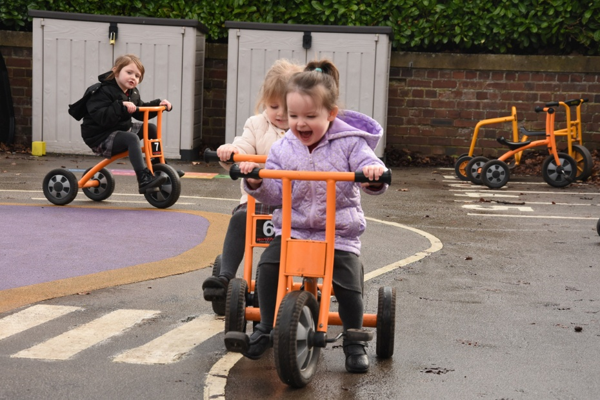


Accessibility Plan 2026-2029

Intent of Our Accessibility Plan
The intent of our Accessibility Plan is to set out a clear, strategic approach to ensuring that all pupils—particularly those with disabilities or additional needs—can participate fully in every aspect of school life. In accordance with the Equality Act 2010 and DfE guidance, the plan aims to remove barriers that may prevent disabled pupils from accessing education and wider school opportunities.
We are committed to ensuring that the school environment, curriculum, and communication systems evolve in response to the diverse needs of our pupils. Needs which will be identified early and tackled robustly to ensure we achieve our aims of creating an environment in which ALL children can achieve, belong and thrive. This includes improving access to the curriculum, developing the physical environment of the school, and ensuring the availability of accessible information as required under Schedule 10 of the Equality Act 2010.
Our intent is shaped by three core principles:

1. Inclusion and Equity
We intend to create a school culture where every pupil—regardless of disability, special educational need, or health condition—is valued, supported, and able to thrive. We aim to advance equality of opportunity and eliminate discrimination, in line with the Public Sector Equality Duty (PSED).

2. Anticipatory, Not Reactive, Planning
We will take an anticipatory approach to identifying and removing barriers. This includes proactive environmental audits, curriculum review, staff training, and continuous reflection on accessibility needs. We will ensure all SLT members have the skills to monitor, case sample and address any areas where children in our schools may require reasonable adjustments and additional intervention and where possible plan in advance.

3. Co-production with Stakeholders
We intend to involve pupils, families, staff, governors and specialists in shaping our accessibility priorities. This collaborative approach will also reflect our desire to emphasise multi-agency partnership and stakeholder engagement in identifying and addressing any areas of need or inequality.
To fulfil this intent, our plan sets out clear, measurable actions designed to:
- Increase pupils’ participation in the curriculum through inclusive teaching practices, staff training, and reasonable adjustments.
- Improve the physical environment so pupils with disabilities can access all areas of the school safely and confidently, consistent with requirements in template accessibility plans and physical environment guidance. https://content.govdelivery.com/attachments/UKWSCC/2025/11/25/file_attachments/3472731/Ofsted New Framework article - Nov2025.pdf
- Ensure that written and digital information is provided in accessible formats for pupils and families who need it, in line with expectations to improve the availability of accessible information.
- Embed a whole-school responsibility for accessibility, where leaders, teachers, support staff and governors contribute to monitoring progress and ensuring compliance with legislation and best practice standards. https://assets.publishing.service.gov.uk/media/690b26c69456634d9795fde0/Schools_inspection_toolkit.pdf
The formulation of the following plan is written with consideration of the following legislative Framework
- Equality Act 2010 (Schedule 10)
- DfE Guidance: Equality Act 2010 and Schools
- SEND Code of Practice (2015)
- Public Sector Equality Duty

Monitoring & Review
The Accessibility Plan will be reviewed every three years, with annual monitoring by the Local Advisory Board via the Inclusion Link. Progress will be reported via the Summer 1 Local Advisory Board Meeting report to all LAB members and also to the CFLP Link Champion in the same term who will ensure Directors can evaluate the schools’ compliance with the above Legislative Framework.

MARLFIELDS PRIMARY SCHOOL ACCESSIBILITY PLAN

Increasing the extent to which pupils with additional needs can participate in the curriculum
The curriculum covers teaching and learning and wider provision embracing after school clubs; leisure, sporting and cultural activities; and school trips. Planning for improved access to the curriculum includes consideration of school and classroom organisation and support, timetabling, curriculum options, deployment of staff and staff information and training. Curriculum audits can support the school to review patterns of achievement and participation by pupils with additional needs in different areas of the curriculum, e.g. the inclusion of physically disabled children in PE, and then to identify action to increase participation
Action | Success criteria | Lead person | Timescale | Review
Increase access to therapeutic interventions (e.g., ELSA, nurture-based provision, wellbeing interventions, SWANs) and track impact through case studies. | School will have a secure understanding of the selected SEMH intervention selected and rationale behind these.  School will have resourced fully to engage with the programme.  Interventions will be running consistently.  ELSA trained member of staff will attend termly supervision.  Observations show that the interventions ran are of high-quality.  SDQ scores increase from the start of the intervention to the end for children accessing (for at least 90% of children).  Behaviour logs and records will show sustained improvement for key children (case study). | RT – ELSA  RM – SENCo  PS – Behaviour lead | April 2028
Expand staff expertise in complex SEND profiles (e.g., PDA, sensory processing differences, trauma-informed practice) through targeted CPD and coaching. | Staff meetings will provide CPD from Virtual School (trauma-informed practice) to aid increased knowledge around specific SEND profiles.  Staff meetings will provide CPD from CEAT (Cheshire East Autism Team) around PDA, and help scripts will be implemented consistently across school to support these children.  CPD will be delivered to all staff (including middays and teaching assistants) to ensure consistency of one-page profiles, RAMPs and risk assessments for SEN children is in place.  SENDco clinics will offer opportunities for staff to discuss and plan for SEND profiles in their class.  PLP target cycles will reflect progress made by each child demonstrating their engagement within the curriculum.  SEN register in school will be implemented and reviewed regularly, ensuring SEN needs are clearly defined and PLP targets reflect the key area of need. | RM – SENCo  PS – Behaviour lead | July 2028
Expand the use of sensory‑smart adjustments (quiet spaces, movement breaks, visual timetables, reduced‑stimulus areas) within clubs and events. | SENCo introduce and monitor a consistent classroom offer for all children (including quiet corners, visual timetables, safe spaces, now/next for planned brain breaks).  Facilitation in lessons demonstrates that staff have considered the needs of SEND pupils who need sensory-smart adjustments to increase access to the curriculum.  Lesson observations demonstrate that identified pupils use agreed sensory-smart adjustments in lessons to increase engagement and access to their learning.  Behaviour logs and Triple A strategy targets indicate that children with SEMH needs use agreed sensory smart adjustments to self-regulate independently. | RM – SENCo  CS - Headteacher
Expand access to safe outdoor regulation spaces, including quiet zones, movement areas and nature‑based calming spaces. | Playground zones to be established (including quiet zone and structured playtime games)  Lunch time clubs to be introduced on a weekly schedule to allow safe/ quiet spaces and activities over less predictable times in the school day.  Lesson observations demonstrate that identified pupils utilise quiet zones to support their access to learning. Safe spaces and privacy desks are in place to facilitate learning and nurture-based intervention timetables are running consistently, to lower frequency of behaviour incidents.  Nurture-base is used to support intervention groups and integration to school for both children accessing our resource base provision and SEN children in the wider school. | RM – SENCo  BG – inclusion  CS - Headteacher
SEND and Medical register and information on children with additional needs to be regularly updated. | SEN and Medical needs will be up-to-date. Teachers and TAs will be aware of the needs of children in their class. | IM – First Aid  RM – SENCo  HH - Clerical | To be continually updated but checked termly.

Improving the physical environment of schools
This strand of the planning duty covers improvements to the physical environment of the school and physical aids to access education. The physical environment includes steps, stairways, kerbs, exterior surfaces and paving, parking areas, building entrances and exits (including emergency escape routes), internal and external doors, gates, toilets and washing facilities, lighting, heating, ventilation, floor coverings, signs, interior surfaces, room decor and furniture. Improvements to physical access include ramps, handrails, lifts, widened doorways, electromagnetic doors, adapted toilets and washing facilities, adjustable lighting, blinds, induction loops, communication aids, well designed (passive) room acoustics and way-finding systems. The provision of ‘quiet’ areas and improvements to the physical safety of the environment, indoors and outdoors, may also enhance access for children with additional learning needs. Improved access in existing buildings can often be achieved by rearranging room space, removing obstructions from walkways, changing the layout of classrooms, providing designated storage space or reallocating rooms to particular subject specialisms.
Physical aids to access education cover ICT equipment, desks, chairs, writing equipment, science equipment and the like. E.g. through enlarged computer screens and keyboards, concept keyboards, communication aids, switches, photocopying enlargement facilities, specialist desks and chairs and portable aids for children with motor co-ordination and poor hand/eye skills such as extra robust scientific glassware and specialist pens and pencils.
Action |  | Success criteria | Lead person | Timescale | Review
Install handles on classroom doors with steps on entry to support pupils with visual processing difficulties, motor coordination challenges and sensory needs. |  | Handrails are installed on all identified steps.  Handrails are positioned at an appropriate height and securely fixed to support safe use by pupils, families and visitors.  Pupils and families report increased confidence and independence when using steps. | SR – Site technician  CS – Headteacher | July 2027
Install high-visibility step tape on internal and external steps to support pupils with visual processing difficulties, motor coordination challenges and sensory needs. |  | All steps and areas of trip risks are clearly highlighted with tape.  Tape is monitored and ensured it remains clearly visible.  Reduced trips on steps. | SR – Site technician  CS- Headteacher
To ensure that pupils can record their learning effectively through a combination of strengthened transcriptional skills, targeted intervention and high‑quality adjustments that remove barriers to written recording. |  | SENCo and English Lead have a secure understanding on how development of transcriptional skills is adapted in school for a range of SEND profiles.  All children have access to adjustments and scaffolds required to be successful within their writing level/ development point.  Lesson observations show pupils independently using their agreed adjustments.  Interventions are consistent and live marking in classrooms supports next steps.  Parents are clear on development of fundamental skills and have the knowledge and resources to support their child at home.  PLP targets and books reflect progress made. | RM – SENCo  TR – English lead
Improving the availability of accessible information to pupils with additional needs
This part of the duty covers planning to make written information normally provided by the school to its pupils – such as handouts, timetables, textbooks, information about school events – available to those with a disability (including those with significant low reading acquisition levels) . This might include alternative formats such as large print, the use of ICT and the provision of information orally, through lip speaking or in sign language. The information should take account of pupils’ additional needs and views expressed by pupils or their parents about their preferred means of communication. The school should consider how all information normally provided in a written format including work sheets, timetables, school examination papers, newsletters, information about school events, trips and extracurricular provision could be made accessible to all those with any additional needs.
Action | Success criteria |  | Lead person | Timescale | Review
Develop a Whole‑School Accessible Communication Framework | 100% of teaching have active Widgit log‑ins and can demonstrate use of the agreed PECs symbols during learning walks or monitoring.  Agreed PECs symbols are displayed in 100% of key areas (entrances, hallways, dining hall, toilets, playground, SEND spaces).  The school newsletter includes the weekly PECs symbol and Makaton sign.  Pupil voice indicates that at least 80% of pupils can explain why some children use PECs or visual supports.  Observations of pre-verbal children show increased confidence to refer to PECs symbols when required. |  | RM - SENCo | July 27
Strengthen Communication Supports for Pupils with SEMH and Complex Needs | Observations show pupils using at least one identified strategy (e.g., zones check‑ins, visuals, scripts, regulation tools)  Staff demonstrate consistent use of agreed approaches (e.g., co‑regulation language, de‑escalation scripts, visual supports).  Tools are visible, accessible and used daily across classrooms and shared spaces.  Parent and pupil voice indicate greater understanding of emotional strategies  Behaviour logs show a decrease in incidents where emotional communication was a trigger.  Learning walks show consistent use of emotional communication supports across settings.  Pupil voice reflects greater confidence in expressing feelings.  Termly data shows positive trends in wellbeing indicators for identified pupils. |  | PS – behaviour  RM - SENCo | July 28
Improve Accessibility of Information for Families | Newsletters are available for collection from the main office to aid those families who do not have access to the internet.  Attendance at parent events (workshops, meetings, celebrations) increases across all demographic groups, including those previously under‑represented.  Events offer flexible access options (e.g., daytime/evening sessions, online alternatives). At least 95% of families report that school communication is clear, timely and easy to understand (via survey or feedback).  Families with additional needs (EAL, SEND, low literacy) receive adapted communication and confirm they can access it.  Families report increased confidence in supporting learning at home.  SEND families confirm they understand provision, targets and support plans. |  | RM – SENCo  HH - Clerical | July 29

