

SEND Policy for Marlfields Primary Academy 2026


The SEND Policy in respect of the Marlfields Primary Academy has been discussed and adopted by the Local Advisory Board
Chair of Local Advisory Board: Mr G Provis
Responsible officer: Headteacher – Mrs C Sleath
Agreed and ratified by the Local
Advisory Board on: February 2026
To be reviewed: February 2027 (or earlier if required)

CONTENTS

Section 1: Main contacts and Policy details
Section 2: Legislative Compliance
Section 3: Our School Profile and School Values
Section 4: Aims and Objectives of this Policy
Section 5: Definitions of SEND and of Disability
Section 6: Graduated approach to identifying whether a child should be in receipt of SEND Support
Section 7: Request for statutory Education, Health and Care needs assessment
Section 8: Statement of Special Educational Needs or Education Health and Care Plan (EHCP)
Section 9: Management of SEND within our school
Section 10: Partnership with Parents/Carers
Section 11: Involvement of Children
Section 12: Supporting pupils at school with medical conditions
Section 13: Effective Transition
Section 14: Admission Arrangements
Section 15: Storing and Managing information
Section 16: Complaints
Section 17: Links with Other Services
Section 18: Information on where the Local Authority’s Local Offer is published

NOTE: Child/children are used throughout to refer to children and young people unless a quote e.g. from the Code


Special Educational Needs and Disability (SEND) POLICY

Section 1: Main Contact details and Policy key dates

Contact details:
Headteacher: Mrs C Sleath
Assistant Headteacher: Mrs B Gosling
The SENDCO: Mrs R McCourt
Inclusion Governor: Mr Provis

Marlfields Primary Academy
Waggs Road
Congleton
Cheshire

SEND INTENT
At Children First Learning Partnership we provide teaching and learning which enables all children to gain access to a broad, balanced and appropriately scaffolded curriculum. We strongly believe in the role of Quality First Teaching and Curriculum Entitlement for all children, regardless of their ability or background.
Inclusion is embedded across all subjects, with teachers held accountable for adapting teaching to meet diverse needs. Leaders monitor this through lesson observations, work scrutiny, and pupil voice.
Aims of the Intent
Our aim is to ensure all children are supported in order that they may work confidently towards reaching their full potential. At times and when it is felt appropriate, modifications to the curriculum may be implemented by providing personalised interventions that break down barriers to learning.
We believe in removing barriers to learning, raising expectations and levels of achievement and working in partnership with other agencies such as the Speech and Language Service, Visyon and Educational Psychologists.

Section 2: Legislative Compliance
2.1 This policy complies with the statutory requirement laid out in Paragraphs 3.1 – 3.9 of the SEND Code of Practice 0 – 25 January 2015. It also meets the requirements of the Statutory Instrument: Special Educational Needs (Information) Regulations (Clause 65).
This guidance is for staff, parents /carers, children and practitioners across education, health and care agencies. It is written with reference to the following further guidance and documents:
- Part 3 of the Children and Families Act 2014 and SEND Code of Practice January 2015
- Equality Act 2010, subsequent updates and DfE advice for schools, February 2013
- Statutory Guidance on Supporting pupils at school with medical conditions, April 2014
- Ofsted Section 5 Inspection Framework, November 2025
- Teachers Standards 2012
- National Inclusion Statement
- Relevant National Curriculum frameworks/ document 2014
- Documents are kept In the School office and on the website
Policies – Marlfields Primary Academy
2.2 Our school has separate policies in place for:
Safeguarding, Accessibility, Assessment, Anti-Bullying.
2.3 Our SEND Information Report sets out how we are implementing our SEND Policy and meeting our duties under the Equality Act 2010.
2.4 SEND and Alternative Provision Improvement Plan: Right Support, Right Place, Right Time Summary Document March 2023 this green paper sets out the ‘government’s proposals for a system that offers children and young people the opportunity to thrive, with access to the right support, in the right place, and at the right time.’ Our intent as a school is to uphold the same proposals so ‘SEND pupils can fulfil their potential and lead happy, healthy and productive lives’.
2.5 The Cheshire East SEND and Alternative Provision (AP) Strategy and Development Plan sets out a clear and ambitious vision for 2025–2028. The strategy aims to ensure that every child and young person with SEND, receives the right support, in the right place, at the right time.
The updated strategy brings together key priorities into a single, unified plan. It aligns with the council’s wider transformation programme and addresses and aligns with critical areas such as:
Managing increasing financial pressures on the Dedicated Schools Grant (DSG)
Making developments in line with findings from feedback, inspections and the SEND self-evaluation (SEF)
National improvement work
At the heart of the strategy is a shared commitment to helping children and young people with SEND to be HAPI:
H - Happy and Healthy
A - Achieving their potential
P - Part of their communities
I - Independent as possible, making choices about their future

Section 3: Our School Profile and School Values
The overall intent of our school curriculum is to:
Recognise uniqueness: in our pupils, staff, resources and whole school community.
Be Inclusive: recognising learning styles, learning needs at all levels and providing solutions to any barriers to learning we encounter.
Engage and Inspire: Through knowledge rich, highly enriched, progressive and purposeful contexts.
Promote Aspiration: offering challenge, accountability and responsibility for their learning.
Create citizens of the Future: who thrive on responsibility, see difference as a strength of our community and use democracy to embed their own values and beliefs.
Our SEND provision strives to drive all of these intentions and links very closely to the achievement and development of them all.
Intent
- We will provide teaching and learning which enables all children to gain access to a broad, balanced and appropriately scaffolded curriculum. We strongly believe in the role of Quality First Teaching and Curriculum Entitlement for all children, regardless of their ability or background.
- Our aim is to ensure all children are supported in order that they may work confidently towards reaching their full potential. At times and when it is felt appropriate, modifications to the curriculum may be implemented by providing personalised interventions that break down barriers to learning such as precision teaching and Nessy.
- We intend to remove barriers to learning, raising expectations and levels of achievement and working in partnership with other agencies such as the Speech and Language Service, Cheshire East Autism Team and Educational Psychologists.

Our Mission Statement

‘Where children come first’

- Marlfields Primary Academy aims to equip each of its pupils with the skills, knowledge and understanding that they will require to succeed in future life.
- Marlfields Primary Academy achieves this by adopting a child-centred, caring approach, working with parents to inspire individual achievement and attainment to the highest level.
- Our aim, through the school curriculum is for children to grow to accept their own individuality, to expand their horizons and to develop a love of learning and enquiry.
- The school’s ability to achieve this can be judged by the confident, caring and able children who leave this school to go out into the wider world.
- All our teaching staff possess a wealth of experience both at the planning stage and the teaching of children with SEND and are responsible for their progress and development.

Section 4: Aims and Objectives of this Policy

The aims of our special educational need and disability policy and practice in this school are:
- To make reasonable adjustments for those with a disability by ensuring increased access to the curriculum, the environment and to printed information for all.
- To ensure that children and young people with SEND engage in the activities of the school alongside pupils who do not have SEND.
- To reduce barriers to progress by embedding the principles in the National Curriculum Inclusion statement https://www.gov.uk/government/collections/national-curriculum
- To use our best endeavours to secure special educational provision for pupils for whom this is required, that is “additional to and different from” that provided within the scaffolded curriculum to better respond to the four areas of need:

1. Communication and interaction
2. Cognition and learning
3. Social, mental and emotional health
4. Sensory/physical

- To request, monitor and respond to parent/carers’ and pupils’ views in order to evidence high levels of confidence and partnership
- To ensure a high level of staff expertise to meet pupil need, through well-targeted continuing professional development.
- To support pupils with medical conditions full inclusion in all school activities by ensuring consultation with health and social care professionals
- To work in cooperative and productive partnership with the Local Authority and other outside agencies, to ensure there is a multi-professional approach to meeting the needs of all vulnerable learners.

Section 5: Definitions of SEND and of Disability

What are special educational needs?
A child or young person has special educational needs if he or she has a learning difficulty or disability which calls for special educational provision to be made for him or her. A learning difficulty or disability is a significantly greater difficulty in learning than the majority of others of the same age. Special educational provision means educational or training provision that is additional to, or different from, that made generally for others of the same age in a mainstream setting in England…. Health care provision or social care provision which educates or trains a child or young person is to be treated as special educational provision. Code of Practice 2014

How does our school know if children need extra help?
We know when pupils need help if:
- Concerns are raised by parents/carers, teachers, or the pupil’s previous school
- Tracking of attainment outcomes indicate a lack of progress
- Pupil observation indicates that they have additional needs in one of the four areas

- Communication and interaction
- Cognition and learning
- Social, mental and emotional health
- Sensory/physical

- A pupil asks for help
- There is a significant change in the pupil’s behaviour

Difficulties which may not be related to SEND

Some children in our school may be working below age related expectations, which may be caused by factors out of our control such as early health conditions or missing out on early life experiences, but will not necessarily have a special educational need. It is our responsibility to spot this quickly and ensure that appropriate interventions are put in place to help these children ‘catch up’.
Difficulties related solely to difficulties in English as an additional language are not SEND. We assess all aspects of a child’s performance in different areas of learning and development to establish whether lack of progress is due to their poor understanding of English or if it arises from SEND or a disability.

The following concerns may impact on a child’s progress and attainment but are not in themselves indicators of SEND:
• Attendance and Punctuality
• Health and Welfare
• Being in receipt of Pupil Premium Grant
• Being a Looked After Child
• Being a child of Serviceman/woman

Section 6: Graduated Response approach to identifying whether a child should be in receipt of SEND Support. (Please refer to Appendix 2 Ks1/Ks2 Appendix 3 EYFS/ Appendix 4 SEMH)

6.1 All our children’s needs are identified and met as early as possible through:
- observation, assessment, target setting and monitoring arrangements (cycle of assessment, plan, do and review). Every APDR cycle is recorded and reviewed termly, with impact measured against progress data. SENDCos ensure external agency involvement is sought promptly where progress is limited, this allows for timely intervention.
- Pupils receive a carefully monitored, graduated response to their needs, and small steps of progress are meticulously tracked, enabling next steps to be identified.
- listening to and following up parental concerns
- listening to and taking into account the child’s views, wishes and feelings
- the analysis of data including baseline assessments and end of Key Stage achievement to track individual children’s progress over time
- reviewing and improving teachers’ understanding of a wide range of needs and effective strategies to meet those needs
- liaison with schools and other settings on phase and in year transfer
- exchanging information from other services across education, health, care and the voluntary sector
- involving an external agency, such as the Cheshire East SEND Team, Cheshire East Autism Team (CEAT) and the Educational Psychology Service (EPS) as a minimum.
- Involving an external agency or the Educational Psychology Service (EP) where necessary, where it is considered that a special educational need may be significant and long term and may require more in-depth and frequently reviewed cycles of assess, plan, do, review.
- Pupils progress is assessed and discussed within Pupil Progress Meetings.
- Data on progress is stored and analysed through various computer database systems.

6.2 General provision for all children using core school funding
- All children will have access to well-scaffolded, quality first teaching enhanced, where appropriate, through low level, short term interventions.
- Language acquisition is best promoted through a range of good, inclusive strategies, interventions and differentiation of the usual school curriculum.
- Children who are underachieving will have been identified as needing to make accelerated progress but will not necessarily be children with SEND.

6.3 Examples of Curriculum Access and Provision
Where children are working below age expectations and/or identified as having high incidence (low need) special educational needs, our school meets these additional needs in a variety of ways. We use a combination of approaches to address targets identified for individual children.
- teachers personalised learning activities as part of quality first teaching
- preparation for new learning experiences and vocabulary development
- low level, short term, evidence-based intervention programmes
- targeted additional adult group and, where appropriate, individual support
- differentiation of curriculum resources
- SMART target setting
- booster intervention groups
- 1:1 support
- Small group work
- Equal access to extra curriculum before and trips
- Specialist intervention led by external agencies including speech and language services, Mental Health Support, Cheshire East Autism Team, Teacher for visually or Hearing impaired or Occupational Therapy

6.4 Monitoring and Evaluation of progress
- ongoing assessment of progress against targets and expected outcomes
- 6 monthly standardised testing scores e.g PHAB, BPLV, Sandwell.
- work sampling and moderation and scrutiny
- scrutiny of planning and level of differentiation and use of classroom resources
- informal feedback from all staff
- staff, child and parental questionnaires and conversations
- Pupil Progress Meetings every half term.
- pupil progress tracking using assessment data (whole-school processes)
- attendance records and liaison with Education Welfare Officer (EWO) where appropriate
- regular meetings about children’s progress between teachers and the Headteacher’s report to parents, governors and directors.
- SENDcos meet with and report to Inclusion Link Governors termly
- meetings with the Senior Leadership Team

6.5 Additional SEND Support provision, monitoring and review using school’s delegated additional needs funding

The Children and Families Act 2014 and the SEND Code of Practice 2014 has introduced SEND support to replace School Action and School Action Plus from September 2014. We will meet with parents during the autumn term to review their child’s educational needs and discuss whether their child should continue to receive SEND provision at this level. Every school has a whole school annual budget made up of core funding per child on roll at a point in time and additional SEND funding which is calculated based upon a formula agreed by schools locally.

In addition to the identification, assessment, provision and monitoring for all children, our approach to SEND Support is as follows:
- the class teacher, sometimes with the SENDCO, will discuss with parents if we feel that their child requires SEND Support
- additional SEND support will be in place when a child’s needs require intervention which is “additional to” or “different from” the well-scaffolded curriculum on offer
- we will agree targets towards longer term outcomes that are reviewed termly with parents and their child as appropriate (on an SEND Personal Learning Plan (PLP) or strategy plan as appropriate)
- evidence of progress made towards PLP targets will be captured and shared with parents/ carers via Evidence Me
- children will have targets they can understand;
- our PLPs are a planning, teaching and reviewing tool which enables us to focus on particular areas of development for children with special educational needs. They are seen as a working document which can be constantly refined and amended
- we will use the latest LA’s guidance on SEND Descriptors
- targets will address the underlying reasons why a child is having difficulty with learning
- our PLPs will be accessible to all those involved in their implementation – children should have an understanding and ‘ownership of their PLP
- our PLPs will state what the child can do, what the child has difficulties doing and how they will be supported to move forward with learning and wider outcomes
- our PLPs will have a maximum of four SMART targets
- targets for a PLP will be arrived at through discussion, wherever possible, with parents/carers, teachers, support staff and the child
- discussion with other practitioners as appropriate
- classroom observations by the school’s Special Educational Needs Co-ordinator (SENDCO) and other senior leaders
- our PLPs will be time-limited – at termly review
- our PLPs will be based on informed assessment and will include the input of appropriate outside agencies particularly where concerns are significant and may require consideration of a statutory assessment if expected progress is not made over time.
- APDR cycles will also be used to contribute to PLP targets.

Where the child’s class teacher, SENDCO and parent agree that the child has made good progress, it may be appropriate for needs to be met through effective class based strategies, resources and whole school interventions and assessment. In this instance, the child would no longer be recorded as being in receipt of SEND Support however a strategy plan would be used to ensure good progress continues.

Section 7: Request for statutory Education, Health and Care needs assessment

For some children with SEND, despite the school, family and other agencies working together to put in place all relevant and purposeful interventions and support, expected progress is not made. In these circumstances, external agencies such as speech and language therapy, Cheshire East Autism Team and Educational Psychologists will become involved in discussing, assessing the child and/or contributing to their provision.

Children with no SEND but with a disability under the Equality Act definition may need equipment provided as a reasonable adjustment as long as this is not cost prohibitive. Specialist equipment and expertise in relation to its use will be purchased/hired/ commissioned by the school from the open market, subject to the usual guarantees, service level agreements and quality assurance criteria. Our school will, wherever possible, join with other schools in joint purchasing/hire of equipment.

For some children additional provision and support will need to be deployed for the longer term in order to meet their needs and planned outcomes effectively. A multi-agency meeting will discuss if it is appropriate to submit a request to the Local Authority to consider whether a statutory assessment of education, health and care needs is necessary.

Section 8: Statement of Special Educational Needs or Education Health and Care Plan

Children with an Education Health and Care Plan (post September 2014) will have access to all arrangements for children in receipt of SEND Support and, in addition to this, will have an Annual Review of their statement/plan. Supplementary or early reviews may be called if required.
Our review procedures fully comply with those recommended in Section 6.56 and 9.173-6 of the Special Educational Needs Code of Practice 2014.

Section 9: Management of SEND within our school

The Head teacher and the Governing Body have delegated the responsibility for the ongoing implementation of this SEND Policy to our Special Educational Needs Coordinator (SENDCO). The SENDCO is responsible for reporting regularly to the Head teacher and the Governor with responsibility for SEND on the ongoing effectiveness of this policy. The Inclusion Governor and SLT receive termly reports on SEND progress, interventions, and outcomes. This ensures accountability and continuous improvement.

Section 10: Partnership with Parents/Carers
Our school aims to work in partnership with parents and carers. We do so by:
- working effectively with all other agencies supporting children and their parents
- giving parents and carers opportunities to play an active and valued role in their child’s education
- making parents and carers feel welcome
- encouraging parents and carers to inform school of any difficulties they feel their child may be having or other needs their child may have which need addressing
- instilling confidence that the school will listen and act appropriately
- focusing on the child’s strengths as well as areas of additional need
- ensuring parents gain an insight into their child’s progress and day through the use of frequent shared observations via Evidence Me.
- allowing parents and carers opportunities to discuss ways in which they and the school can help their child
- Parents and carers are equal partners in decision-making. We co-produce PLPs and EHCP reviews, ensuring their voice shapes provision and outcomes. We work together to agree targets for all children, in particular, those not making expected progress and, for some children identified as having SEND, involving parents in the drawing-up and monitoring progress against these targets.
- keeping parents and carers informed and giving support during assessment and any related decision-making process
- making parents and carers aware of sources of information, advice and support
- providing all information in an accessible way for parents with English as an Additional Language
- producing an SEND Information Report that will be published on the school website; and
- Parents are consulted at a variety of times during the year.

Section 11: Involvement of Children
Children have the right to be involved in making decisions and exercising choice. In most lessons, all children are involved in monitoring and reviewing their individual progress through the use of layered targets. We endeavour to involve all children fully by encouraging them to:
- share their views about their education and learning
- identify their own needs and learn about learning
- share in individual target setting across the curriculum so that they know what their targets are and why they have them
- self-review their progress and set new targets
- monitor their success at achieving the targets on their PLP.

Section 12: Supporting pupils at school with medical conditions (Please refer also to our policy)
Some children in our school have medical conditions that require care and support to enable full access to education, including school trips and physical education. Some children with medical conditions may be disabled and where this is the case the school will comply with its duties under the Equality Act 2010.
Some may also have special educational needs (SEND) and may have a Statement, or EHCP which brings together health and social care needs, as well as their special educational provision.
Pupils with allergies, food allergies have warning photos in the relevant places around school.

Section 13: Effective Transition
- For all children, we will ensure early and timely planning for transfer into our school, within our school year groups and onto the next phase of education
- We begin preparing children for independence and future learning early, embedding skills such as resilience, communication, and self-advocacy. This ensures that transitions are smooth and that children are equipped with the skills they need for the next stage of their education.
- A meeting with the class teacher can be arranged for pupils entering our school in the Early Years Foundation Stages Classes.
- Where risk assessments indicate a need, we may implement an Induction Plan that will be developed in partnership with parents, professionals and the local authority.
- During the year in which children are due to change school, transition meetings and class transition days for all children are held and arrangements discussed.
- When children are due to leave our school, they and their parents will be encouraged to consider all options for the next phase of education. We will involve outside agencies, as appropriate, to ensure information is impartial, comprehensive but easily accessible and understandable. Accompanied visits to other providers may be arranged as appropriate.
- We will discuss transition needs of all children with Statements of SEND or an Education Health and Care Plans at their statutory Annual Reviews to be held during Year 5.
- Liaison with High schools takes place and SENCOs are invited to SEND reviews

Section 14: Admission Arrangements

No child will be refused admission to school on the basis of his or her special educational need, ethnicity or language need. In line with the Equalities Act 2010, we will not discriminate against disabled children and we will take all reasonable steps to provide effective educational provision (see Admission policy for the school).

Section 15: Storage of records

Children’s records are sent to the next school as soon as possible after a child has transferred. Whilst the pupils are attending Marlfields Primary Academy the records are kept with the SEND file and copies made for the relevant staff. The confidentiality policy is updated annually and signed by all staff and governors annually.

Section 16: Complaints

If a parent wishes to discuss their child’s educational needs or are unhappy about something regarding their child’s schooling please contact the following:
- The class teacher
- The SENDCO
- The assistant Headteacher
- The Headteacher
For complaints please contact the School Governor with responsibility for Inclusion.

Appointments can be made with any of these people through the school office Tel: 01260 633120

Section 18: Links with Other Services

Cheshire East Information and Advice Service (CEIAS)
Cheshire East Information Advice and Support

Telephone 0300123 5166 during office hours.
Alternatively email ceias@cheshireeast.gov.uk

Section 19: Information on where the Local Authority’s Local Offer is published

Information on where the Local Authority’s Local Offer can be found on Cheshire East Council Website.
Local Offer

Version Control

Version | Review Date | Changes Made
V3 | February 2026 | Section 1 updated to strengthen the SEND Intent statement, emphasising high-quality, inclusive teaching and curriculum entitlement for all pupils.
V3 | February 2026 | Section 2 updated to reflect current national guidance and ensure the policy aligns with best practice across education, health and care.
V3 | February 2026 | Section 3 expanded to make clearer links between whole-school values and SEND provision, ensuring consistency and shared expectations across the curriculum.
V3 | February 2026 | Section 6.1 updated to highlight the importance of early identification, a robust graduated response, and precise tracking of small-step progress.
V3 | February 2026 | Section 6.3 updated to include additional examples of evidence-based interventions and strengthened multi-agency collaboration.
V3 | February 2026 | Section 9 updated to clarify SEND leadership roles, including regular reporting to governors and SLT to support transparency and continuous improvement.
V3 | February 2026 | Section 10 strengthened to highlight co-production with parents and improved communication through Evidence Me, supporting strong home–school partnerships.
V3 | February 2026 | Section 13 updated to reflect enhanced transition planning, with a greater focus on preparing children for independence and the next stage of learning.
V3 | February 2026 | References to Head of School/ Executive Headteacher replaced with Headteacher

Policy agreed:
To be Reviewed: February 2027

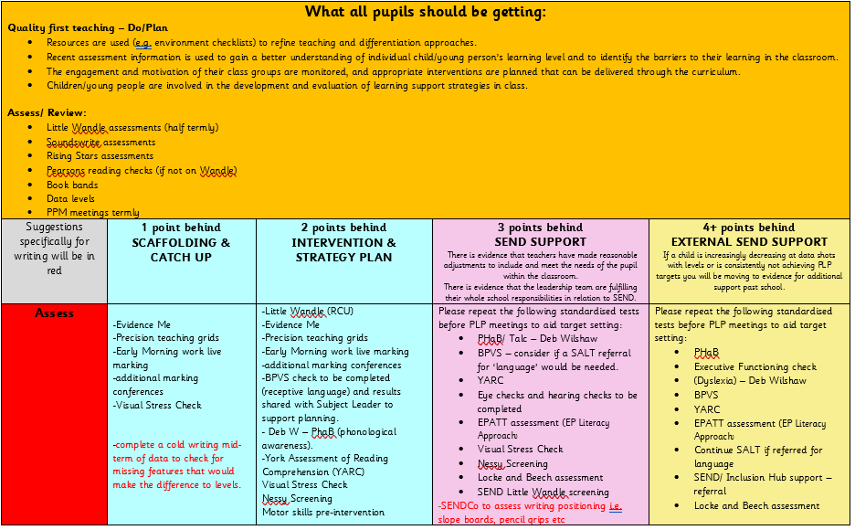
Appendix 2/3: Graduated Response Exemplar

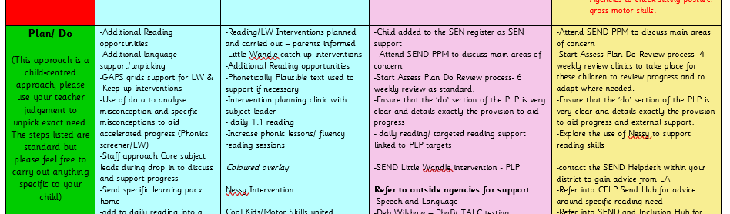
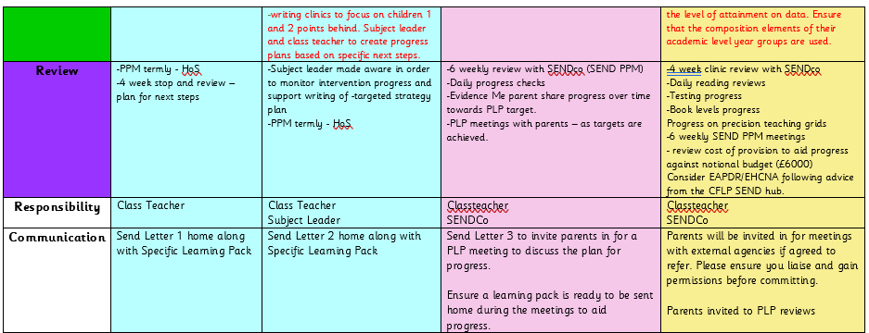

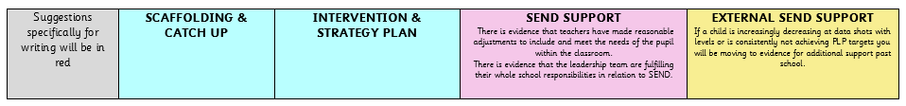
Appendix 4: SEMH Graduated Response exemplar structure
