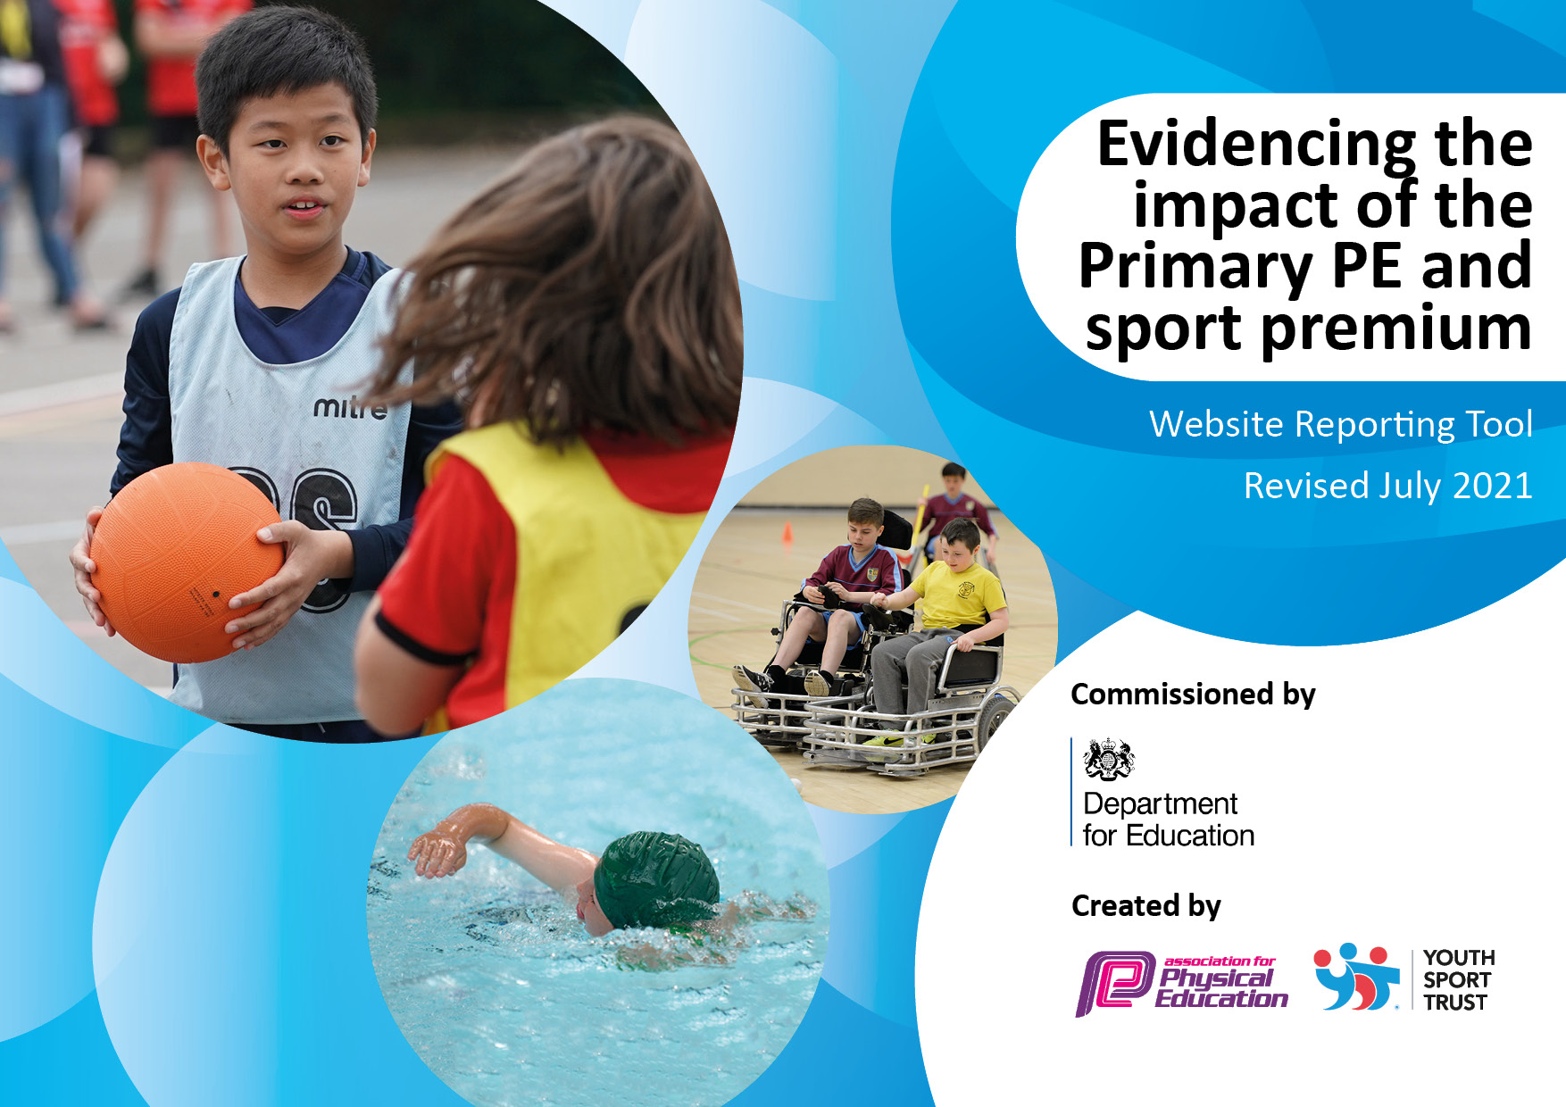
Total amount carried over from 2021/2022 | £ 0
How much (if any) do you intend to carry over from this total fund into 2023/24? | £ 0
Total amount allocated for 2022/23 | £17,550.00
Total amount of funding for 2022/23. To be spent and reported on by 31st July 2023. | £17,550.00
Details with regard to funding
Please complete the table below.

MARLFIELDS PRIMARY ACADEMY

Swimming Data
Please report on your Swimming Data below.

Meeting national curriculum requirements for swimming and water safety.

N.B. Complete this section to your best ability. For example, you might have practised safe self-rescue techniques on dry land which you can then transfer to the pool when school swimming restarts.
Due to exceptional circumstances priority should be given to ensuring that pupils can perform safe self rescue even if they do not fully meet the first two requirements of the NC programme of study
What percentage of your current Year 6 cohort swim competently, confidently, and proficiently over a distance of at least 25 metres?  N.B. Even though your pupils may swim in another year please report on their attainment on leaving primary school at the end of the summer term 2023. | 92%
What percentage of your current Year 6 cohort use a range of strokes effectively [for example, front crawl, backstroke and breaststroke]? | 92%
What percentage of your current Year 6 cohort perform safe self-rescue in different water-based situations? | 88%
Schools can choose to use the Primary PE and sport premium to provide additional provision for swimming but this must be for activity over and above the national curriculum requirements. Have you used it in this way? | Yes – see below

Action Plan and Budget Tracking
Capture your intended annual spend against the 5 key indicators. Clarify the success criteria and evidence of impact that you intend to measure to evaluate for pupils today and for the future.

Academic Year: 2022/23 | Total fund allocated: £17,550.00 | Date Updated: July 26th 2023
Key indicator 1: The engagement of all pupils in regular physical activity – Chief Medical Officers guidelines recommend that primary school pupils undertake at least 30 minutes of physical activity a day in school |  |  |  | 2023-24  allocation plan/spending
Intent | Implementation |  | Impact
Intentions | Actions to achieve | Funding allocated 2022/3 | Evidence of impact: what do pupils now know and what can they now do? What has changed?: | Sustainability and suggested next steps:  2023-24 plan/spending
- Swimming - there is a need to build confidence within a comfortable environment and re-engage the children into swimming as a regular physical activity to be enjoyed for both competitive and ones own mental health and wellbeing. This will empower them to make positive healthy lifestyle choices.  To increase the children’s skills in water safety – classroom-based activities and water-based activities – offer Rookie Lifeguard course.  - Cheshire East Council has closed the local swimming pool for refurbishment, and we have had to bus our children this year to another pool outside of town to continue meeting our National Curriculum requirements for swimming.  - New sports offered to the children with taster days. | Hire of the coach to nearest pool facilities to maintain swimming lessons for children – weekly coach for 38 weeks.  This is necessary due to the closure of our local pool – we intend to take the year 4/5 children and Year 6 for a final assessment period to ensure we have correct assessment of ability in this cohorts.  Sport introduction sessions  To contribute to the replacement of the EYFS resources in particular provision for climbing activities.  Replacement of necessary outdoor equipment failing due to safety.  Sports days were held that introduced Quidditch, Skateboarding, Bubble footballing, tennis. | 1 £4856.25  Swimming extra class 50% cost of pool/teachers for extra cohort to attend – Y4.  2. £4725.00 - coach costs due to local pool closure.  3. Theme days – taster sports – £3364.00  £428.21  Dance costumes – kept in stock.  Swimming t-shirts for team members – in stock | The children developed a positive attitude to partaking in swimming and their enthusiasm for swimming is evident when children are asked about it.  There is now a readiness to learn new sports and partake in physical activities.  Leadership skills developed of older children who learn younger children new skills in PE.  Additional staff employed all year to ensure children were supported for both physical and mental health concerns and maximising opportunities for children to be active.  EYFS Gross motor skills improved and enjoyment of physical personal challenge.  We gained the Sports Award at Gold level this year.  Ambassador for sports are in place now and support younger pupils to gain skills.  Children’s voice ensured that their evaluations of the new sports tried were listened to – e.g., the day held on Quidditch was successful and motivating as the children wished it to be continued – kit was purchased to enable this.  Children took part in two dance festivals following the theme sports days.  21 of our pupils achieved Bronze Rookie Lifeguard status | Due to a large percentage of our children not being taken swimming outside of school we have a need to start teaching this part of the curriculum before Y5 – in 2022-23 we too cohorts Y4 and Y5 - in 2023-4 years 2/3/4/5/6 will be taking part in swimming lessons weekly.  Continue with sports leaders who can be ambassadors for sport within school.  Continue to improve the less popular areas of the curriculum this year. Focused on this year being Dance.  Offer different styles of dance e.g., Street dance, country dancing etc.  Ensure that the house system gives the Quidditch day calendar time.  Consider the purchase of the other theme days and train staff to use this e.g., Bubble football.  Enhance the number of days that we go to outdoor facilities close by in 2023-24. E.g., tennis club.
Key indicator 2: The profile of PESSPA being raised across the school as a tool for whole school improvement
Intent | Implementation |  | Impact | 2023-4 Plan
Celebration assemblies and newsletter ensure that the children know the importance of PE and Sport alongside the whole curriculum and when not in school – eg. Club recognition.  Badges/t-shirts for children doing team events.  To continue to update and raise the profile of PE and Sport within the school through display boards for all visitors, pupils and parents to see.  Sports day to be inclusive and celebrate both achievement and participation.  To work to attain and then sustain the GOLD School Games Award using the criteria given  PA – physical activity breaks built into lesson time to improve body movement. Sharpen skills in being able to focus when learning – standing desks introduced, equipment on playground to encourage particular interest of children , skipping etc. | Achievements in and out of school celebrated in assemblies and newsletter regularly.  Regular changing of display board for PE.  Sports Day held which encourages a variety of skills for children to participate in as well as the traditional races for all.  Time for subject lead to collate and present evidence to the local Sports Partnership to gain the School Games Award. | £451.95  Reward badges  Swimming  Rookie Lifeguards  £128.33  Sports play leader badges  Sports Ambassador badges  Distance swimming badges | Children take part in different sports and these have been recognised in newsletters.  There has seen a increase in those children wanting to take part in the school teams during the year. There is an understanding that you have to be in it to win and participation is more important that winning at times.  Club participation after school has increased in number.  Increased confidence in PE has been seen during the year from pupils returning from the pandemic situation.  There is now an improve culture that is positive about PE and considered important.  PE lessons have improved in quality focusing on activities that improve skills and not just play games.  Pupil voice collection shows that pupils find PE enjoyable, challenging and rewarding, wanting more.  Sports partnerships are stronger.  High School used for PE – supporting transition | Sustain the GOLD award with support from the lead within our area.  Continue to increase the after school offers to pupils especially in areas which allow personal challenge.  Ensure that pupils who do not have kits are provided with them and washed within school to ensure they are ready each week for the activity.  PE passport that recognises both participation and achievement.  Continue to maintain the School Games Award.

Key indicator 3: Increased confidence, knowledge and skills of all staff in teaching PE and sport
Intent | Implementation |  | Impact | 2023-24 Plan
To improve social skills, behavioural development and academic achievement through access to broadened and improved physical education and activity provision by ensuring the subject is well led and has current children’s interest at the heart of decisions. | PE Subject Lead to attend CPD courses and webinars as provided to implement the requirements in school.  To engage with the CeCP Subject lead group and local new School Games leader with a view to attaining a standard of the award.  Quidditch sport introduced in school.  Curling kit purchased | £370 for non-contact /time for subject lead. | Increased enjoyment and positive attitudes through more creative lesson structures seen.  There has been an opportunity for children to practice and enhance skill in tradition and new sports during the year.  Quidditch equipment purchased. | Develop Orienteering skills of the teachers so that the course within school is used to good level.  Enhance the opportunities for our less active and other targeted groups.  Continue to provide opportunities for ‘ Personal Challenge’ within PE activities.  Maintain and promote links with local clubs.  Enable every adult to have access to watch and learn from an expert coach, this will increase confidence and staff then will take a more active role in Physical activity.
Key indicator 4: Broader experience of a range of sports and activities offered to all pupils
Intent | Implementation |  | Impact | 2023-24 Plan
Sports enrichment days including After school club  Maths on the Move coach | Summer term sports enrichment getting children to move linked to our creative curriculum work. | £1028.00  Cost of coach 38 weeks – after school session 38 x 1 hour  £3080.00  Maths on the move ½ day 38 weeks 3 cohorts  Equipment  Quidditch /renewal  £1240.00 | Children have knowledge of new skills in adventurous activities and overcame initial fears of taking part in the planned activities.  Children have developed their leadership and team building skills through taking part in these activities.  Children have experienced how all learning uses their fine and gross motor skills and being an active learner can help concepts to stick within their minds. | Continue to plan to offer adventure activities for the pupils.  Continue to offer after school clubs – different sport activities than offered in normal PE lessons.  Make links with the local Tennis club/golf club/ramblers association.  Introduce Geocaching to children as a personal sport.

Key indicator 5: Increased participation in competitive sport
Intent | Implementation |  | Impact | 2023-24 Plan
Your school focus should be clear | Make sure your actions to | Funding | Evidence of impact: what do | Sustainability and suggested
what you want the pupils to know | achieve are linked to your | allocated: | pupils now know and what | next steps:
and be able to do and about | intentions: |  | can they now do? What has
what they need to learn and to |  |  | changed?:
consolidate through practice:
To continue the membership of the CeCP and access increased opportunities for competitive activities.  To engage in level 2 activities whenever possible. | Promote competition participation  Promote home school links – signposting to events/clubs and teams.  Host the local Rugby coach to show the children the fun of rugby and how outside sports club participation can be rewarding. Y3,4,5,6.  Arrange tester sessions of sports not normally chosen by the children eg. Orienteering, paddle boarding, raft building etc.  Run after school clubs with outside support to increase the range of sport offered to children. | £370 for release time for teacher/TA’s to cover events.  TOTAL SPEND  £20,042.65 | There has been a clearer understanding of good sportsmanship within competitive environments and increased participation at level 2 inter competition with other schools.  Children have experienced competitiveness not only against others in a sport but also in challenging themselves to aim to improve in sports they did not know before, (new opportunities having now got the confidence.) They have been supported to be ready to achieve the best they can with support from the coaches employed during the year. | Local sports partnershilp is to be continued at a cost of £250 for the year.  A new partnership of 9 school will be formed in September 2023.  Contact has been made with the Level 2 lead within the areas for further support in 2022-23 school year.  Continue to employ coaches where possible to prepare the children for the competitions, developing skills from a lead coach.

Signed off by
Head Teacher: | Sandra Isherwood
Date: | 26th July 2023
Subject Leader: | Linsey Jackson 2/3rd (Aut/Spring) . S Isherwood 1/3rd year (summer)
Date: | 26th July 2023
Governor: | Margaret Gartside
Date: | 26th July 2023

