**Marlfields Newsletter**

**26th January 2024**

**LATE CHILDREN**

This week we have had a new signing in machine fitted. This means that if you are late and have missed the gates and have to bring your child to the Office door, you now have to sign your child in on the machine. Please don’t drop your child at the door, you must now physically bring them in.

The machine is linked to our registration system within class and marks them in; if you don’t sign them in, they will get an unauthorised mark on the register.

Signing in is very easy to do and takes just seconds for you to complete.

Thank you in anticipation for your co-operation with this.



**CALLING ALL SWIMMERS!**

We are looking for more team members from Years 3, 4, 5, and 6 to join the **“Marlfields Marlins”** – the name of our **Rotary Club Swimathon Team 2024.**

The Swimathon takes place on **Friday 15th March 2024**.

We have been allocated two lanes at 2:00pm as our swimming time. We must do as many lengths as we can, working as a team.

Our team captain is Mr Isherwood, and the vice-captain is Mrs Isherwood, and we need children in the team from Years 3, 4, 5, and 6.

The team will swim for a total of 55 minutes which means that each person will swim for just over 5 minutes (the average swimmer can complete a length of the pool in 35 seconds); however the Swimathon is not a race, but a fun fund-raising event.

Every swimmer is different, and it doesn’t matter how far you swim as long as you have fun. The main aim of the Swimathon is to raise as much money via sponsorship as you can. Half of the monies raised will go to the Rotary Club’s nominated charities, which this year is a variety of Congleton charities. The other half goes to a charity of our choice, and we have chosen the **RNLI** as our nominated charity.

We hope that you are able to join us on the team – send an email to Mrs Isherwood at **head@marlfields.cheshire.sch.uk** if you can be a member of our team on that date.

**FREE SCHOOL MEALS**

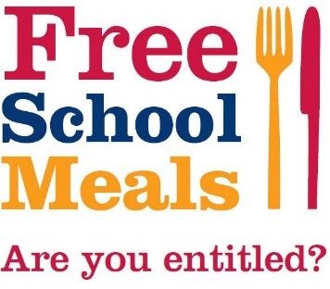Do you think your child may be eligible to Free School Meals?

If your application is successful, your child will not only get a free lunch, but other benefits too such as vouchers to cover food for the child during school holidays. In December, children already in receipt got £40 supermarket vouchers to cover the cost of lunches over the holiday.

If your child is in receipt of income related free school meals, they are automatically eligible for the [Household Support Fund](https://www.cheshireeast.gov.uk/council_and_democracy/council_information/coronavirus/household-support-fund.aspx).

You can claim free school meals for each child who attends school in Cheshire East if you receive one of these benefits:

* **Universal Credit with no earned income or with net monthly earnings less than £616.67**
* **Income Support**
* **Income based Jobseeker's Allowance**
* **Income related Employment Support Allowance**
* **Support under Part VI of the Immigration and Asylum Act 1999**
* **The guaranteed element of State Pension Credit**
* **Child Tax Credit  - as long as you have a yearly household income of less than £16,190 (as assessed by HM Revenue and Customs) and do not get Working Tax Credit**
* **Working Tax Credit run-on (paid for 4 weeks after you stop qualifying for Working Tax Credit)**

**We suggest you make a claim for free school meals even if your child is in key stage 1 as the school can claim additional funding (pupil premium) for new equipment and resources for your child to use.**

You can also apply for nursery-age children if they attend before and after lunch sessions at a local authority nursery school, nursery class or an Academy nursery if it has the same Ofsted number as the primary school.

**It’s worth a phone call to see if you are eligible. You can also apply if you are already getting the Universal Infant Free School Meals. Call 0300 123 5012 to find out or complete an on-line form on the Cheshire East web-site.**

**CROSS COUNTRY**

On Tuesday we sent a Cross Country Team up to Eaton Bank for Part of the very muddy Team

a competition.All the children ran so well, they pushed themselves individually and they all did their best, and even took the time to support each other by encouraging those who needed a boost. In fact two of our girls saw a child from another school suffering from an asthma attack; they immediately stopped running the race to comfort the child until a first aider got to her, then they continued their run. Thank you, girls. We really do have some exceptional children here at Marlfields!

Reece injured himself on the way round, but he pushed himself to complete the course and even managed a sprint at the end to push his place up. All of these children were and are, an excellent representation of Marlfields! Thank you all of you for your sportsmanship and thank you also to you parents for taking them for us. It is much appreciated. Both Reece and Blake ran for us but did not get on the photo. Next time boys

**FOOTBALL**

Years 3 and 4 took part in a football tournament at Congleton High School on Thursday after school. They played **8 matches** against other Congleton primary schools.

](https://blog.marlfieldsprimary.co.uk/wp-content/uploads/2024/01/IMG_1823-scaled.jpeg)Although we didn’t win, the team spirit shown was inspiring! **Well done Team Marlfields!**

**SCHOOL LUNCHES**

If your child would like to have a hot school lunch the week beginning 5th February, please see below the choices.

Please make your choices by return email.

We prefer not to have paper copies as the children don’t always hand them in until it is too late.

**We need to have your replies by 5:00pm on Monday 29th January** to enable us to order the food to come in.

**Dinners W/B 05.02.24 Child’s Name:                                                                    Class:**

|  |  |  |  |  |  |  |  |  |  |
| --- | --- | --- | --- | --- | --- | --- | --- | --- | --- |
| **MON** | | **TUES** | | **WEDNES** | | **THURS** | | **FRI** | |
| **Cottage Pie** | **Potato, Cheese and Leek Bake** | **Beef Lasagne** | **Vegetable Lasagne** | **Roast Chicken**  **Breast** | **Vegetarian Hotpot** | **Steak Pie and Cheesy mash** | **Penna Pasta with tomato and basil sauce** | **Fish fingers and chips** | **Macaroni Cheese** |
| **Vegetables and a pudding are served each day** | | | | | | | | | |

**Uniform**

Yesterday, our Chair of Governors paid a visit to school and commented on how many children were coming to school not wearing their uniform. Please ensure that your child comes to school wearing their FULL uniform each day, the only exception is if it is their birthday, and they can come dressed in everyday clothing.

**P.E. KIT**

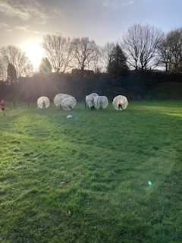Today, as a treat, we arranged for Bubble Football to come in to school. Unfortunately a great number of children were unable to join in as they didn’t have their P.E. kit in school. It is so sad to see the disappointed faces of the children who are unable to take part in these treat activities whilst their friends were enjoying themselves.

It is days like this why we say to bring a P.E. kit each Monday only taking them home on a Friday to be freshened up.

**SCHOOL-HOME COMMUNICATIONS**

To keep everyone informed on a day-to-day basis we use various ways to communicate with parents. Teachers use Class Dojo, the Office uses e-mails and a text message system which goes out to the school as a whole, or individual classes. It is not time/cost effective to send messages to, foe example, a third of the school and omit the rest. If you wish to opt-out of these communications, you can, but may miss out on important information. Please let the Office know if you no longer wish to have emails/texts from us.

**BLUE PETER BOOK BADGE**

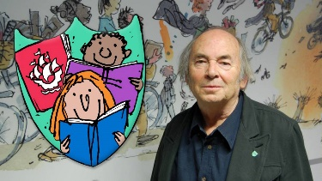You may have seen on a previous Newsletter about applying for a Blue Peter Book Badge; why not apply for one in time for WORLD BOOK DAY?

This year World Book Day is on Thursday 7th March.

To earn this badge, you must:

* Be aged between 5-15 years old.
* [Apply for your Book badge online using the uploader form on the Blue Peter web-site,](https://www.bbc.co.uk/send/u152443929) or click the 'get the Book badge' button above, to download the paper form.
* Ask your parent or guardian for permission to apply and ask them to read the [**Privacy Notice**](https://www.bbc.co.uk/cbbc/findoutmore/bp-blue-peter-badges-privacy-notice) and [**badge attraction terms and conditions.**](https://www.bbc.co.uk/cbbc/findoutmore/bp-attractions-terms-and-conditions)
* Tell us about a book you have read and what you think about it. Maybe you liked the characters, or perhaps you enjoyed going on exciting adventures in faraway places.
* Upload your illustration of a character or a scene from the story. This could be a drawing, painting or even digital artwork.
* Let us know what other books and authors you have enjoyed reading and why.
* Get your parent or guardian to help you fill out your form and personal details.
* If applying by post, send your application with the correct postage to:

**Blue Peter, BBC Bridge House, MediaCityUK, Salford, M50 2BH.**

**HEALTH ISSUES**

CHICKEN POX – are back again.

## Chickenpox treatment

There is no treatment for chickenpox. But you can get remedies from your pharmacy that can help symptoms. These include:

* [paracetamol](https://www.nhsinform.scot/tests-and-treatments/medicines-and-medical-aids/types-of-medicine/paracetamol/) to help bring down a fever
* calamine lotion and cooling gels to ease itching.

In most children, the blisters crust up and fall off naturally within 1 to 2 weeks.

Adults with chickenpox may be helped by taking antiviral medicine if its diagnosed early enough.

## Stopping the spread of chickenpox

You should keep children off school or nursery until all their spots have crusted over. This will help stop chickenpox being spread.

Adults with chickenpox should stay off work until all the spots have crusted over.

Chickenpox is infectious from 1 to 2 days before the rash starts. It stops being infectious when all the blisters have crusted over. This happens usually 5 to 6 days after the start of the rash.

If you or your child has chickenpox, try to keep them away from public areas. This will help them avoid contact with people who may not have had it.

You should especially stay away from people who are at risk of serious problems, such as:

* newborn babies
* pregnant women
* anyone with a weakened immune system, (for example people having cancer treatment or taking steroid tablets)

HEAD LICE – please see below the current NHS advice

Head lice and nits are very common in young children and their families. They do not have anything to do with dirty hair and are picked up by head-to-head contact.

## Check if it is head lice

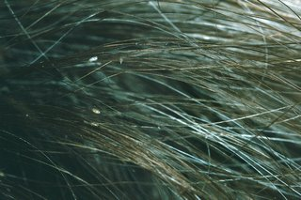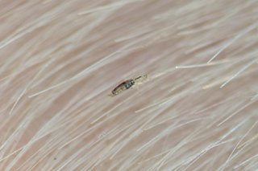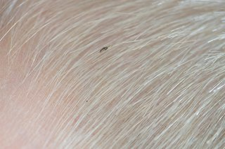Head lice are small insects, up to 3mm long.

They can be difficult to spot in your hair.

Head lice eggs (nits) are brown or white (empty shells) and attached to the hair.

Head lice can make your head feel:

* itchy
* like something is moving in your hair

The only way to be sure someone has head lice is by finding live lice.

You can do this by combing their hair with a special fine-toothed comb (detection comb). You can buy these online or at pharmacies.

## How to get rid of head lice

Treat head lice as soon as you spot them. You can treat head lice without seeing a GP.

You should check everyone in the house and start treating anyone who has head lice on the same day.

There's no need to keep your child off school if they have head lice.

### **Wet combing**

Lice and nits can be removed by wet combing.

You can buy a special fine-toothed comb (detection comb) online or from pharmacies to remove head lice and nits.

There may be instructions on the pack, but usually you:

* wash hair with ordinary shampoo
* apply lots of conditioner (any conditioner will do)
* comb the whole head of hair, from the roots to the ends

It usually takes about 10 minutes to comb short hair, and 20 to 30 minutes for long, frizzy or curly hair.

**Do wet combing on days 1, 5, 9 and 13** to catch any newly hatched head lice. **Check again that everyone's hair is free of lice on day 17.**

### **Medicated lotions and sprays**

If wet combing has not worked or is not suitable, you could try a medicated lotion or spray. These kill head lice in all types of hair, and you can buy them from pharmacies, supermarkets or online.

Head lice should die within a day. Some lotions and sprays come with a comb to remove dead lice and eggs.

Some treatments need to be repeated after a week to kill any newly hatched lice.

Check the pack to see if they're OK for you or your child and how to use them.

If lotions or sprays do not work, speak to a pharmacist about other treatments.

Some treatments are not recommended because they're unlikely to work. For example:

* products containing permethrin
* head lice "repellents"
* electric combs for head lice
* tree and plant oil treatments, such as tea tree oil, eucalyptus oil and lavender oil herbal remedies

## You cannot prevent head lice

There's nothing you can do to prevent head lice.

You can help stop them spreading by wet or dry combing regularly to catch them early.

Do not use medicated lotions and sprays to prevent head lice. They can irritate the scalp.

**There's no need for children to stay off school or to wash laundry on a hot wash.**

## Did you know there is an NHS Minor Ailment Scheme?

If you don't pay for your prescriptions, you may be able to use the NHS Minor Ailment Scheme to get advice and, when appropriate, free treatment for certain common illnesses without seeing a GP.

##### What minor illnesses are covered?

Illnesses supported within the scheme may differ between locations.

Some illnesses covered include:

|  |  |  |
| --- | --- | --- |
| • Back-ache, sprains and strains  • Colds  • Conjunctivitis  • Constipation  • Coughs  • Diarrhoea  • Earache  • Haemorrhoids  • Hay fever  **• Head lice**  • Headache and fever | • Heartburn and indigestion  • Insect bites and stings  • Mild eczema and dermatitis  • Minor fungal skin infections  • Mouth ulcers  • Nappy rash  • Sore throat  • Teething  • Threadworm  • Thrush | **Not all pharmacies offer this service, but it is worth an ask at your local one.** |

The SPACE course is a programme designed for all parents with the aim of providing information and awareness about children’s and adult’s emotional well-being.

We discuss some of the factors which might account for challenging behaviour in children, and we look at how our adult behaviours can have an impact on the children. The course aims to: develop strategies for building your resilience and that of your children: To gain a better understanding of the impact that early life experiences have had on your children.

***Highly recommended by parents who have attended the course so far.***

.



SPACE

Supporting Parents and Children Emotionally

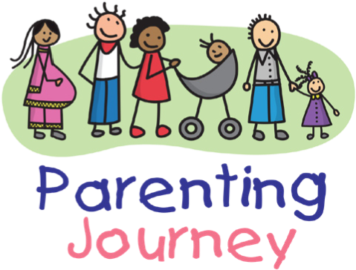

What will the course involve?

You will attend a total of 5

sessions which will be two

hours long at your local

Children’s Centre

Contact your local children’s

Centre to find out more

