**Marlfields**

**Newsletter**

**21st December 2023**

Well, here we are at the end of the Autumn school term. It’s been a long, hard slog, but we made it!

We would like to take this opportunity to thank you all for you your co-operation throughout this term, we couldn’t have done it without your help.

Thanks also for your gifts to the staff; gifts aren’t expected, but they are gratefully received, and all the staff appreciate your sentiments and generosity.

**WHAT AN EXCITING WEEK**

This week has been simply amazing, starting with ……..

**SANTA RUN**

Monday morning was our Santa Run, with all monies raised going to the East Cheshire Hospice.

](https://blog.marlfieldsprimary.co.uk/wp-content/uploads/2023/12/IMG_9536-scaled.jpeg)The children, staff and some family members joined in the fun, running twice around the field chasing Santa. As you can tell from the photographs a great time had by all.

Thank you to everyone who took the time to get sponsorship for the run and to those who donated to this self-funding charity who do amazing work; a special well done to Oliver S. who gained sponsorship to the tune of £175!

We have done a final count this morning and are extremely pleased to let you know that with your help we have raised **£1003.16**. This includes funds raised at raffles held at this year’s Christmas productions.

**BUBBLE FOOTBALL**

](https://blog.marlfieldsprimary.co.uk/wp-content/uploads/2023/12/IMG_1516-scaled.jpg)Following the Santa Run, Years 4, 5 and 6 were given a treat of playing bubble football. Some of the children spent more time on the floor than on their feet! They all had a great time full of laughter and fun.

](https://blog.marlfieldsprimary.co.uk/wp-content/uploads/2023/12/A45E6F37-AB6F-4FD7-94CE-1C1588505B3E-rotated.jpeg)**POLAR EXPRESS**

On Tuesday, Nursery, Reception, Year 1, and Year 2 excitedly got onto coaches to take them on a magical journey to the Churnet Valley Railway to board The Polar Express Train, which whisked them all through the Northern Lights, whilst having a hot chocolate and biscuit.

On their way to see Father Christmas, they were entertained with singing and dancing by Santa’s helpers, and were given

](https://blog.marlfieldsprimary.co.uk/wp-content/uploads/2023/12/IMG_9616-scaled.jpeg)

When they finally reached their destination, they got to see Father Christmas, who gave them, (if they believed), a silver bell.

**EVERYONE BELIEVED!**

**CASTAWAY ALPINE RETREAT**

On Wednesday, Miss Booth and staff took a party of children to Castaway Alpine Retreat. They had a fantastic time playing on all of the equipment, they met Santa and joined in the Build-a-Bear section. There was just so much to do. Happy children all round!

**EYFS NATIVITY**

Wednesday morning saw the children of the Early Years Foundation Stage entertaining their families with their Christmas production of The Tip Toe Nativity.

Considering that the age of the children taking part ranged from 2 – 5 years old, the confidence with which they all performed was amazing. We have some budding actors amongst them!

](https://blog.marlfieldsprimary.co.uk/wp-content/uploads/2023/12/IMG_5894-scaled.jpg)[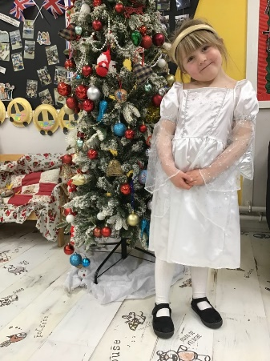](https://blog.marlfieldsprimary.co.uk/wp-content/uploads/2023/12/IMG_5896-scaled.jpg)[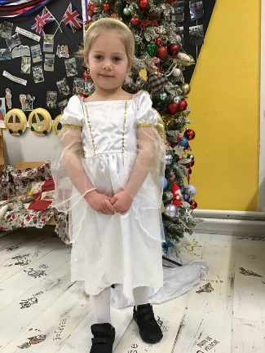](https://blog.marlfieldsprimary.co.uk/wp-content/uploads/2023/12/IMG_5901-scaled.jpg)

](https://blog.marlfieldsprimary.co.uk/wp-content/uploads/2023/12/IMG_5890-scaled.jpg)

](https://blog.marlfieldsprimary.co.uk/wp-content/uploads/2023/12/IMG_5891-scaled.jpg)

**SCHOOL DINNERS**

Due to Dolce Catering cancelling our school lunch contract, when we come back in January we will be unable to provide any lunches. Therefore **ALL** children will have to bring their own packed lunch for the first week back.

Hopefully by January 15th the new company will be up and running.

We apologise for the inconvenience but we have been let down just the same as you.

**Have a fantastic Christmas holiday, and we will see you all back in school on Monday 8th January 2024.**

