MARLFIELDS NEWSLETTER
24th November 2023

CHRISTMAS PRODUCTIONS
DATE | TIME | EVENT
Wednesday 6th December | 2:00pm | Sing the Christmas Story for Yrs 3 - 6
Wednesday 13th December | 1:30pm | Years 1 & 2 Christmas Production
Thursday 14th December | 9:30am | Christingle
 | Lunchtime | Children’s Christmas Dinner
Monday 18th December | 9:30am | Santa Run
Tuesday 19th December | 1:45 – 5:00pm | EYFS/Year 1/Year 2 Polar Express Trip
Wednesday 20th December | 9:30am | EYFS Christmas Production
 | 10:00am | Castaway Visit
Thursday 21st December | 1:00 – 5:30pm | Years 3 – 6 Christmas Panto visit

SING THE CHRISTMAS STORY
If you would like to join us Wednesday 6th December Years 3, 4, 5, 6 will be Singing the Christmas Story at the United Reformed Church in Congleton at 2:00pm, please e-mail admin@marlfields.cheshire.sch.uk with your child's name and the number of tickets you require
We would like to invite you to join us to enjoy the performance at 2:00pm. Due to the capacity of the church, we will only be able to allocate 2 tickets per child.

YEARS 1 & 2 CHRISTMAS PRODUCTION
Please let us know how many seats you would like to come to see the Years 1 and 2 Christmas play on Wednesday 13th December at 9:30pm. At the moment we can only allow 2 tickets per child, but if you need more, let us know and we will do our best to accommodate your requests.

EYFS CHRISTMAS PRODUCTION
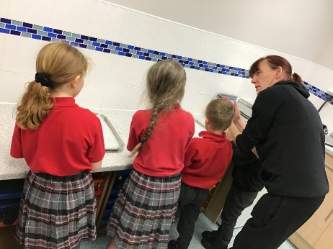
Please let us know how many seats you would like to come to see the EYFS Christmas play on Wednesday 20th December at 9:30pm. At the moment we can only allow 2 tickets per child, but if you need more, let us know and we will do our best to accommodate your requests.

After School cooking
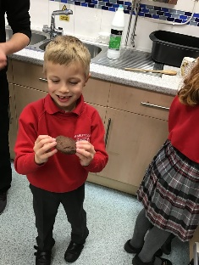
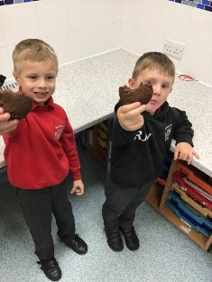
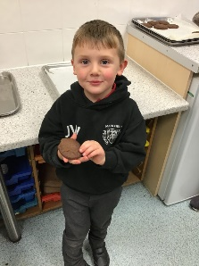
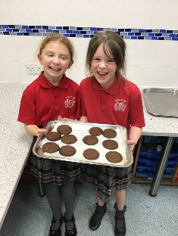
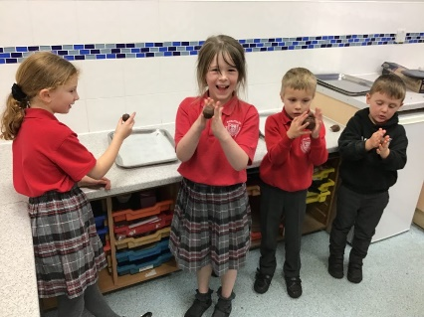
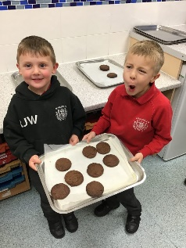
Last Friday after school, Kelly, our school chef taught a few children to bake some cookies. The children measured, rolled, shaped and baked some amazing cookies. Unfortunately because they were so delicious, they all got eaten very quickly. Only crumbs and smiling faces remained ……..…
In January we will be opening up the Friday Cooking Club to the children Year 1 – Year 6. If you would like your child to take part, there is a cost of £2 per week payable for the half term in advance. This is to enable us to buy the ingredients that they will use. Place are limited to 12 children. The £2 fee is payable in advance on SCOPAY. To secure child’s place, please register you interest as soon as possible, by calling school as soon as possible; payment should be forwarded once you have confirmation of your child’s place.

Year 4 World Religions – Communities
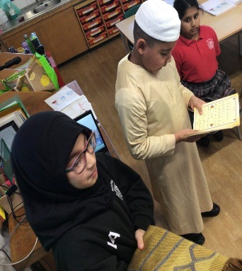
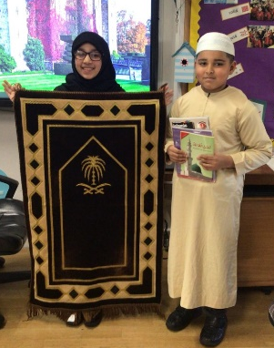
Over the past few weeks the children in Year 4 have been looking at the understanding of community and how we are all part of separate communities. They then looked at religious communities and what it means to be part of certain communities.
This week we were lucky enough to have two volunteers explain to us all about the Islamic community and what it means to them to be Muslim, what they do within their community and how to show that they are part of their community. The children and staff learnt so much about the Islamic faith and were even introduced to some religious items.
Year 4 wish to say a big thank you to our two volunteers and their amazing knowledge of their religion, sharing with us and teaching us all about their community.

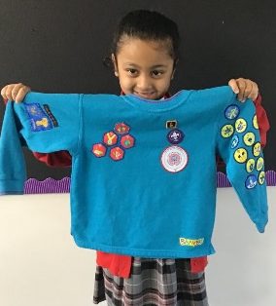  Reyah was given a Chief Scout Bronze Award for completing 6 Beaver scout challenge badges and 4 activity badges. We are all very proud of her! |  | Amelia proudly showing off her Swimming Award
CONGRATULATIONS
HOLIDAY DATES
Academic Year 2023 - 2024
TERM | SCHOOL OPENS  FOR CHILDREN | SCHOOL CLOSES  FOR CHILDREN
Autumn 2 | 31.10.2023 | 21.12.2023
CHRISTMAS HOLIDAYS
Spring 1 2024 | 08.01.2024 | 16.02.2024
Spring 2 | 27.02.2024 | 28.03.2024
EASTER HOLIDAYS
Summer 1 | 15.04.2024 | 24.05.2024
HALF TERM
Summer 2 | 04.06.2024 | 23.07.2024
INSET DAYS

04.09.2023 30.10.2023 22.12.202326.02.2024 03.06.2024

