Marlfields Newsletter
1st December 2023

Welcome to December, and the cold frosty days that it brings with it.

As we get deeper into the Winter months, the inevitable is going to happen – SNOW!
In the event that snow does fall, as always, we will do our utmost to keep school open. Should we need to close during the school day we will text/e-mail/send Dojo messages out asking you to collect your child(ren) early. (Please ensure that all of your contact details are up to date, especially if you have changed your phone number).
If there is a heavy snowfall during the night and we are unable to open because staff are unable to get into school safely, we will text/e-mail/send Dojo messages and make an announcement on local radio - SIGNAL RADIO 96.4 FM / SILK RADIO 106.9FM / RADIO STOKE 94.6FM.

Please ensure that your child has a warm, waterproof coat with them each day for outdoor play. The children should also wear sturdy sensible shoes to keep feet dry and to provide a decent grip on potentially icy pathways to and from school. We also urge you all to keep to the Gritting Plan when on school grounds, a copy of which is on each gate. This shows you the routes around school that have been gritted and are safer to use.

CHRISTMAS PRODUCTIONS
Rehearsals are well underway, preparing for the Christmas productions for all Key Stages.

To get tickets, simply e-mail the office with your child’s name, class , how many tickets for the performance (2 in the first instance)and if available any extra tickets you may need should there be any available.

The deadline for ticket applications is noon on Monday 4th December.
Applications after this time may be refused.
No ticket, no entry due to insurance and safety requirements.
DATE | TIME | EVENT / VENUE
Wednesday 6th December | 2:00pm | Sing the Christmas Story for Years 3 – 6 at the United Reformed Church, Antrobus Street, Congleton
Wednesday 13th December | 1:30pm | Years 1 & 2 Christmas Production - School
Thursday 14th December | 9:30am | Christingle – St. Peter’s Church, Chapel Street, Congleton
 | Lunchtime | Children’s Christmas Dinner in school
Monday 18th December | 9:30am | Santa Run - School
Tuesday 19th December | 1:45 – 5:00pm | EYFS/Year 1/Year 2 Polar Express Trip – Froghall Station
Wednesday 20th December | 9:30am | EYFS Christmas Production - School
 | 10:00am | Castaway Visit – Castaway, Moss Road, Congleton
Thursday 21st December | 1:00 – 5:30pm | Years 3 – 6 Christmas Panto visit – Buxton Opera House

CHRISTMAS DINNER
Christmas Dinner for the children is on Thursday 14th December. If you would like your child to join in and have a lunch it MUST be PRE-ORDERED and PAID for (unless your child is in Key Stage 1 or is eligible to Free School Meals)on your SchoolGrid account. If you do not have an account, please contact Mrs Yoxall in the office either on (01260 633120 or admin@marlfields.cheshire.sch.uk) and she will sort one out for you.

Our School Cook, Miss Roberts has agreed to buy in some Halal turkey for those who can only eat Halal meat so that all can enter into the spirit and have a Christmas Lunch. If your child would like to have a Halal Christmas Lunch, please let us know in the office by Tuesday 5th December a) to order it in and b) to ensure it is given to the right children.

We would like to take this opportunity to remind you that school meals should be paid for in advance and not in arrears

PARKING
Please park considerately when dropping children off for school and again at pick-up time. Last week we had a few complaints about parents blocking driveways by the Waggs Road and The Westlands entrances in particular.
The Highways Department have been informed by neighbours about the parking situation, and they will be sending round traffic enforcements agents who will be giving out tickets to anyone parked illegally.
The Staff Car Park is just that, for staff and visitors to school only, not for the use of parents.

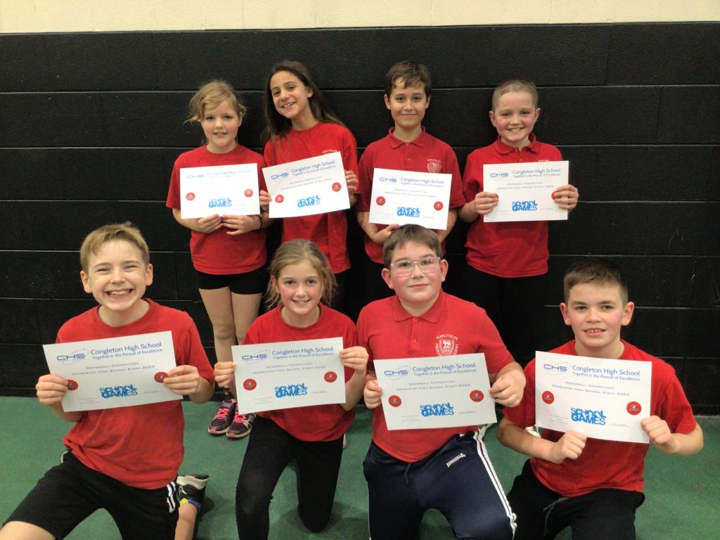
DODGEBALL
Earlier this week some members of Year 5 and 6 went to compete in a dodgeball competition at Congleton High School. All we can say is “WOW, WHAT A TEAM!”.
The children played as a wonderful team, ducking, diving and dodging! After playing five games they lost one game finishing third place.
Miss Trussler and Mr Price went with them and were incredibly impressed with their teamwork and sportsmanship, well done Team Marlfields and thank you for representing us, you are a credit to Marlfields as well as your parents – just look at their smiling faces.
HOLIDAY DATES Academic Year 2023 - 2024
TERM | SCHOOL OPENS  FOR CHILDREN | SCHOOL CLOSES  FOR CHILDREN
Autumn 2 | 31.10.2023 | 21.12.2023
CHRISTMAS HOLIDAYS
Spring 1 2024 | 08.01.2024 | 16.02.2024
Spring 2 | 27.02.2024 | 28.03.2024
EASTER HOLIDAYS
Summer 1 | 15.04.2024 | 24.05.2024
HALF TERM
Summer 2 | 04.06.2024 | 23.07.2024
INSET DAYS

04.09.2023 30.10.2023 22.12.2023 26.02.2024 03.06.2024

