MARLFIELDS NEWSLETTER
17th November 2023

CHRISTMAS TRIPS
We would like to remind you that the deadline for giving permission for your child to go on the Christmas trips that we have organised is MONDAY 20th November at 5:00pm. Any permission slips returned after this time WILL NOT BE ACCEPTED. We accept that this may seem harsh, but we have deadlines to stick to with regards to confirming numbers; after all, we don’t want to have tickets left over if your child decides not to attend.

ATTENDANCE
This week Mrs Isherwood and Mrs Yoxall had a meeting with the Education Welfare Service to discuss childrens’ attendance. We currently have a number of children/families who are causing concern. Any absence percentage below 95% gets flagged as concerning. Anything below 85% and the process may begin to prosecute serial offenders.
Being in school on time, all day, every day is a legal requirement for every child over the age of 5. The Attendance Officer is keeping a close eye on the children who are consistently late.
We understand that if a child is genuinely ill that they need time off, but some children are kept off for non-valid reasons, and as such are recorded on the register as an unauthorised absence.
Similarly if you book a holiday during term time unless there are compelling compassionate reasons these too will go down as unauthorised and will be forwarded to the Education Welfare Service who will issue you with a fixed penalty notice. This also applies to families who have already been on holiday from September!

FORTHCOMING SPORTING EVENTS
These dates are to let you know in advance what team events that some children will be invited to take part in. Not all children will be chosen, as we are sure that you will appreciate, we can only enter a certain number of children at some of these events. Those who are chosen will be given a letter to bring home prior to the event.
There may be more events to add to the list, which we will give you advance notice of.

16th January 2024 | Sports Hall Athletics | Yrs 5 & 6
18th January 2024 | High 5 Netball | Yrs 5 & 6
25th January 2024 | Cross Country | Yrs 5 & 6
 | Football | Yrs 3 & 4
31st January 2024 | Cross Country | Yrs 3 & 4
6th February 2024 | Netball League | Yrs 5 & 6
14th February 2024 | Football - boys | Yrs 5 & 6
15th February 2024 | Athletics | Yrs 3 & 4
29th February 2024 | Football - girls | Yrs 3 & 4
5th March 2024 | Football - boys | Yrs 5 & 6
14th March 2024 | Netball League | Yrs 5 & 6
27th March 2024 | Football - girls | Yrs 5 & 6
16th April 2024 | Netball Tournament | Yrs 5 & 6
3rd July 2024 | Town Sports | Key Stage 2

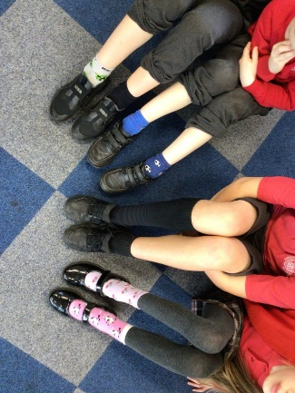
Odd Socks Day
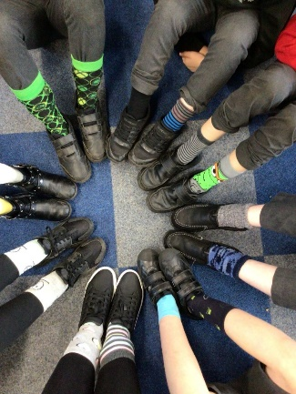
On Monday many children came to school wearing for Odd Socks day to celebrate the start of Anti-bullying week.
Thank you everyone for showing us we are all unique and different, and that it is okay to be different.

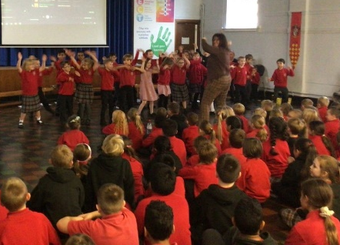
Year 2’s super assembly
On Thursday Class 2 showed off what they have learnt so far this year in an assembly for the whole school and their parents. This included fossils, the story of Mary Anning, and finished with an enthusiastic carnival dance which the parents also had a go at learning too.

* Wednesday 6th December Years 3, 4, 5, 6 will be Singing the Christmas Story at the United Reformed Church in Congleton.
We would like to invite you to join us to enjoy the performance at 2:00pm. Due to the capacity of the church, we will only be able to allocate 2 tickets per child.

If you would like to join us, please e-mail admin@marlfields.cheshire.sch.uk with your child's name and the number of tickets you require.

DATE | TIME | EVENT
*Wednesday 6th December | 2:00pm | Sing the Christmas Story for Yrs 3 - 6
Wednesday 13th December | 1:30pm | Years 1 & 2 Christmas Production
Thursday 14th December | 9:30am | Christingle
 | Lunchtime | Children’s Christmas Dinner
Monday 18th December | 9:30am | Santa Run
Tuesday 19th December | 1:45 – 5:00pm | EYFS/Year 1/Year 2 Christmas Surprise
Wednesday 20th December | 9:30am | EYFS Christmas Production
Thursday 21st December | 1:00 – 5:30pm | Years 3 – 6 Christmas Surprise
HOLIDAY DATES
Academic Year 2023 - 2024
TERM | SCHOOL OPENS  FOR CHILDREN | SCHOOL CLOSES  FOR CHILDREN
Autumn 1 | 05.09.2023 | 20.10.2023
 | HALF TERM
Autumn 2 | 31.10.2023 | 21.12.2023
CHRISTMAS HOLIDAYS
Spring 1 2024 | 08.01.2024 | 16.02.2024
Spring 2 | 27.02.2024 | 28.03.2024
EASTER HOLIDAYS
Summer 1 | 15.04.2024 | 24.05.2024
HALF TERM
Summer 2 | 04.06.2024 | 23.07.2024
INSET DAYS

04.09.2023 30.10.2023 22.12.2023

26.02.2024 03.06.2024

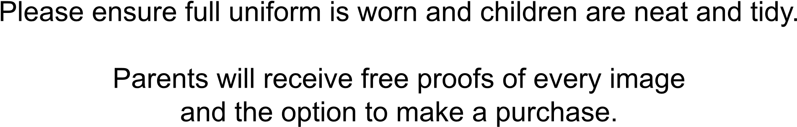
P
l
e
a
s
e

e
n
s
u
r
e

f
u
l
l

u
n
i
f
o
r
m

i
s

w
o
r
n

a
n
d

c
h
i
l
d
r
e
n

a
r
e

n
e
a
t

a
n
d

t
i
d
y
.
P
a
r
e
n
t
s

w
i
l
l

r
e
c
e
i
v
e

f
r
e
e

p
r
o
o
f
s

o
f

e
v
e
r
y

i
m
a
g
e
a
n
d

t
h
e

o
p
t
i
o
n

t
o

m
a
k
e

a

p
u
r
c
h
a
s
e
.
Thursday 23rd November 2023
The Whole School
For Families with babies

Starting at 8.15 am
Siblings during school
Individuals during school
Powered by TCPDF (www.tcpdf.org
)

