MARLFIELDS NEWSLETTER
5th MAY 2023

NO SCHOOL ON MONDAY DUE TO EXTRA BANK HOLIDAY FOR THE CORONATION

BAKING FOR THE CORONATION
Class 5 had fun on Thursday morning helping Ms Roberts, our cook, to cut biscuits out in the shape of crowns. We are looking forward to eating them!

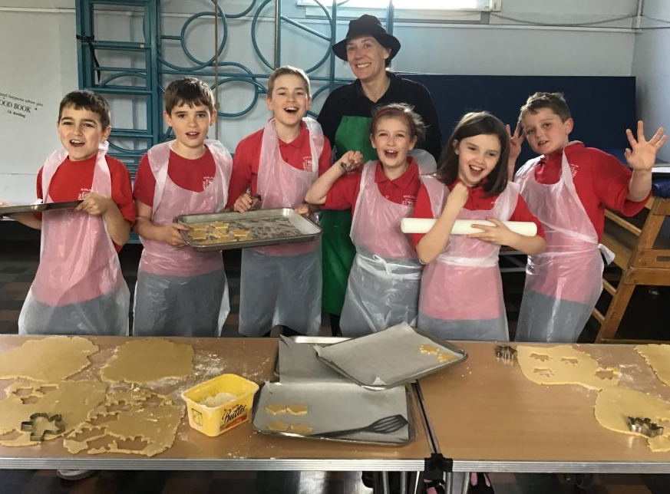
Getting ready to cut out the dough Oven ready Cooked to perfection!

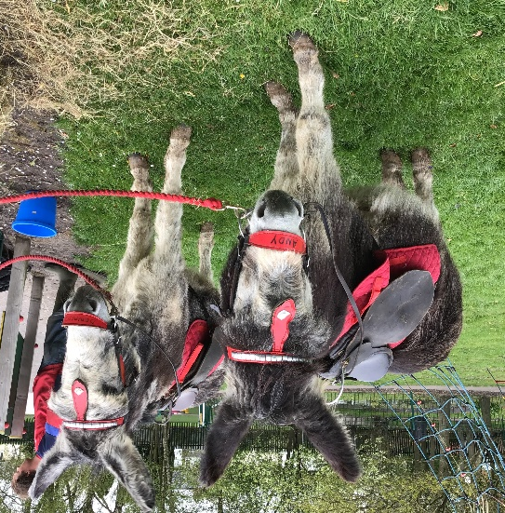
Donkey Visit
On Tuesday, we had two special visitors - two donkeys from a donkey sanctuary. They were named Andy and Dennis.

Did you know that donkey’s coats aren’t waterproof?
Or that donkeys have bigger brains than horses?
No, we didn’t either!
We found out lots of interesting facts during the visit.

Most of the children in school got to have a short ride on the donkeys. Unfortunately, not all were able to as there is a weight limit of what these beautiful animals can carry, and some of the older children were over that threshold, they were however able to spend time with the donkeys and were able to pet them.

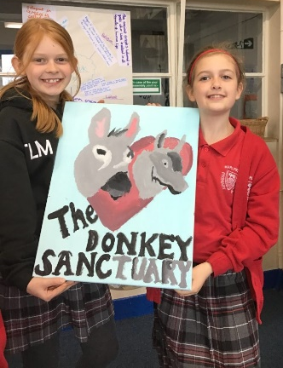
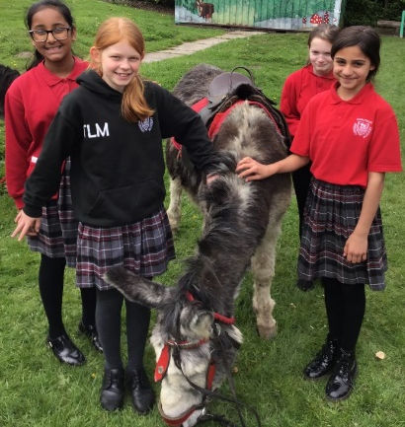
We hope that the children enjoyed the experience, we certainly did! We enjoyed the visit so much we decided to raise funds for the sanctuary by selling framed photos of the children and cakes. We also hope to eventually adopt a donkey. When you adopt a donkey with The Donkey Sanctuary the support reaches donkeys around the world, not just in this country; it could help buy food and medicines, help to pay for vets and help build shelters and hospitals. And, most importantly of all, it can help to rescue helpless donkeys from hopeless situations.
SCHOOL PHOTOGRAPHS
Academy Photographers will be in school on Monday 15th May to take class group photographs and Year 6 Leaver photographs. Please ensure that your child wears their full Marlfields uniform that day – red Marlfields sweatshirt/cardigan, red polo shirt, kilt, grey trousers.

Communication methods
Our apologies again for the late sending of last week’s newsletter. We send a newsletter written by Mrs Yoxall, for which we thank her, each week. This is usually e-mailed out each Friday and is also loaded onto our website ‘newsletter’ page. Should you not get the newsletter by email check for it on the website.
Other communication from the office is ‘Text2Parents’, text messages sent out when necessary.
Class teachers send class messages also via ‘Class Dojo’ and now and then Mrs Isherwood will send a whole school message using this method.

P.E.
During Covid-19 times we allowed the children to come into school on their P.E. days wearing their P.E. kit. From next week, Tuesday 9th May this will change as the Governors have noticed, when they come in to visit that some children are not wearing the full school kit throughout the day. It has therefore been decided that P.E. kits MUST be brought into school at the beginning of each week and hung on your child’s peg and NOT worn all day.
When it is time for them to take part in sports the children will take their kit into our state-of-the-art changing rooms that we had installed just before the pandemic. Kits should remain in school throughout the week and taken home for washing each Friday.

LATENESS/ABSENCE
Lateness is becoming a huge problem throughout every year group within school. On one day alone this week 27 children arrived late – some around 9:15, but some not until almost 11:00!
Registration begins at 8:55 and all pupils are expected to be in school for registration at this time. Arrivals after this time will be noted in the register as late.
Pupils who are consistently late are disrupting not only their own education but also that of others.
Where persistent lateness gives cause for concern further action may be taken.
The school aims to have ALL children or young people attending regularly and punctually and parents need to know that should their child fail to attend in this way then the matter will be referred to the Education Welfare Service.

Parents need to be aware that Cheshire East Schools work in co-operation with the Education Welfare Service.

Parents need to be aware that Cheshire East Council in conjunction with Schools are operating Fixed Penalty Notices for non-attendance.
Every Minute Counts
Lateness = Lost Learning
(Figures below are calculated over a school year)

5 minutes late each day | 3 days lost!
10 minutes late each day | 6.5 days lost!
15 minutes late each day | 10 days lost!
20 minutes late each day | 13 days lost!
30 minutes late each day | 19 days lost!
The Governing Board are following Government guidance have that authorisation will NOT be given for ANY holidays taken in term time unless there are exceptionally extra-ordinary circumstances.
Requests for authorised absence must be made in writing in advance of the absence. Fixed Penalty Notices can and will be issued by the Local Authority for unauthorised absences. The school has a statutory duty to monitor and challenge absences, reporting these to Local Authority.
Absences for medical or dental appointments will only be authorised if an appointment card or letter, reminder text message or evidence from the doctor/dentist is provided, and then only ½ day absence will be approved. Absence means missed learning.

SCIENCE WORK IN SCHOOL
Year 2 have been busy during their topic sessions this week. They have been learning about animations and conducting an experiment on plants!
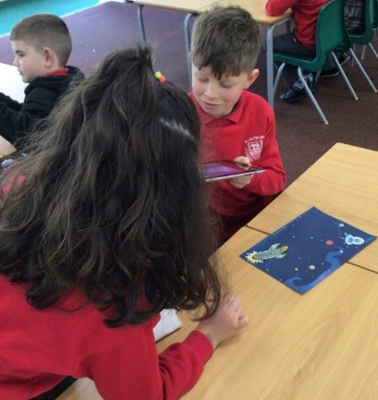

Year 4 have continued their scientific enquiry into insulators and conductor.
They gathered several items from around the school and tested them using circuits to see if they can complete the circuit and conduct electricity or if they would insulate the electricity.
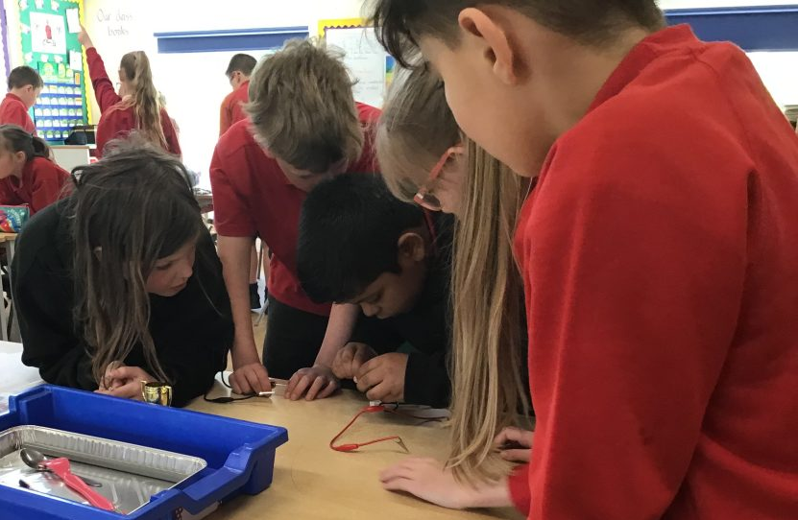
The children then tested the different items to see if their bulb would light. Some items gave the children a little shock when they found that part of them would conduct, and parts would insulate. We concluded that metals make the best conductors.
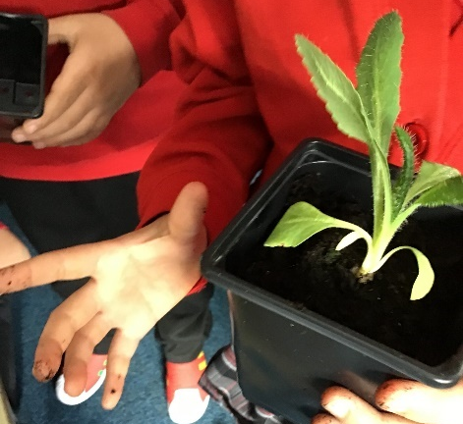
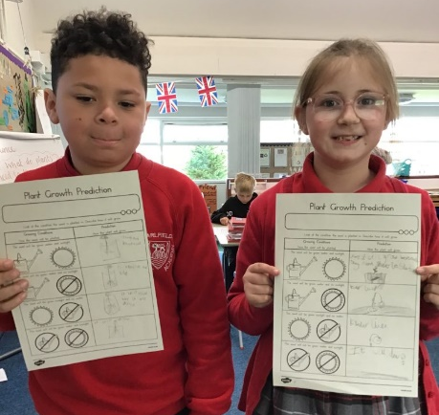
In science Year 3 made predictions about which plants would grow the strongest in different conditions.

Congleton Youth Orchestra
Congleton Youth Orchestra will be welcoming all aspiring orchestral musicians on Saturday 13th May 2023.

They cater for all, from complete beginners, those who have started playing an instrument in school and also established musicians.
The event will run between 9:30am and 12:00noon, with two time slots:

- 9:30-11:00am - For musicians playing for 1 year or more.
- 11:00am-12noon - For complete beginners.

First established in November 1994, the Congleton Youth Orchestra gives young people from Congleton, and the surrounding areas the opportunity to learn, play and perform music in an orchestral setting.
The Orchestra has both a Senior Orchestra (Grade 4+) and an Intermediate Orchestra (Grade 0-3), and provision for beginner players restarting in September 2023.
The Orchestra performs a concert at the end of each term, which are generally held in Congleton Town Hall.
The Orchestra meets each Saturday morning during term time at Trinity Methodist Church, Wagg Street, Congleton, CW12 4BA.
All of the groups are taught by experienced instrumental staff and volunteers, staff are all Disclosure and Barring Service (DBS) checked.

For more information or to register your interest, contact them via Facebook,
e-mail: secretary@congleton-youth-orchestra.org
or visit their website https://www.congleton-youth-orchestra.org

