**MARLFIELDS NEWSLETTER**

**25TH MAY 2023**

We break up today for the half term holiday, tomorrow being an INSET Day for the staff. The children are expected back in school on **TUESDAY 6th June**.

Have a lovely, safe break, the weather forecast looks promising. Don’t forget to use sunscreen. Enjoy yourselves.

**MR LIEW**

Due to personal circumstances Mr Liew has resigned from his post as teacher in Year 1. His last day will be tomorrow, 25th May.  We would like to let you know the arrangements for our last term of this year. The class will be taken by Miss Trussler, who is a qualified teacher and knows the children well, having worked with them since September.  She will be supported by Mrs Boon and Mrs Wood, who are both highly skilled assistants in our team.

We wish Mr Liew happiness for the future and would like to let him know that he will be missed by children and staff alike.

**PLANT UP**

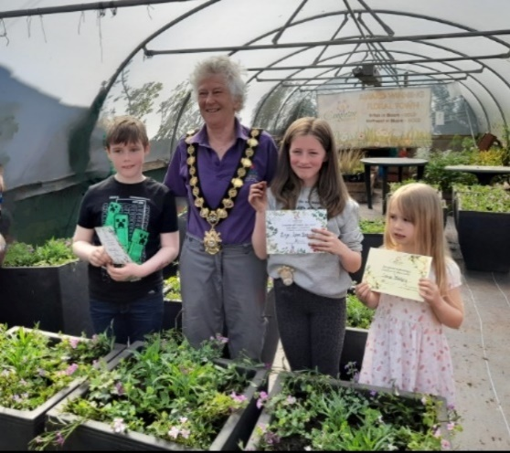

Last weekend, Iona Bailey, Evie-Jean Brewer, and Wyatt Kay planted up tubs and planters on behalf of Congleton Town Council, along with children from other schools.

The children were joined by the Town Mayor, and Chair of Marlfields Governor, Mrs Gartside. The planters will be displayed around the town. Keep your eyes peeled for them. The children did an amazing job of planting them.

Thank you, all of you for representing Marlfields, and for doing such a good job. We are proud of you all.

**CELEBRATIONS**

|  |  |  |
| --- | --- | --- |
| Two girls holding medals posing for the camera  Description automatically generated with low confidenceCongratulations to Scarlett Evans and Evie-Jean Brewer for being medal winners.  Scarlett got her medal for being a part of “Team Goal” at the Egerton Football Tournament who won 6 matches, and subsequently won the Tournament.  Evie-Jean brought in two medals to share with us. The first medal was for being a part of the Kenzoku self-defence for the past 6 years, and for helping out in the classes. The second medal is from the Rotary Club for being part of the ECO-group. |  | Harvey Porter got a certificate for completing his Piano Book 1. He is now able to play Dishwasher Blues, Russian Rumble and Feel like a Monster! |

](https://blog.marlfieldsprimary.co.uk/wp-content/uploads/2023/05/IMG_3674-scaled.jpeg)**YEAR 6 RESIDENTIAL**

Year 6 set off on their residential visit to Glan Llyn by Lake Bala in Wales on Monday.

They arrived, along with the sunshine, and after being allocated their rooms, they went canoeing on the lake, and all returned soaking wet, including Miss Booth!

](https://blog.marlfieldsprimary.co.uk/wp-content/uploads/2023/05/IMG_3679.jpeg)Others took part in an orienteering exercise.

After a break, they were introduced to three owls. Some children jumped at the chance to hold one of them. Some lay on the floor while one of the owls, Bronwen, flew over them.

](https://blog.marlfieldsprimary.co.uk/wp-content/uploads/2023/05/IMG_3669-scaled.jpeg)

](https://blog.marlfieldsprimary.co.uk/wp-content/uploads/2023/05/IMG_3792-scaled.jpeg)This is the stunning view that the children had to ‘suffer’ while at Glan Llyn. On the second day, amongst other things, the children learned archery skills, mapping skills, bushcraft, toasting marshmallows and popped corn on a campfire. Mmmm, lovely.

](https://blog.marlfieldsprimary.co.uk/wp-content/uploads/2023/05/IMG_3803-scaled.jpeg)The Climbing Wall showed that we have a number of supermen and super women! It became very competitive as to would be first to the top!

There was also a rope course and ‘the descender’ – otherwise known as the ‘death drop’! a great deal of bravery was needed. After that the children then learned how to row a boat across the lake – it was very tricky rowing in a straight line!

Later on, the children went on a treasure hunt and played ten-pin bowling, before showing off their best dance moves to banging tunes by DJ Horton!

At the end of the day, they packed our bags, got ready for bed and then headed out to look at the crescent moon and a very clear Venus. To finish the night off they watched the International Space Station travel across the sky.

By the time they got back to school on Wednesday afternoon everyone, children, staff and parents alike, were totally exhausted. Roll on next year.

**ILLNESSES**

We would like to take the opportunity to advise you that we have a number of illnesses currently doing the rounds.

**IMPETIGO**

Impetigo is a skin infection, caused by one of two bacteria.

Impetigo may affect the skin anywhere on the body but is most commonly found around the nose and mouth area. It is characterised by blisters that may burst and ooze a clear fluid, which then develops into a honey-coloured crust. Impetigo is highly contagious it can be caught from skin contact with a person who already has it, even by just holding hands.

If you see these signs on your child, you need to see your G.P. who following diagnosis can give you antibiotics and or a cream to aid recovery.

**CHICKEN POX**

Chickenpox is a very contagious infection that causes an itchy, spotty rash. Read NHS information on their web-site about symptoms and when to seek medical advice.

**HEADLICE**

Please check your hair, the rest of the family and your child’s hair thoroughly over the holiday and treat accordingly with conditioner or a recommended shampoo from the chemist should you find evidence of any lice or nits.

|  |  |  |
| --- | --- | --- |
| **HOLIDAY DATES**  **Academic Year 2022 – 2023** | | |
|  | **SCHOOL OPENS**  **FOR CHILDREN** | **SCHOOL CLOSES**  **FOR CHILDREN** |
| **Summer 1** | **17.04.2023** | **25.05.2023\*** |
| **Half Term** | | |
| **Summer 2** | **\*06.06.2023** | **21.07.2023** |
| **INSET DAYS *26.05.2023,* 05.06.2023** | | |

**HOLIDAY DATES**



**Have a fantastic half-term holiday.**

**See you all on Tuesday 6th June.**