**MARLFIELDS NEWSLETTER**

**19th MAY 2023**

**WARNING**

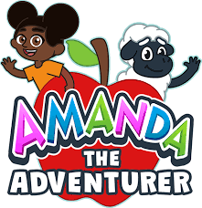We have received information from the local safeguarding team regarding a new game that is currently circling around. The game is called "Amanda the Adventurer”.

**Please see below the email from the safeguarding team.**

**There is a new online kid’s game to be made aware of called ‘Amanda the Adventurer.’**

**This is a violent horror game with challenging escape room type puzzles, with inappropriate language and content for kids.**

**This can also be accessed via You Tube Kids – as gaming footage from players (similar to ‘Huggy Wuggy’ and ‘Rainbow Friends.’) The game begins with the player inheriting a family house and a letter explaining that there isn’t much time left. VHS tapes are to be unlocked during the game; watching them you uncover some disturbing stories behind the show. It ends with the player being killed by a spindly creature that resembles Amanda. Other endings with the player escaping the attic and various other dark areas, until the final ending is a trench coat wearing figure joining the player in the attic.**

**Throughout the game it shows the character gleefully abusing characters like a sheep ‘woolly’ and choosing various surgical tools to torment it with, as well as killing animals.**

Please keep an eye on the games that your child is playing to ensure that they aren’t

accessing games like this that appear innocuous but are in fact horrendous.

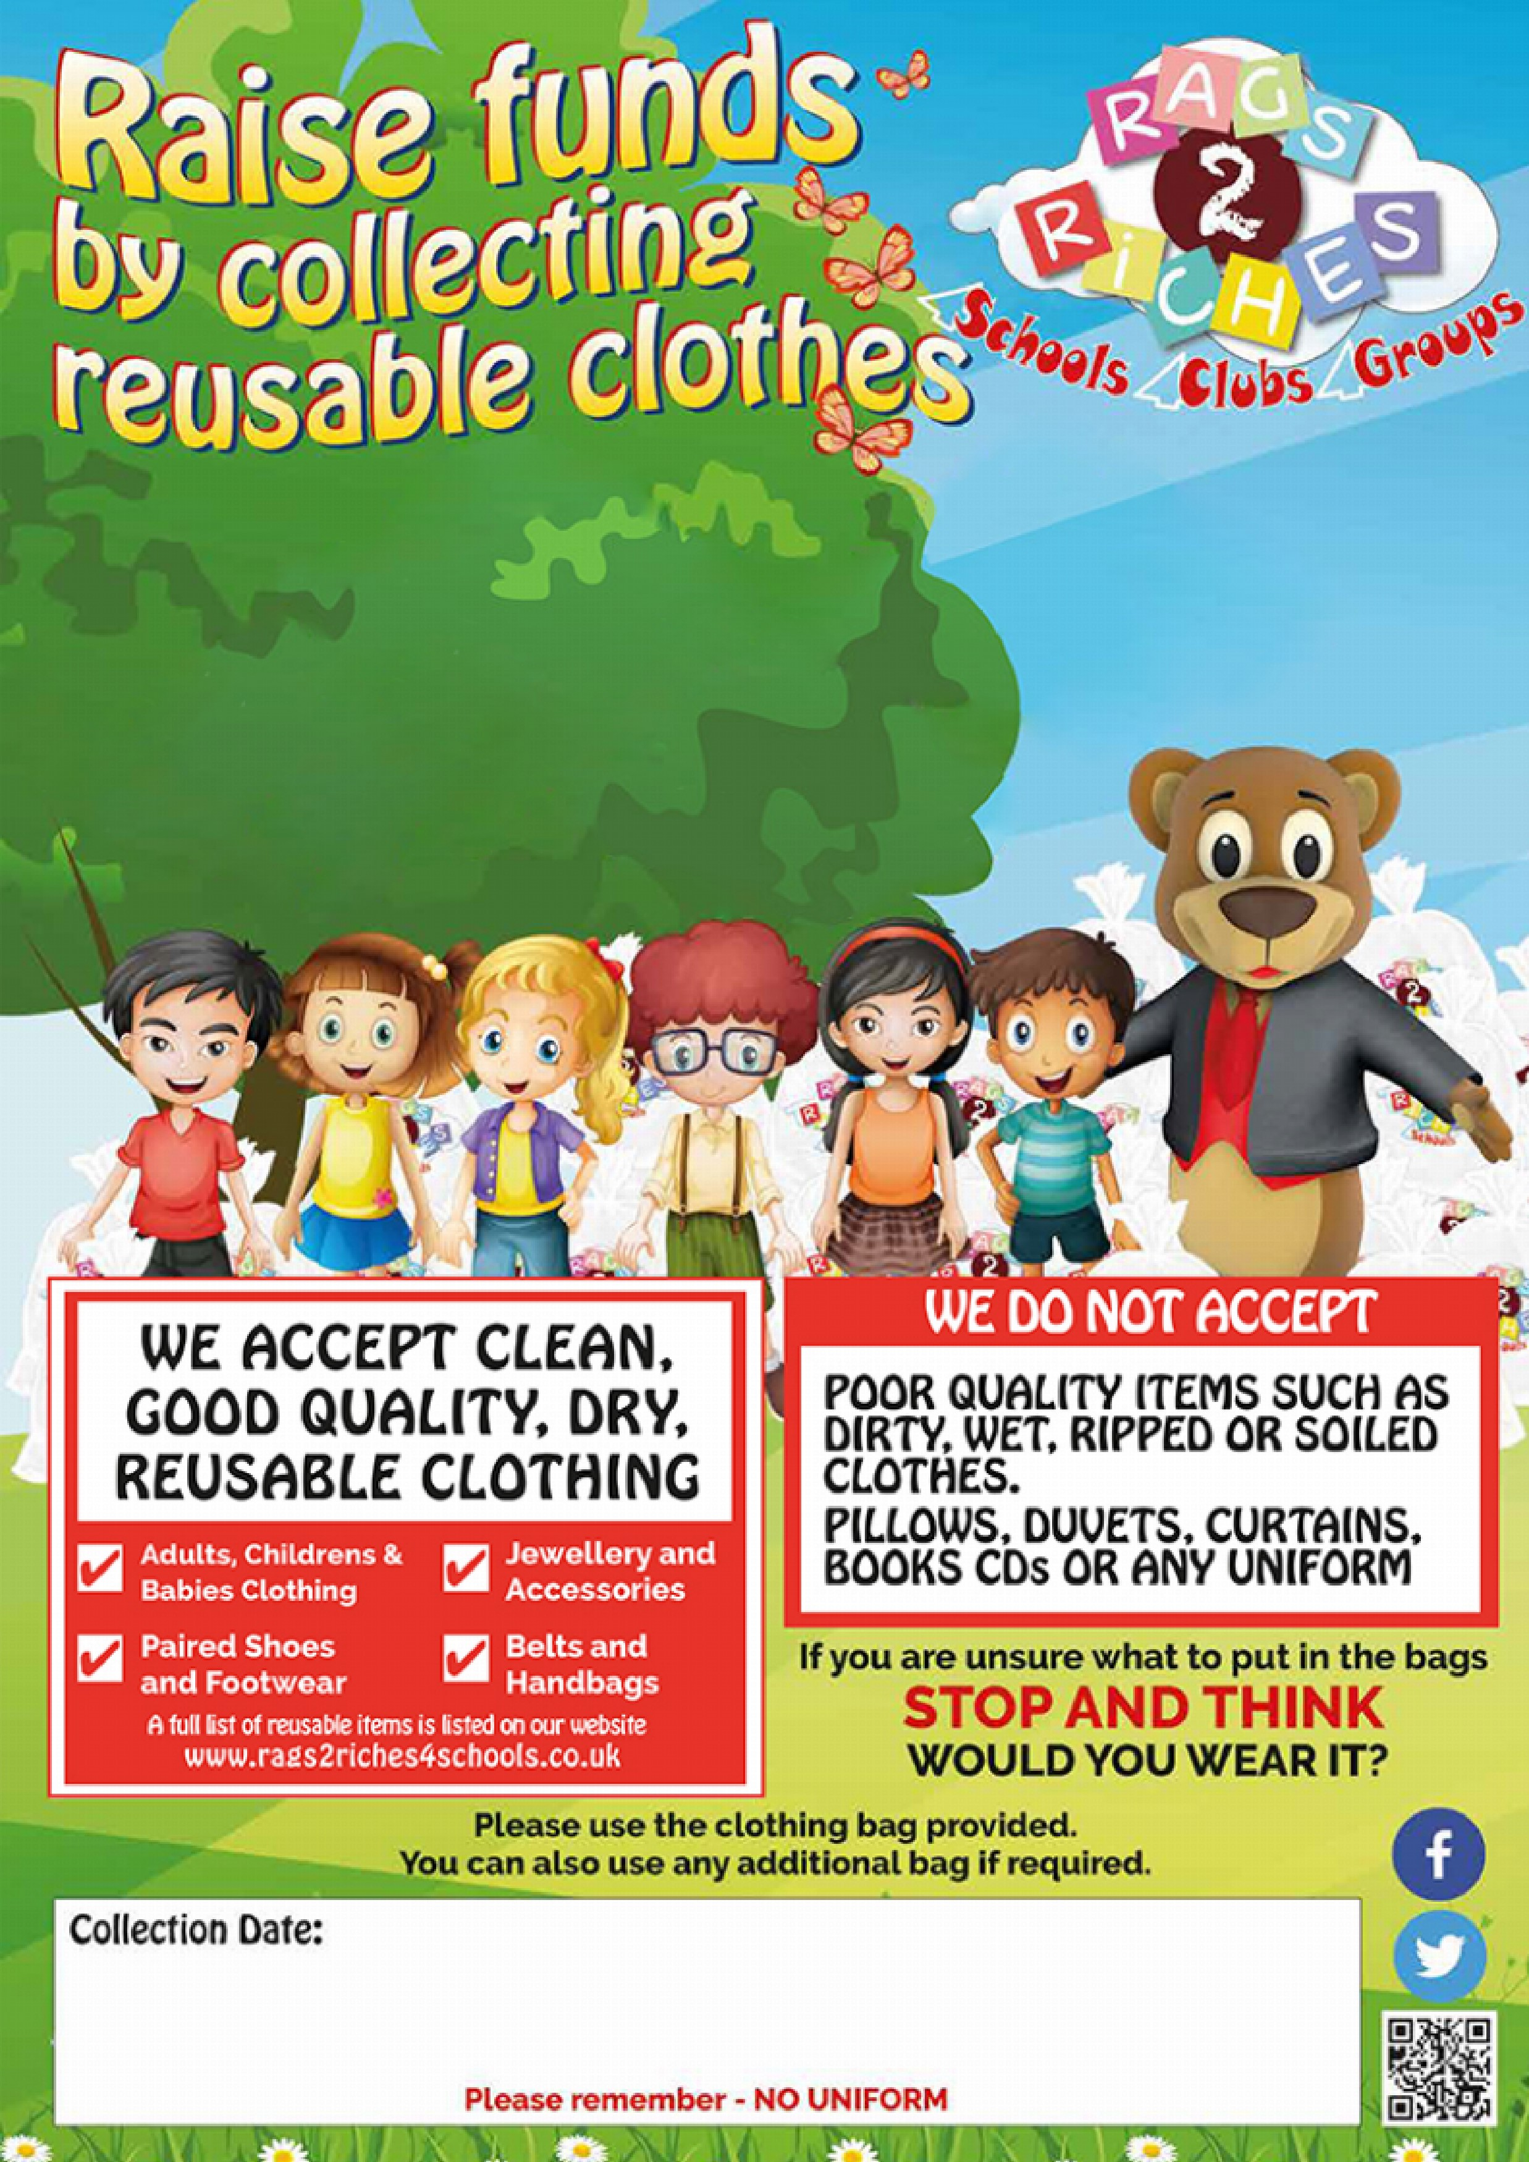

**At MARLFIELDS PRIMARY ACADEMY**

**RAGS2RICHES FOR SCHOOLS**

We will shortly be sending out collection bags for the Friends of Marlfields’ latest fund-raiser.

Why not take this opportunity to Spring-clean your drawers, cupboards, and wardrobes. Please see the flyer below of what you can and cannot put in the bags, but basically, we are looking for re-usable clothing, shoes/boots/trainers, belts, handbags, jewellery and accessories. There is no limit as to how many bags you bring can in. Items don’t have to be in the bag that we send out, any black bag will do.

Collection of the bags isn’t until **4th July**, which seems a long time away, but it will soon be here. Perhaps have a good rummage round over the forthcoming half-term holiday and put them to one side. Monies raised will go towards ‘extras’ for the children.

**TUESDAY 4th JULY**

**CONGRATULATIONS!**

|  |  |  |  |  |  |
| --- | --- | --- | --- | --- | --- |
| A child holding a pink ribbon  Description automatically generated with medium confidenceLast week,  Ruby went to  Marton to take part in some  horse riding.  Well done  Ruby. | | A child holding a paper  Description automatically generated with low confidenceAmira has completed the whole of her Piano Book 1.  Well done Amira. | | A child wearing a black sweatshirt with a red lanyard  Description automatically generated with low confidenceEvie-Jean  recently won a medal for her  Ju-Jitsu.  Well done  Evie-Jean. | |
| IMG_7457.jpgElliot and his  younger sister  Darcey won  medals and  trophies with  their ‘Acro’  team last  weekend.  Well done  both of you. | | A person running on a track  Description automatically generated Tilly represented Macclesfield Harriers Running Club in a Inter Club Cheshire League Competition last week, which was held in Ellesmere Port.  This is the first of four competitions to decide an overall winner. Tilly competed in long jump, javelin, 75m and 100m relay. Well done Tilly. | |

[**Outdoor Learning**](https://blog.marlfieldsprimary.co.uk/outdoor-learning-2/)

[**Class 6**](https://blog.marlfieldsprimary.co.uk/author/class-6/)

Thursday was Outdoor Learning Day so we took our maths lesson outside. We played a strategic game called Nim. The aim was to leave your opponent with one item in the pile and then they would lose. Some children worked out the way in which you would always win!

After that we set about an investigation: Is there a correlation between your arm span and the distance you can throw a javelin?

Once we had measured our arm spans, we then measured the distance we could throw a javelin. We then looked at the ratio between those numbers and the difference. We concluded that there wasn’t a correlation, but it was dependent on how much “umph” you used!

We finished the morning off with creating chalk patterns inspired by the artist Mondrian.

](https://blog.marlfieldsprimary.co.uk/wp-content/uploads/2023/05/IMG_2016-scaled.jpeg)

[**Class 5**](https://blog.marlfieldsprimary.co.uk/author/class-5/)

Today we drew our own character that we are going to use to help us in our writing tomorrow. It will be our version of this term’s book The Barnabas Project.

](https://blog.marlfieldsprimary.co.uk/wp-content/uploads/2023/05/10A0E8AE-CEEE-4441-B047-34EAFCA788C5-scaled.jpeg)

[**Class 4**](https://blog.marlfieldsprimary.co.uk/author/class-4/)

](https://blog.marlfieldsprimary.co.uk/wp-content/uploads/2023/05/IMG_4239-scaled.jpg)We have been writing poems all about colour. Using the different skills that we have learnt throughout our time on poetry through the years. We then went outside to get inspiration to plan and edit our draft poems.

](https://blog.marlfieldsprimary.co.uk/wp-content/uploads/2023/05/IMG_4266-1-scaled.jpg)The children then continued to enjoy their outdoor learning by taking our Science outside.  
The children were given the challenge to create a switch that could be used similar to a buzzer on a gameshow. After a rocky start from some groups who were trying to work out what could be used as conductors and insulators, we were finally successful. Well done for the perseverance and resilience of those groups who found the challenge a little tricky to problem solve.

[**Class 3**](https://blog.marlfieldsprimary.co.uk/author/class-3/)

](https://blog.marlfieldsprimary.co.uk/wp-content/uploads/2023/05/IMG_1710-scaled.jpeg)We have been finding out the different ways seeds are dispersed. We have learnt that seeds can be dispersed by wind, animals, drop and roll or by water. The children found out that some seeds explode to spread their seeds, so we made our own seed bombs.

](https://blog.marlfieldsprimary.co.uk/wp-content/uploads/2023/05/IMG_1729-scaled.jpeg)

](https://blog.marlfieldsprimary.co.uk/wp-content/uploads/2023/05/DC1230E1-E3E0-4747-BFCC-8E6A57DF25FA-scaled.jpeg)[**Class 2**](https://blog.marlfieldsprimary.co.uk/author/class-2/)

Year 2 had a story outside in the school grounds. We read the story ‘Mr Peg’s Post’ and discussed what we predicted the story would be about from the title and blurb. The children then discussed how the book was similar to our text we have been studying in English ‘The Lighthouse Keeper’s lunch’ and also discussed the differences.

**Class 1**

We started exploring doubles and worked out the amounts using dice, multi-link cubes, counters and chalk.

Later in the day we also did our art lesson outside. We are looking at Paul Klee, who used shapes to make his pictures. We used his method and used different 3D shapes to create a picture of things we could see outside.

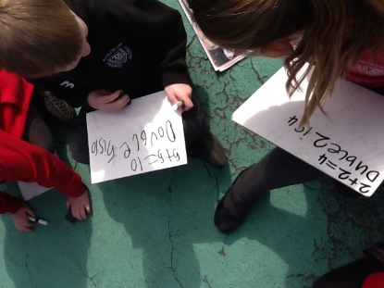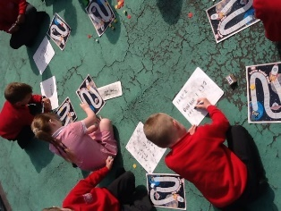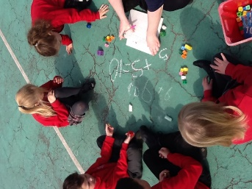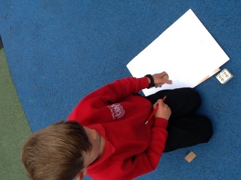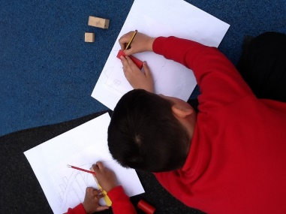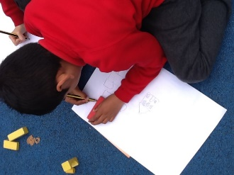

|  |  |  |
| --- | --- | --- |
| **HOLIDAY DATES**  **Academic Year 2022 – 2023** | | |
|  | **SCHOOL OPENS**  **FOR CHILDREN** | **SCHOOL CLOSES**  **FOR CHILDREN** |
| **Summer 1** | **17.04.2023** | **25.05.2023** |
| **Bank Holidays** | **Monday 01.05.2023**  **Monday 08.05.2023** | |
| **Half Term** | | |
| **Summer 2** | **06.06.2023** | **21.07.2023** |
| **INSET DAYS 31.03.2023, 26.05.2023, 05.06.2023** | | |



