MARLFIELDS NEWSLETTER
12TH May 2023

SCHOOL DRIVEWAY
We would like to take this opportunity to remind parents that the school drive and parking area is FOR STAFF ONLY. Parents should not be using this area for their own use. We have noticed that some families arrive late just so that they can use the carpark rather than walking!

Parents should not use the driveway to walk to the playground to drop off the children. Staff and taxis continue to access this route until 9:00am; we would not wish for an accident to happen, but it could easily, with the volume of people who walk this route. instead, please walk PAST the driveway to the gate after the terraced houses and use that gate to access the playground. It is no further to walk, and is a safer, and easier way to get onto the playground.

UNIFORM, COATS & P.E. KITS
Please ensure that your child comes to school wearing the FULL Marlfields uniform each day. As a reminder, the full uniform is a red Marlfields sweatshirt/cardigan with the school logo on, red polo shirt, Marlfields kilt/grey trousers. The only exception to this is when it is your child’s birthday they are allowed to wear every day clothes. No P.E. clothing is to be worn except during a P.E. lesson.

Your child still needs to have a coat with them to school each day.
Whilst the days are a little warmer, there is still a chill in the air and regular showers, which means that those without coats may be unable to go out at break times.

P.E. kits MUST be brought into school at the beginning of each week and hung on your child’s peg and NOT worn all day.
When it is time for them to take part in sports the children will take their kit into our state-of-the-art changing rooms that we had installed just before the pandemic. Kits should remain in school throughout the week and taken home for washing each Friday.

SCHOOL PHOTOGRAPHS
Academy Photographers will be in school on Monday 15th May to take class group photographs and Year 6 Leaver photographs. Please ensure that your child wears their full Marlfields uniform that day – red Marlfields sweatshirt/cardigan, red polo shirt, kilt, grey trousers.

SCHOOL DINNERS
When ordering your child’s lunches on the Dolce/SchoolGrid app please, please, please check that what you are ordering is actually what your child would like to eat, as quite often a child will get to the canteen and not like what has been ordered. As we are sure you appreciate the cook cooks the food to order and isn’t always able to provide something different in the middle of service.

LATENESS/ABSENCE
Lateness continues to be a huge problem throughout every year group within school. Even though we mentioned the situation on last weeks Newsletter, the situation has not changed.
The Education Welfare Officer came to school last term, and is coming again in the next two weeks to see if there has been any progress in attendance and punctuality of the children identified by her on the last visit.

As a reminder, Registration begins at 8:55 and all pupils are expected to be in school for registration at this time. Arrivals after this time will be noted in the register as late.
Pupils who are consistently late are disrupting not only their own education but also that of others.

FOUNDATION STAGE CORONATION TEA PARTY
Last Friday, the children in the Foundation Stage celebrated the coronation of King Charles III with an afternoon tea party.
The children had been planning the party for the last couple of weeks; writing lists, writing invitations, writing recipes for cakes and making cakes and biscuits.

The children came to school that morning dressed in red, white and blue clothes.
During the morning, the children set to, making the sandwiches, jelly, fruit salad and decorating the classroom ready for their party visitors!
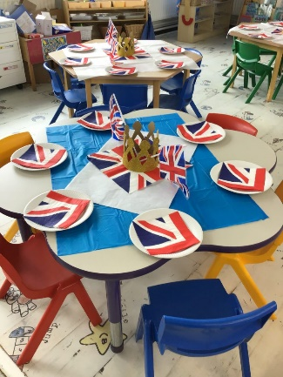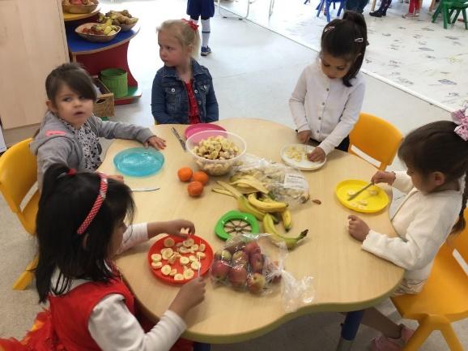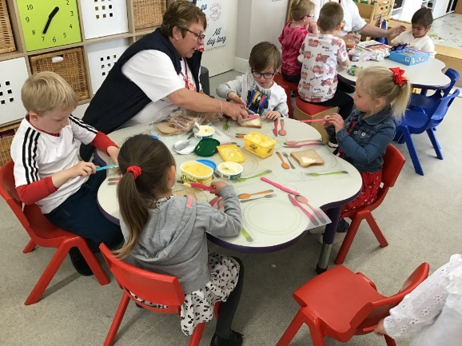
It was then time to celebrate….the children had invited their parents and the Town Mayor, Mrs Gartside to come along to their party.
Then we all enjoyed our afternoon tea. The children finished by enjoying their special Crown Cake they made for the King!

