**MARLFIELDS NEWSLETTER**

**28TH APRIL 2023**

**KING CHARLES III CORONATION**



As you are probably aware, Saturday May 6th is the coronation day of King Charles III.

As we are not in school on Saturdays, we thought it would be nice if the children could come into school wearing **Red**, **White** and **Blue** as a tribute to His Majesty.

**COOKING CLUB**

Cooking Club began this week.

We started by making a tropical island using fruit; we used bananas, apples and oranges. We used our cutting skills to cut and slice and arranged them to look like a palm tree on a tropical island.

We also made some cheese on toast – a very nice after school snack!

](https://blog.marlfieldsprimary.co.uk/wp-content/uploads/2023/04/08FFC34F-0E72-483E-8AE8-8F955082090F-scaled.jpeg)

](https://blog.marlfieldsprimary.co.uk/wp-content/uploads/2023/04/E4F8E5EF-50AF-489F-A83D-BE5B6F2C89B2-scaled.jpeg)

**DESIGNERS OF THE FUTURE?**

Some of Class 5 are beginning to finish the bags that they have been designing.

Before making the bags, they each thought about how the bag handles should be attached, what sort of handle, if the bag should have a pocket and which materials, they should use to make a sturdy bag.

[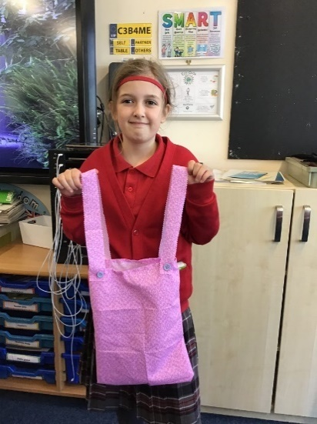](https://blog.marlfieldsprimary.co.uk/wp-content/uploads/2023/04/C6D54276-1038-4CC4-937A-E0E454CC7764-scaled.jpeg)[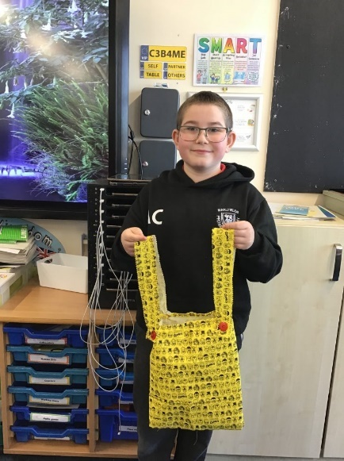](https://blog.marlfieldsprimary.co.uk/wp-content/uploads/2023/04/991B0402-5BC9-4EE7-8B60-19455E273055-scaled.jpeg)We hope that you are as impressed with them as we are.

](https://blog.marlfieldsprimary.co.uk/wp-content/uploads/2023/04/8F15A4DF-D722-4F15-A10A-65938A00EA34-scaled.jpeg)

**ANCIENT GREECE**

Last week Year 5 started to learn about the physical geography of Greece. They researched lots of facts about Greece and began to compare modern and Ancient Greece.

](https://blog.marlfieldsprimary.co.uk/wp-content/uploads/2023/04/BDA439E1-C4E7-47F0-A982-0DCDDC236328-scaled.jpeg)

The children enjoyed doing the research, with everyone staying on task, as you can see in the photographs.

[**Bags of Talent**](https://blog.marlfieldsprimary.co.uk/bags-of-talent/)

**SCHOOL PHOTOGRAPHS**

Academy Photographers will be in school on **Monday 15th May** to take class group photographs and Year 6 Leaver photographs. Please ensure that your child wears their full Marlfields uniform that day – **red** Marlfields sweatshirt/cardigan, red polo shirt, kilt, grey trousers.

**UNIFORM**

May we please remind you that correct uniform **MUST be worn in school at ALL TIMES**.

|  |  |
| --- | --- |
| **BOYS** | **GIRLS** |
| * **Red sweatshirt** bearing the academy logo. * **Red polo shirts** bearing the academy logo should be worn beneath the sweatshirts. * **Black/ Dark Grey trousers** or **shorts.** Shorts may be worn throughout the year. * Fleece bearing the academy logo. | * **Red sweatshirt** or **cardigan** bearing the academy logo. * **Red polo shirts** bearing the academy logo should be worn beneath the sweatshirts. * **Academy tartan skirt** * **Black/ Dark Grey trousers**. * **Red gingham dress** (summer wear) * Fleece bearing the academy logo. |

School tracksuits with logo **ONLY** (not an everyday tracksuit) may be worn on P.E. days. Children may wear ‘civvy’ clothes when it is their birthday.

Please ensure that your child has their P.E. kit in school every day of the week, especially now that the weather is getting better as we may be doing more sports practice in the lead up to Sports Day. Many thanks in anticipation of your co-operation.

**CONGRATULATIONS**

Please join us in congratulating Edith in Year 3 for winning this wonderful trophy for Gymnastics. Well done, Edith!

# Yesterday we had a fun day in school. We did lots of experiments. All the children had the opportunity to take part in the activities.

|  |  |  |
| --- | --- | --- |
| [Anti Gravity](https://blog.marlfieldsprimary.co.uk/anti-gravity/)We learnt that if a ball was filled with air it will rise higher than one with hardly any air in.  [A picture containing text, indoor, person, ceiling  Description automatically generated](https://blog.marlfieldsprimary.co.uk/wp-content/uploads/2023/04/87193E4B-BF17-4813-981C-9E7215AB184D-scaled.jpeg) |  | SLIME [A picture containing person, floor, red  Description automatically generated](https://blog.marlfieldsprimary.co.uk/wp-content/uploads/2023/04/7B732C35-7DAE-47ED-873D-D77F924AC773-scaled.jpeg)[A picture containing floor, indoor, person, red  Description automatically generated](https://blog.marlfieldsprimary.co.uk/wp-content/uploads/2023/04/FC618550-4581-4E56-8C2A-49DB942EEF82-scaled.jpeg)Today we made our own slime out of pva glue, food colouring and activator. It got very messy! |
| **SHERBERT**  We also made our own sherbet out of sugar, bicarbonate of soda and citric acid. As you can see, it was very sour.  [A picture containing person, indoor, red, curtain  Description automatically generated](https://blog.marlfieldsprimary.co.uk/wp-content/uploads/2023/04/DAE7A8B4-650F-4DD1-94BC-4234046DB9EC-scaled.jpeg)[A picture containing person, window, indoor  Description automatically generated](https://blog.marlfieldsprimary.co.uk/wp-content/uploads/2023/04/B72C8960-3493-43E6-93E0-89958D92F908-scaled.jpeg)[A picture containing person, indoor, red  Description automatically generated](https://blog.marlfieldsprimary.co.uk/wp-content/uploads/2023/04/6D38C176-0350-4477-844A-50D747C042E8-scaled.jpeg) | | |

|  |
| --- |
| **TEACHER STRIKE**  Next Tuesday, 2nd May, is another Strike Day  for the teachers.  Please check your inbox for an update sent out today. |

|  |  |  |
| --- | --- | --- |
| **HOLIDAY DATES**  **Academic Year 2022 – 2023** | | |
|  | **SCHOOL OPENS**  **FOR CHILDREN** | **SCHOOL CLOSES**  **FOR CHILDREN** |
| **Summer 1** | **17.04.2023** | **25.05.2023** |
| **Bank Holidays** | **Monday 01.05.2023**  **Monday 08.05.2023** | |
| **Half Term** | | |
| **Summer 2** | **06.06.2023** | **21.07.2023** |
| **INSET DAYS 31.03.2023, 26.05.2023, 05.06.2023** | | |

