MARLFIELDS NEWSLETTER
24th March 2023

What an OPERA-tunity!
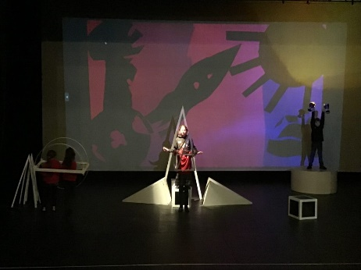
Year 5 visited Clonter Opera earlier this week. They wrote and composed their own songs, worked on costume designs, made a Gobo, and did a freeze-frame for their Gobo (a Gobo is an object placed inside or in front of a light source to control the shape of the emitted light and its shadow.
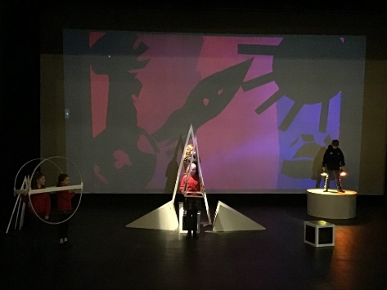
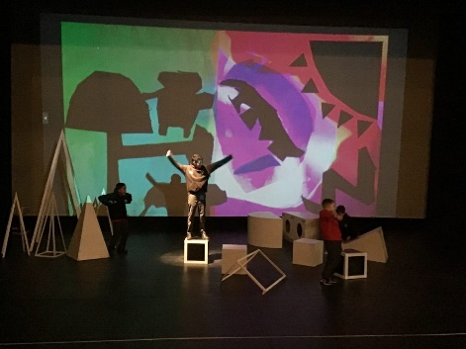
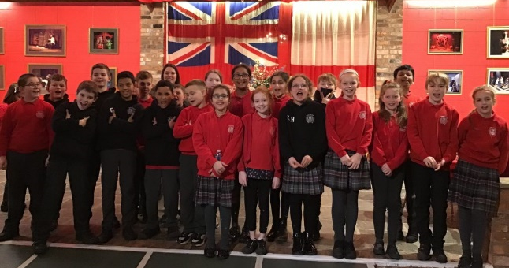

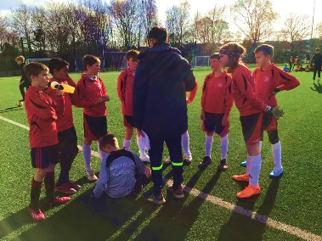
Year 5 and 6 Football
On Wednesday we sent a team of Year 5 and 6 to Congleton High School for a football competition with other schools in Congleton with the help of ‘gaffer’ Mr Liew.
Before the game started the boys began with a friendly warm up.
Our first game was against Buglawton. What a fantastic start for our Marlfield’s group with a win or 2-1.
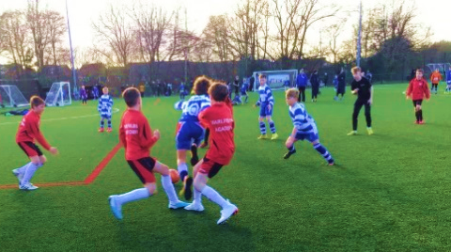
Our next round was against Quinta and after some ‘challenging’ tactics from the other team we were beaten. Our final round was against Mossley. Our Marlfields team played hard and worked hard to no avail as we were beaten.
Well done boys you all played amazingly; we are proud of you.

SINGFEST 4 and 5 perform at Sing-Fest
After months of practicing this week Years 4 and 5 went to the Congleton Town Hall to perform a ‘Dancers and Dreamers Medley’ organised by The Love Music Trust. Other schools that were involved in the show were Daven and Astbury St. Mary’s. The aim of Singfest is to teach children how to sing and harmonise with others, as well as performing in front of an audience.
A group of our young performers volunteered to sing solos, stepping forward and performing to the best of their abilities.
A huge thank you goes out to everyone who have helped in making today the success, and to you as parents for supporting the event by buying tickets to watch! We cannot say how proud of the children we are. To see a video of the performance, please take a look at the school blog where there is a video of the children performing – enjoy!

Year 1 have also been rehearsing over the past few weeks, and they too performed at Congleton Town Hall along with Alsager Highfields and Elworth Hall Primary School – ‘Betty Bear’s Cheshire Staycation’. They sang songs about Betty’s adventures around Cheshire; wool mills, trains, canals, the salt mines to name just a few things. As you can see from the photographs, they all had a fun time, although Betty Bear doesn’t look too happy!
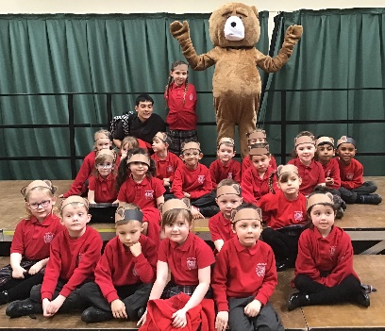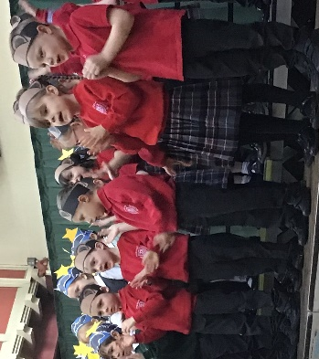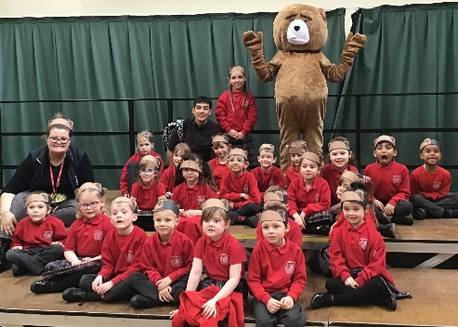
SCIENCE WEEK CELEBRATION ASSEMBLY
We celebrated all of the hard work, investigations and research with each other on Monday with a whole school assembly.
The assembly started with some children showing their exploration of connections, followed by Eco work and how we can help our world and finally our science linked to the current topics that had taken place within their classes.
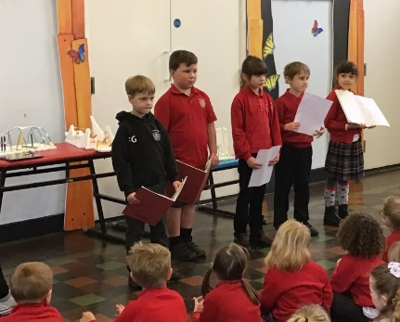
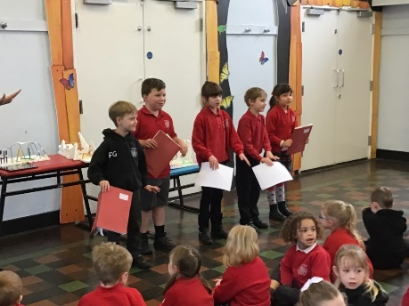
It was evident that they all learnt a lot. It was fantastic to see the children showing and celebrating their findings.
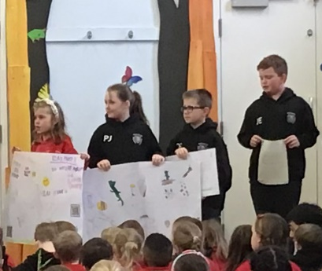
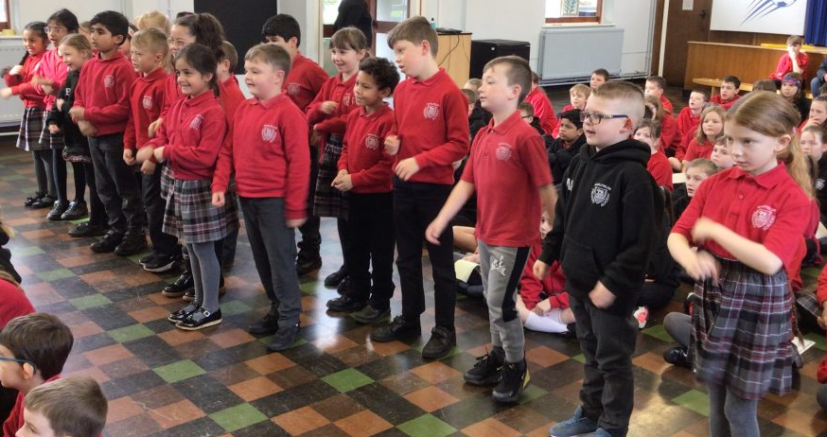

HOLIDAYS Academic Year 2022 – 2023
 | SCHOOL OPENS  FOR CHILDREN | SCHOOL CLOSES  FOR CHILDREN
Spring 2 | 27.02.2023 | INSET DAY Fri 31.03.2023 Tuesday 04.04.2023
Easter Holidays
Summer 1 | 17.04.2023 | 25.05.2023
Bank Holidays | Monday 01.05.2023  Monday 08.05.2023
Half Term
Summer 2 | 06.06.2023 | 21.07.2023
INSET DAYS 31.03.2023, 26.05.2023, 05.06.2023

Don’t forget to put
your clocks forward
an hour this weekend

