Marlfields’ Newsletter
27th January 2023

GREGGS SUPPORT SCHEME
As you are aware we are lucky to be supported by the Greggs Foundation for support with the current cost of living crisis. This can be in the form of beds, bedding, small kitchen appliances, washing machines and uniform support. Please let Mrs Isherwood know if you need some support and she will apply for you to the grant organisation. Please note this is open to all our families and if you have already had one then you will not be eligible for a second. If you have not had one, or are unsure if you have, please let us know if we can help you. Mrs Isherwood’s email is head@marlfields.cheshire.sch.uk.

STRIKE ACTION BY TEACHER
As you know the NEU have confirmed there will be a number of strike days for Teachers in their union on the following dates: 1st and 28th February and 15th and 16th March 2023.

The dispute is a national one over teachers’ pay and other working conditions. This note details advice regarding actions schools are advised to take. Headteachers, alongside your Trustees or Headteachers and their Governing Board are responsible for taking the appropriate actions in response to industrial action.

Under the Health and Safety at Work etc Act 1974, the employer in a school must take reasonable steps to ensure that staff and pupils are not exposed to risks to their health and safety. This applies to activities on or off school premises and schools will need to be mindful that responsibilities could be impacted on because of industrial action.

The decision to open, restrict attendance, or close our school is for the management to decide. As you will appreciate we will only close if it is unsafe to open with regard to safety. The DfE has given us guidance and if open we will not be following the normal teaching day. As you will also appreciate we do not know if any of our teachers will strike it is their decision and so we cannot give you notice of this until nearer the dates. It may be that there is a decision to open but with restricted numbers and if so this will be on a rota basis of classes to ensure all have an equal opportunity to continue to come to school while these strikes are being undertaken. Any questions please call or email Mrs Isherwood who will help you further.

Year 3 working on their art

Year 3 have been experimenting with Digital Art – inspired by Warhol’s

Volcano pictures. This links in with their current topic.
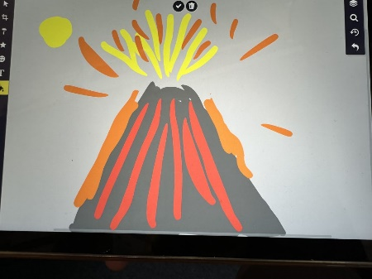
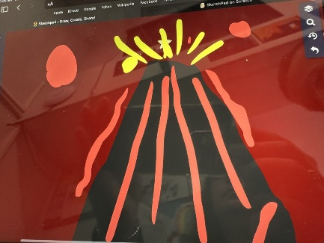
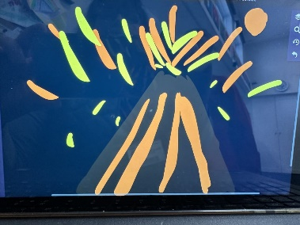

Year 4

Year 4 have been looking at Wider religions and finding out about the celebrations. They have looked at the celebration of Passover and why it is important to religious communities.
We have looked back at the story of where it all began, and role played the Exodus from Egypt and the 10 Plagues of Egypt.
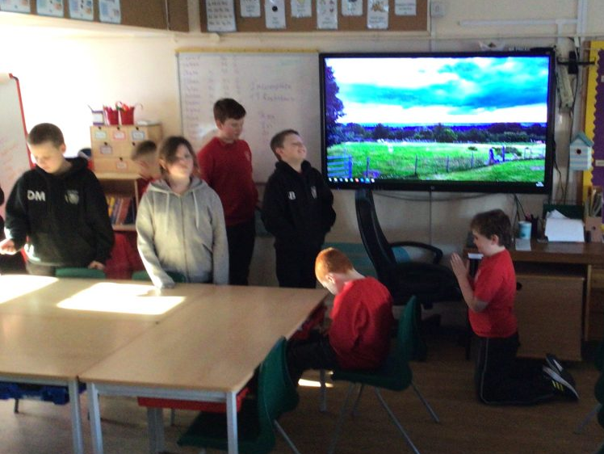
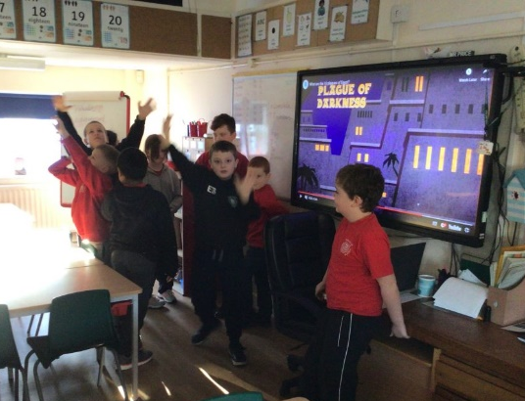

YEAR 1 BETTY BEAR CONCERT

Further to the date we asked you to save for our Betty Bear Concert for Year 1 –
Congleton Town Hall on Tuesday 21st March 2023
Concert 1 (arrive 9:00 am Concert Starts 9:30 Concert Finishes 10:30)

Parent tickets are available via www.lovemusictrust.com/betty-bear-tickets
and will go live on Monday 13th February at 9am. They will be available on a
first come first served basis.
We hope you will join us.

AFTER SCHOOL & BEFORE SCHOOL CLUB
If you wish your child to attend our (paid for) after and before school club, you need to book your place in advance on our booking form.
Due to staffing levels, we need as much notice as possible of a booking. As we are governed by staff/child ratios we cannot accept any last-minute bookings under any circumstances. Booked sessions MUST be paid for in advance on receipt of an invoice.

On Friday afternoon, in science the children looked at a range of materials and made predictions about whether they thought they were magnetic, metal/non mental.
Academic Year 2022 – 2023
 | SCHOOL OPENS  FOR CHILDREN | SCHOOL CLOSES  FOR CHILDREN
Autumn 1 | 06.09.2022 | 21.10.2022
Half Term
Autumn 2 | 31.10.2022 | 16.12.2022
Christmas Holidays
Spring 1 2023 | 03.01.2023 | 16.02.2023
Half Term
Spring 2 | 27.02.2023 | *04.04.2023
Easter Holidays
Summer 1 | 17.04.2023 | 25.05.2023
Bank Holiday | Monday 01.05.2023
Half Term
Summer 2 | 06.06.2023 | 21.07.2023
INSET DAYS
05.09.2022,17.02.2023, *31.03.2023,
26.05.2023, 05.06.2023
Academic Year 2023 – 2024
 | SCHOOL OPENS  FOR CHILDREN | SCHOOL CLOSES  FOR CHILDREN
Autumn 1 | 05.09.2023 | 23.10.2023
Half Term
Autumn 2 | 01.11.2023 | 21.12.2023
Christmas Holidays
Spring 1 2024 | 08.01.2024 | 16.02.2024
Half Term
Spring 2 | 27.02.2024 | 28.03.2024
Easter Holidays
Summer 1 | 15.04.2024 | 24.05.2024
Bank Holiday | Monday 06.05.2024
Half Term
Summer 2 | 04.06.2024 | 23.07.2024
INSET DAYS
04.09.2023, 30.10.23, 22.12.23,
26.2.2024 & 03.06.24

HOLIDAY DATES 2022-23 & NEW INFORMATION FOR 2023/24

Please note our up-and-coming INSET day on the 17th February 2023.

