Marlfields’ Newsletter
20th January 2023

GREGGS SUPPORT SCHEME
As you are aware we are lucky to be supported by the Greggs Foundation for support with the current cost of living crisis. This can be in the form of beds, bedding, small kitchen appliances, washing machines and uniform support. Please let Mrs Isherwood know if you need some support and she will apply for you to the grant organisation. Please note this is open to all our families and if you have already had one then you will not be eligible for a second. If you have not had one, or are unsure if you have, please let us know if we can help you. Mrs Isherwood’s email is head@marlfields.cheshire.sch.uk.

SATs MEETINGS for YEARS 2 - third reminder.
We will be holding meetings for parents to explain the expectations of the Standard Attainment Tests that your child will be doing in May as part of the Department for Education requirements.
The meeting will explain the changes and discuss the support that school will be giving to your child during the build up to the tests and how you can support your child at home.
The meetings will take place in school on:
Monday 23rd January for Year 2 at 5:30pm
We expect to be finished no later than 6:30pm. There will be an opportunity for you to ask questions and look at some of the new style questions that you child will be experiencing. Please let us know whether you will be attending the meeting or not.

STRIKE ACTION BY TEACHER
As soon as we have more information, we will send out notification.

SNOW DAY THURSDAY 19th JANUARY
We are sure you will want to thank our staff who worked to continue to provide education under the difficult conditions. Even though education continued, the playtimes provided the fantastic opportunity to come together as friends to enjoy the snow. For some of our pupils, it is the first time they have seen this highly talked about white power, that can bring things to a standstill!

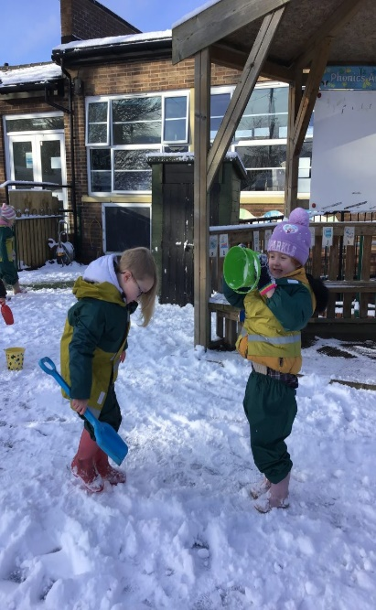

WILLOW FUN WITH YEAR 5
Last Thursday Year 5 worked with a visitor and by the end of the day they created this wonderful lion for school. They also have prepared and assembly to do with the school and a name had yet to be chosen. Please check out the school blog for more pictures of the day. An excellent job Year 5 it will be a fabulous addition to our artwork.

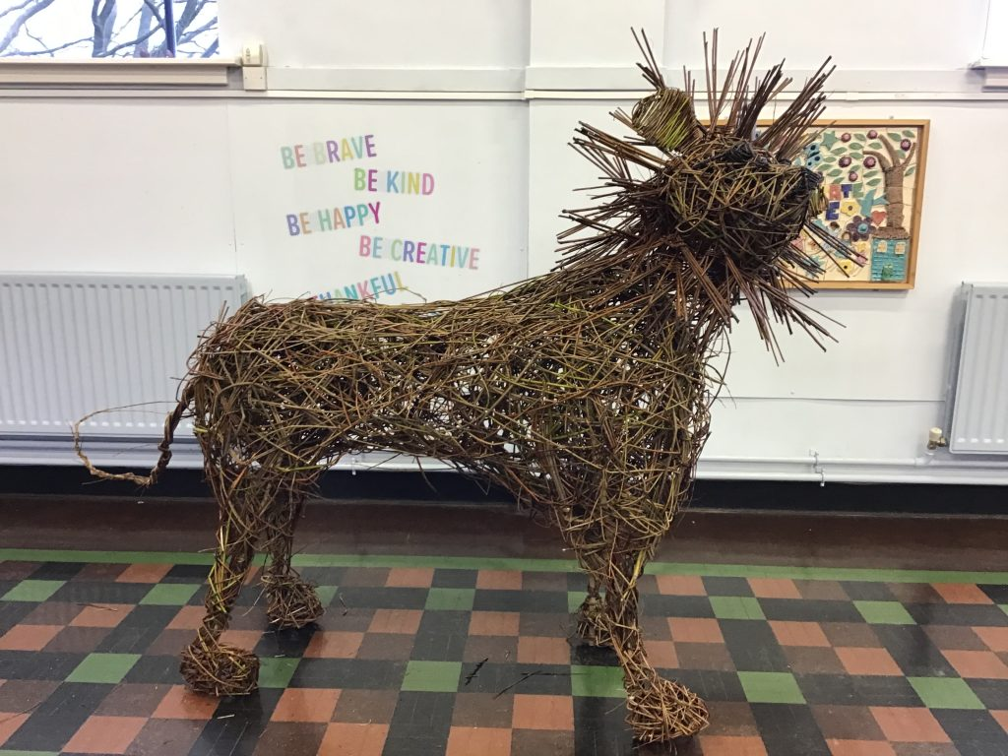

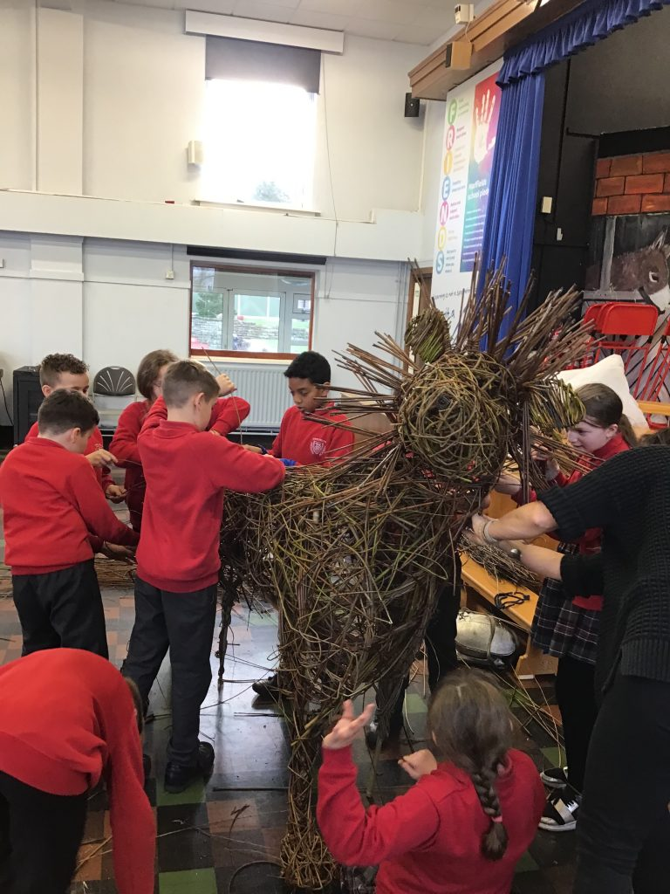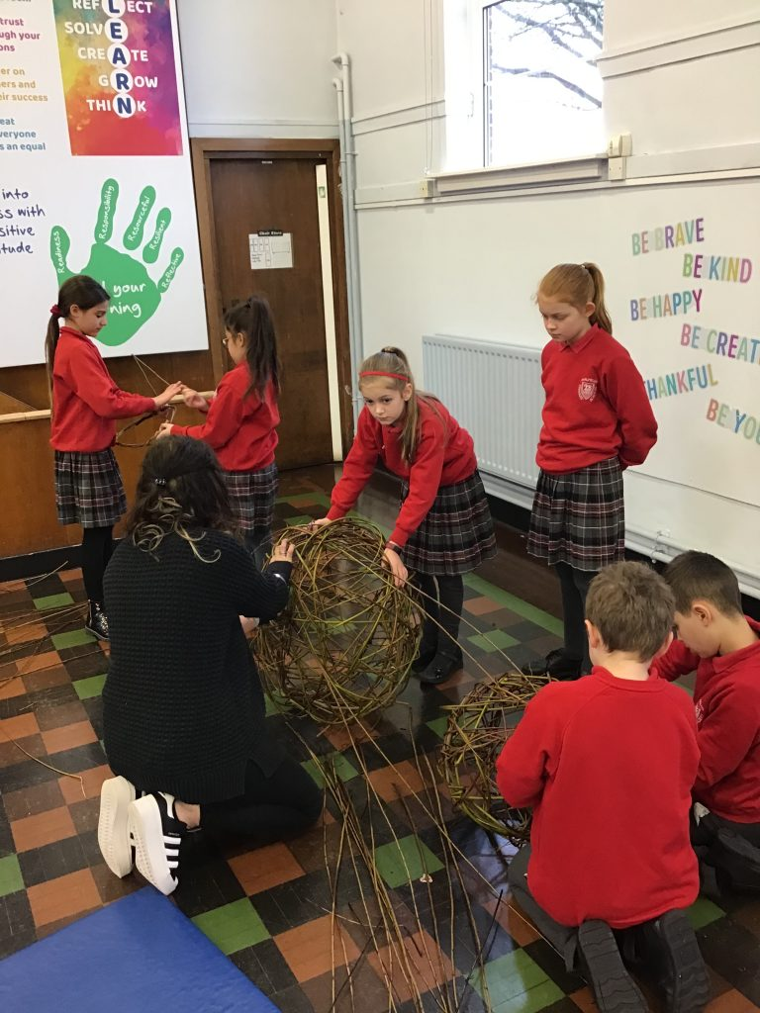
Academic Year 2022 – 2023
 | SCHOOL OPENS  FOR CHILDREN | SCHOOL CLOSES  FOR CHILDREN
Autumn 1 | 06.09.2022 | 21.10.2022
Half Term
Autumn 2 | 31.10.2022 | 16.12.2022
Christmas Holidays
Spring 1 2023 | 03.01.2023 | 16.02.2023
Half Term
Spring 2 | 27.02.2023 | *04.04.2023
Easter Holidays
Summer 1 | 17.04.2023 | 25.05.2023
Bank Holiday | Monday 01.05.2023
Half Term
Summer 2 | 06.06.2023 | 21.07.2023
INSET DAYS
05.09.2022,17.02.2023, *31.03.2023,
26.05.2023, 05.06.2023
Academic Year 2023 – 2024
 | SCHOOL OPENS  FOR CHILDREN | SCHOOL CLOSES  FOR CHILDREN
Autumn 1 | 05.09.2023 | 23.10.2023
Half Term
Autumn 2 | 01.11.2023 | 21.12.2023
Christmas Holidays
Spring 1 2024 | 08.01.2024 | 16.02.2024
Half Term
Spring 2 | 27.02.2024 | 28.03.2024
Easter Holidays
Summer 1 | 15.04.2024 | 24.05.2024
Bank Holiday | Monday 06.05.2024
Half Term
Summer 2 | 03.06.2024 | 23.07.2024
INSET DAYS
04.09.2023, 30.10.23, 22.12.23,
26.2.2024 & 03.06.24

HOLIDAY DATES 2022-23 & NEW INFORMATION FOR 2023/24

Please note our up-and-coming INSET day on the 17th February 2023.

