[**Marlfields Newsletter**](https://blog.marlfieldsprimary.co.uk/lots-of-lego-going-on/)

**9th February 2023**

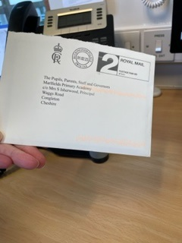**ROYAL SURPRISE IN THE POST**

We had a wonderful surprise in the post on Monday.

Can you imagine our astonishment when we saw an envelope, franked from Buckingham Palace, addressed to The Pupils, Parents, Staff and Governors?

We carefully opened the envelope and pulled out the contents.

It was a card from King Charles.

On the front cover was His Majesty’s Royal Crest, the inside showed him as a young boy alongside his late mother, Queen Elizabeth II alongside a note of thanks from him, which reads:

***“It was very kind of you to send me***

***such a wonderfully generous message following***

***the death of my beloved mother. Your most thoughtful words are enormously comforting, and***

***I cannot tell you how deeply they are appreciated at this time of immense sorrow.***

***Charles R”***

The card was sent in response to some letters and pictures that we sent to express our sorrow at the passing of Her Majesty.

The letters were written by our Head Girls and Boys along with, amongst others a picture of the Queen’s head which we made using copper and silver coins. All the monies raised was sent to charity in Her Late Majesty’s name.

**WORLD BOOK DAY**

This year, World Book Day takes place on **Thursday 2nd March**.

**](https://www.worldbookday.com/book/boot-it/)Children can come in to school dressed as their favourite book character in exchange for a £1 donation. Monies raised from the World Book Day Dress Up will be donated to the charity raising money for the current disaster in Turkey and Syria. Payments can be made on SCOPAY. Below is the selection of books that you can choose from using your World Book Day voucher.

](https://www.worldbookday.com/book/marvel-spider-man/)[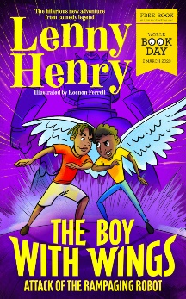](https://www.worldbookday.com/book/billys-bravery/)**

We will be arranging to take the children to W.H. Smith on the day so that they can choose their own book.

On World Book Day, Dolce, who provide our school lunches, are entering into the spirit of things by producing a special book themed lunch. Don’t forget to book one for your child. Please see the special menu below.

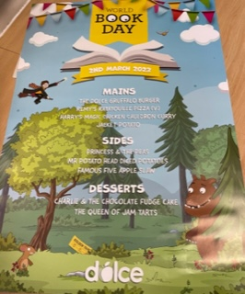

**MAINS**

**The Dolce Gruffalo Burger**

**Remy’s Ratatouille Pizza (V)**

**Harry’s Magic Chicken Curry Cauldron**

**Jacket Potato**

**SIDES**

**Princess & The Peas**

**Mr. Potato Head Diced Potatoes**

**Famous 5 Apple Slaw**

**DESSERTS**

**Charlie & The Chocolate Fudge Cake**

**The Queen of Jam Tarts**

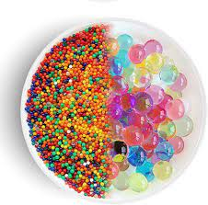**ORBEEZ – WARNING**

If you have bought any Orbeez or their equivalent for your child, we advise that you **exercise extreme caution** and **keep your eye on them**, so they **do not put any** of these sweet-like beads **in their mouth** whilst is playing with them.

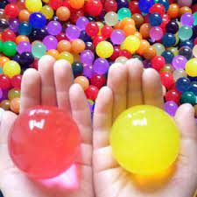Orbeez are very popular and can be found in almost every home now, but do we know what Orbeez are? They are small polymer pellets which by themselves are not dangerous, but put them into hot water or swallow them, they greatly expand in size. **Orbeez are dangerous if swallowed**. Orbeez do not break down when swallowed and are not absorbed by the body and could cause your child to become very unwell. It is vitally important to **seek medical help** if your child has, or you suspect they have swallowed Orbeez as they can cause a **bowel obstruction** which will require medical intervention as your child may become **extremely unwell**.

**Year 4’s exploration of the Shang Dynasty**Over the past few weeks the children have looked at the definition of the word ‘hierarchy’ and how the social order of civilisation started thousands of years ago.

The children have now begun to create a script based on different levels of the hierarchy:

Royal Family, Warriors, Priests and Nobles, Artisans, Merchants, Farmers, Slaves.

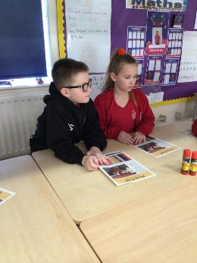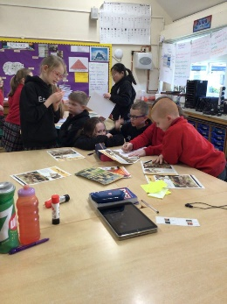Working in groups the children are now writing a play to re-enact to the class.

Can’t wait to see the finished thing!