**[Marlfields Newsletter](https://blog.marlfieldsprimary.co.uk/lots-of-lego-going-on/" \o "Permalink to Lots of Lego going on!)**

**3rd February 2023**

**LEGO WORKSHOP**

On Wednesday Marlfields Primary Academy had a visit from a Lego workshop. Year 2 ,supported by their year 6 friends, had a brilliant time making London landmarks with the Lego bricks. The models they made were fantastic. Have a look, can you recognise these famous landmarks?

Years 3,4,5,6 joined together for a workshop on making Lego models. Creative Builds Workshop came into school to help the children build a light up city using a large assortment of Lego bricks. They all really enjoyed themselves. Mrs Gartside, our Chair of Governors also came along to support the children. Thank you Mrs Gartside, we had a great time.

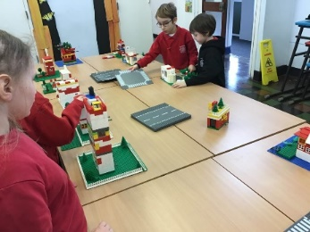**WATER SAFETY CODE**

On Wednesday the children had a lesson on water safety and what to do if they were near to water and an emergency arose, such as falling in themselves, or seeing someone else fall in.

They then all wrote down everything that they have learned as an aide memoire. Mr Isherwood went through all of the instructions and picked out 5 that were the best. Here are the winners. Perhaps you can take on board the advice if you are ever near water and an emergency happens.

To acknowledge what has been learned and the good that The RNLI do to help people in difficulties we are asking if the children could bring in a small donation that can be placed into the collection box that we have in school. All we are asking for is a 10p, 20p, 50p or £1that will go towards funding this marvellous service provided by the RNLI.

Thank you in anticipation.

**COATS**

Please remember to send you child in each day with a coat. It is still winter, and you would be surprised how many children come to school without a coat. Sure, they might not need them on if they come by car, but they certainly need one for break and lunch when they are outside.

|  |  |  |
| --- | --- | --- |
| **Academic Year 2022 – 2023** | | |
|  | **SCHOOL OPENS**  **FOR CHILDREN** | **SCHOOL CLOSES**  **FOR CHILDREN** |
| **Autumn 1** | **06.09.2022** | **21.10.2022** |
| **Half Term** | | |
| **Autumn 2** | **31.10.2022** | **16.12.2022** |
| **Christmas Holidays** | | |
| **Spring 1 2023** | **03.01.2023** | **16.02.2023** |
| **Half Term** | | |
| **Spring 2** | **27.02.2023** | **04.04.2023** |
| **Easter Holidays** | | |
| **Summer 1** | **17.04.2023** | **25.05.2023** |
| **Bank Holiday** | **Monday 01.05.2023** | |
| **Half Term** | | |
| **Summer 2** | **06.06.2023** | **21.07.2023** |
| **INSET DAYS**  **05.09.2022,17.02.2023, 31.03.2023,**  **26.05.2023, 05.06.2023** | | |

**HOLIDAYS**

Please see below the list of upcoming school term dates. **Please note that we have an INSET Day on Friday 17th February**, so the **last day in school for the children is Thursday 16th February**.