**Marlfields Newsletter**

**21st September 2022**

On Friday 16th September, the whole school paid tribute to Her Majesty the Queen.

We created a portrait of her as seen on coins of the realm, using coins of the realm. As you can see, it looks absolutely fantastic alongside a small bunch of her favourite flower, Lily of the Valley!

Congleton’s Town Mayor Mrs Gartside joined us, who is also our Chair of Governors for a brief assembly to honour our late Queen. All our families were presented with a book published to celebrate the recent Her Majesty The Queen’s Jubilee. We hope you all enjoy sharing this together as a family. As you can see our community rose to the challenge to bring in coins and while the money is still being counted it looks like we will be sending around £280 to the East Cheshire Hospice in memory of HRH Queen Elizabeth II.

**Head Boy / Head Girl 2022-23**

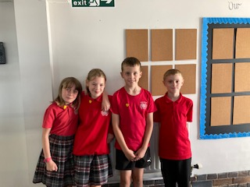 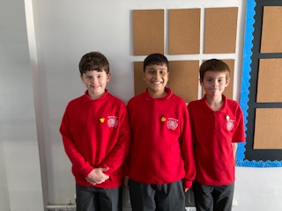

We are pleased to say that following a job description being sent out to Year 6 pupils asking them to

apply for the positions of Head Boy and Head Girl we have made the following appointments;

**Head Girls Daisy and Haylee**

**Head Boys Thomas and Dominic**

**Deputy Head Boys Jenson, Vayun and Elliott**

Congratulation to those appointed, we look forward to you all making a positive contribution to our

school community during this year.

**News from Year 4**

This half term we will be looking at the weather. Questions we are asking are; What is the weather? What it means to us? How can we monitor the weather? How can we record the weather.  
We discussed the three major elements we look at with the weather is: The temperature, the wind and amount of rain. We found that rain is measured in millimetres (mm), wind is measured in miles per hour (mph) and temperature is measured in degrees Celsius (°C). In groups we then made our own weather stations to record these three elements of weather. This started with some thinking time. What would we need? After collecting our equipment, it was time to start construction.

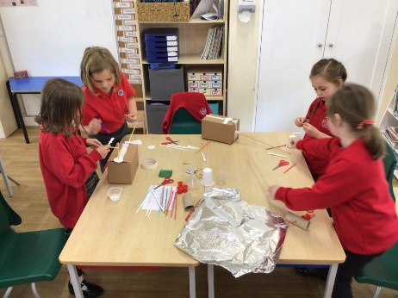

After a long afternoon of thinking and construction, more thinking and rebuilding it was time to reveal our finished projects and discuss if indeed they would work.

**Music -** This week, Year 4 had a special guest from Music Squad. Everyone was able to have a go at being part of the Year 4 Keyboard Crew. Everyone left having learnt something new. Piano lessons are available at a small cost for pupils who are interested, within the school day. Please contact the school office for further information.

**Science**

This week Year 4 have started our new topic all about habitats.  
 *What is a habitat? Why are they important? Where can they be found?*  
Once our scientific minds began to question, we turned our attention to our own school. What habitats can we find around school? So, we set our minds to finding different habitats around

the school and found that they are everywhere if you look carefully.

**PE Kits**

Although we have been back for two weeks we are still seeing children without PE kits in school each Monday. Please support your child to remember to bring them each week. Thank you

**Blue Peter Bages**

Congratulations Daisy for being awarded a Blue Peter Eco Badge. Check out the Blue Peter website and challenge yourself to gain one for yourself as there is a number of different ones you can gain. If you already have one, challenge yourself to get a different one this term.

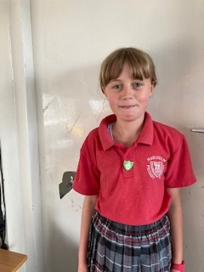

**McMillian Coffee Morning – Thursday 29th September 2022 9-10.30am**

Each year we support the annual McMillian Coffee Morning and have had to do so by sending out our ‘Afternoon Tea’ boxes. This year we can welcome you in for our traditional ‘on site’ coffee morning, which we are so looking forward to as we have missed having you with us.

Please join us between 9-10.30 for a coffee/tea and snack in our hall. We say snack as we are providing some special French breakfast treats, as well as our traditional cakes. We will also be offering tickets on sale for a raffle (£1 per ticket), and a ‘Lucky Dip’ (£1 a go), for children.

If you are able to support us by making some cakes please bring them into school by Wednesday for us.

Should you not be able to join us and want to support please send money in with your child who will be able to visit the event with their class. If as a parent you wish to visit with your child, please make your way to the classroom. Here they will be registered and you can then make your way to the hall to enjoy the event together.



**THURSDAY 29TH SEPTEMBER**

**9AM TILL 10.30AM**

**IN THE SCHOOL HALL**