**Marlfields Primary Academy**

**Newsletter**

**17th June 2022**



**READING CHALLENGE**

Congleton Library staff are busily preparing for this year’s exciting **Summer Reading Challenge** ***‘Gadgeteers’*** which begins on **Saturday 9th July**.

The Summer Reading Challenge is a really fun and free way to keep children reading over their long summer holidays to help avoid that dip in literacy skills when they return to school in September. Each child will receive free incentives such as stickers and activity sheets and if they **complete the challenge**, a medal and certificate are presented to children at a special award ceremony. Mrs Gartside, our Chair of Governors will also the children who complete the challenge in the Autumn Term on showing us their certificate and medal.

Staff from the Library will be coming in to school to hold an assembly to explain it to the children.

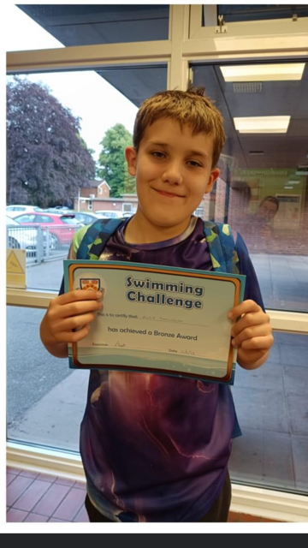

**CONGRATULATIONS**

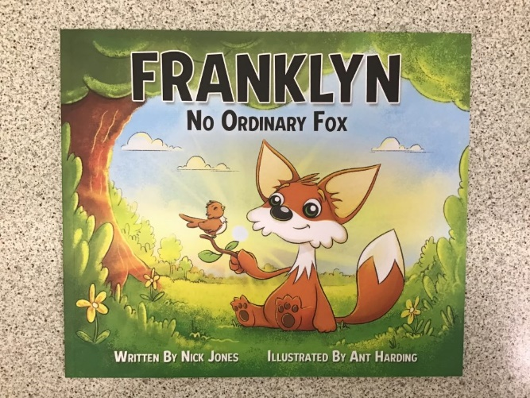This week, our “CONGRATULATIONS” go to Alfie Tomlinson from Year 6. Alfie swims for Congleton Amateur Swimming Club and achieved his Bronze Award on Monday. Alfie worked hard towards achieving Bronze Award status, and is obviously very proud to have reached this goal.

Well done Alfie!

**YEAR 3 VISITORS**

On Wednesday, Year 3 had a visitor from a very unusual individual!

It all started out when a lady called Chloe read us a story called ‘Franklyn – No Ordinary Fox’. The children did some fantastic listening and asked amazing questions. However, Chloe was not alone. Listening carefully to the story and to the children, Franklyn Fox himself was hiding around the corner to surprise the children. The children were all so excited to see Franklyn the Fox, and they all gave him a high five and a huge cheer.  
What a fantastic surprise and Year 3 wish to say a big thank you.

It is a book explaining how to be a great money manager, learning how to handle your finances in the future.

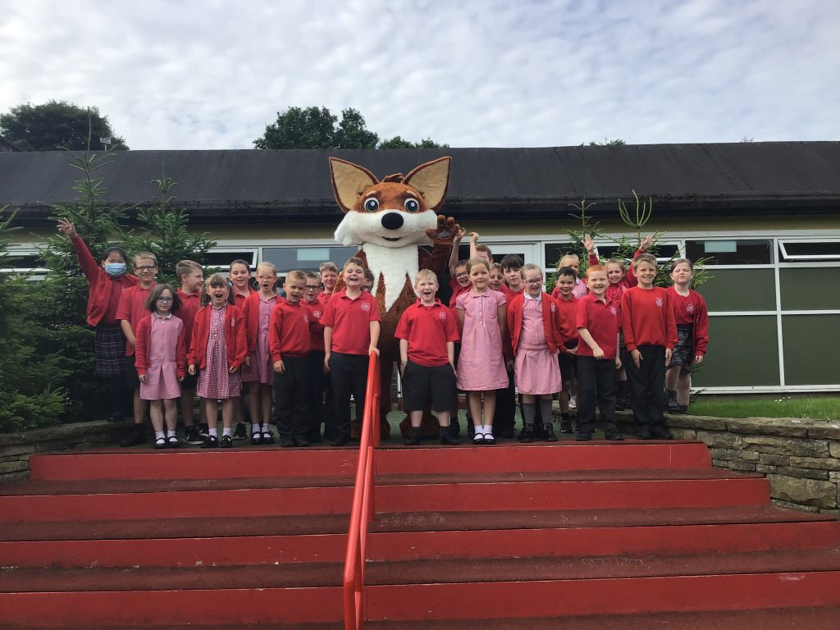

An excited Year 3 with Franklyn.

# http://blog.marlfieldsprimary.co.uk/wp-content/uploads/2022/06/IMG_1589-768x1024.jpghttp://blog.marlfieldsprimary.co.uk/wp-content/uploads/2022/06/IMG_1591-768x1024.jpghttp://blog.marlfieldsprimary.co.uk/wp-content/uploads/2022/06/IMG_1569-768x1024.jpg**MINI EXPLORERS**

# Foundation Stage went to the Woods on

# Wednesday for their ‘Wood Wednesday

# Session’. The children explored the woodland

# environment by having a treasure hunt looking

# for different objects we find in the woods. The

# children had to find 1 green leaf, 2 brown

# leaves, a pine cone and a small stick.

To finish the session, the children enjoyed the story of “The Very Hungry Caterpillar”. After the story, they thought about what they had learnt about the title character of The Very Hungry Caterpillar.

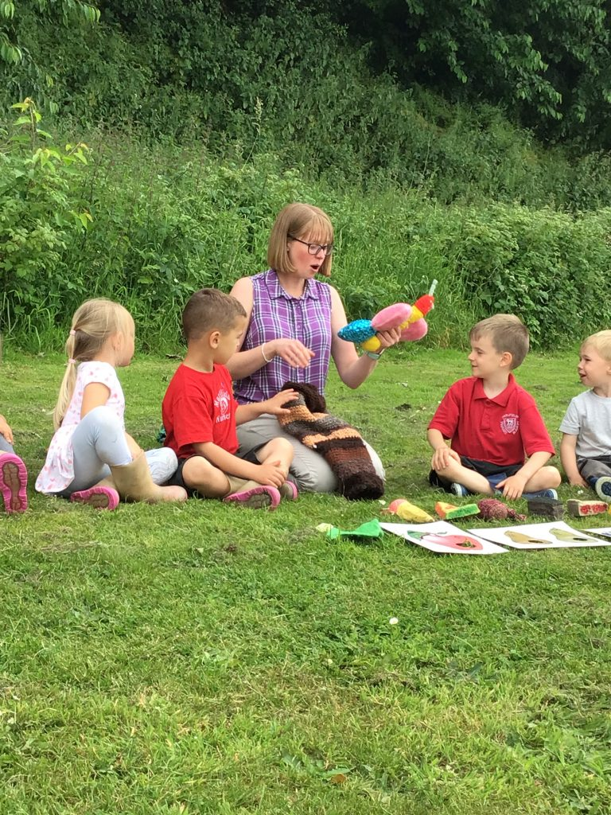

**COMMUNICATION WITH PARENTS**

School makes every endeavour to communicate activities etc with you via -

1. Weekly Newsletter
2. Regular e-mails
3. Regular text messages
4. Class Dojo

Please note; that if you do not receive regular communications through these media, it may be that we have incorrect details. Please let the Office (01260 633120) know if you are not receiving at least one a week from one of these sources.

Please also note, that staff are not allowed to have their mobile phones on during the day and therefore cannot collect Dojo messages until the end of the day. Instead, please send any messages to them via the Office.



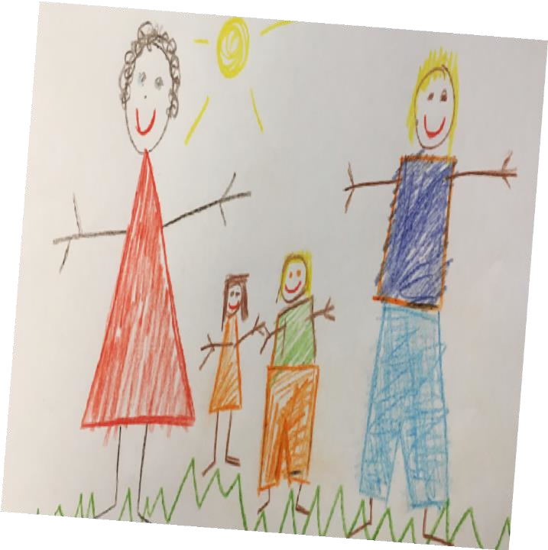

**Childhood Development**

FAMILIES AND COMMUNITY TEAM

**PARENT WORKSHOPS**

Visyon’s Family and Community Wellbeing Team are pleased to offer a **90-minute Parent Workshop,** which will explore a child’s development journey during the school years to build on current knowledge and it will provide strategies to support children during this period of considerable change.

This workshop will look at the inevitable changes in childhood, brain development, attachment, childhood experiences and resilience.

This workshop **is suitable for families with children aged 8+** and is available to families in **Cheshire East.** It will be held at **Sandbach Children’s Centre** for **face-to-face** delivery.

If you would like to book a place on the Workshop, please contact [lynne.fitton@visyon.org.uk](mailto:lynne.fitton@visyon.org.uk) who will contact you with further details.

Places are limited and will be allocated on a first come basis.

**There are other Workshops available which may be of interest to you** e.g. separationof parents, amongst others. Please contact[lynne.fitton@visyon.org.uk](mailto:lynne.fitton@visyon.org.uk) for further information.