Marlfields Newsletter
27th January 2022

WEATHER
As the weather is currently very cold, frosty and slippery, may we please remind you that the children need good warm outwear and sensible shoes.

REMINDER:
On each of the external gates and doors is a copy of our ‘Gritting Plan’; when entering the school grounds please take care on the paths and only walk where the grit has been scattered as shown on the plan.

Should the worst happen over the next few weeks, and we have a heavy snowfall that may mean that staff cannot get into school for us to run efficiently. We may have to close school for the day. If this were to happen, we will text parents in the first instance to let you know; and also advertise it on local radio stations: SIGNAL RADIO 96.4 FM / SILK RADIO 106.9FM / RADIO STOKE 94.6FM.
If we have a heavy snowfall during the day, and we have to take the decision to close school early, we will again text and/or email you to collect your child early.
Fingers crossed we don’t have to take any of these actions.

GUITAR ASSEMBLY

Earlier in the week the children from Year 2 – Year 6 were invited to a guitar assembly and demonstration. The guitar teacher who led the assembly then gave out flyers offering a free taster session to learn the guitar. We have had lots of reply slips returned already, however, if you wish your child to take advantage of this offer, please return the slip to school as soon as possible.

HEADTEACHER AWARD
One afternoon this week, Mrs Isherwood was lucky enough to be able to return to class teaching, by working with children in class 3. The children ran out of time, but one budding writer took her poem home and finished it there.
Here is Callie’s poem:

A SUPERMARKET VISIT
In my trolley, I will have …………
A white loaf of bread,
A jar of nuts, a box of brown cereal.
Push that trolley, push that trolley.
Put that back, we don’t need that.
In my trolley, I will have …………
A tub of vanilla ice cream,
A bottle of strawberry milk,
A robot controller and a robot toy.
Push that trolley, push that trolley.
Put that back, we don’t need that.
In my trolley, I will have …………
A box of six Cream Eggs,
A box of birthday cards,
A tub of cold butter.
Push that trolley, push that trolley.
Put that back, we don’t need that.

Well done Callie for using your initiative to finish this at home. You are now one of Mrs Isherwood’s Headteacher Award winners!

SPORTS REPORTS
On Wednesday this week, children from Year 3 and Year 4 took part in an athletics competition at Eaton Bank High school. The Year 3 and 4 children were an absolute credit to Marlfields School. The children took part in a variety of events including: 1 x 1 relay, 2 x 2 relay, over and under obstacle, hurdles, javelin, shot putt, vertical jump, long jump, speed bounce etc. They are worked hard as a team. It was very competitive and tense at times in the races but all the children fully embraced the opportunity to compete and excelled.

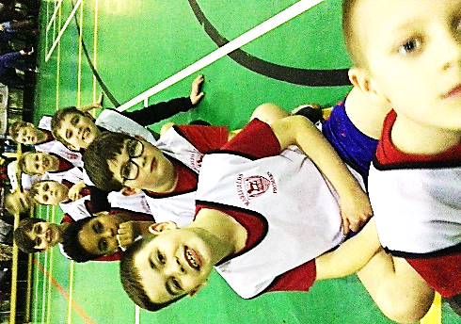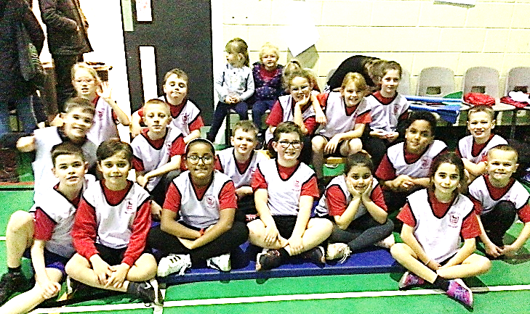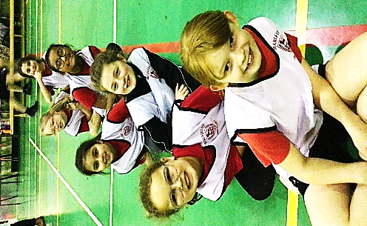

On Thursday evening the Years 5 and 6 Football Team competed in the next round of football matches. The first match was against Saint Mary's which was a tough start but we kept the score to a 0-0 draw. Unfortunately, Smallwood did not turn up for our next match so we then played against Daven. We scored first after a few attempts at goal and then Daven equalised, leaving the final score at 1-1.
Player of the Matches as voted by the team went to Thomas D.
Well done everyone for your sporting successes this week. We are really proud of you all.
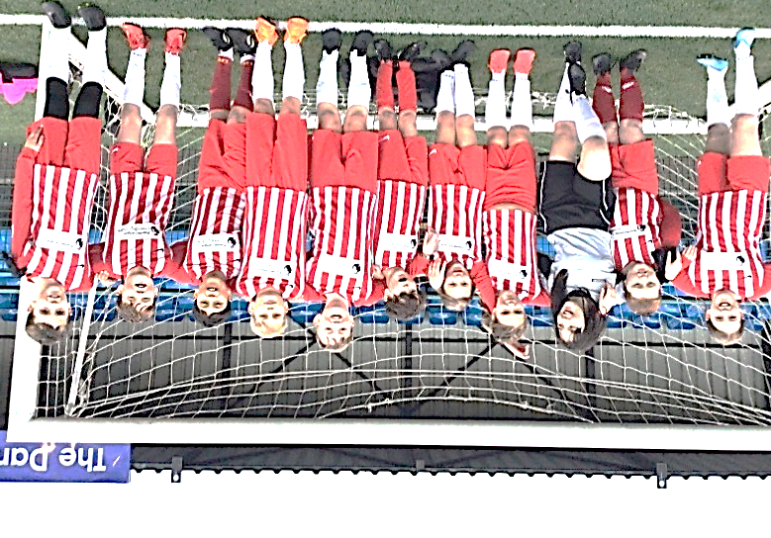

MESSAGE FROM DIRECTOR OF PUBLIC HEALTH
And the DIRECTOR of EDUCATION
We are delighted to see that our children and young people have settled back into their education at the start of this new year, and we trust that they are enjoying the new opportunities for learning and personal development.
We want to thank everyone for their commitment and continuing support to assist all educational settings to remain open. Last term was the most challenging across Cheshire East in terms of positive cases and outbreaks of COVID-19 but your support, coupled with the management of COVID-19 across the local authority area, has been an excellent example of effective coordination and consistent use of available resources.
The COVID-19 virus is still with us, and so we wanted to explain the current position in Cheshire East, and outline how we are working with schools to manage this while making every effort to keep as many children and young people as possible in school.

As you may be aware, mandatory face coverings for secondary pupils in classrooms ended from 20 January and their use in communal areas is due to end from this Thursday (27 January). Whilst we are supportive of this approach, Cheshire East has advised schools to take a ‘planned and paced approach’ to the removal of face coverings in classrooms. In particular, we have recommended that those schools who currently have an outbreak of COVID-19 may want to review their outbreak management plan before withdrawing this measure. It is important to remember that most children and young people are not severely ill if they contract COVID-19, indeed many have no symptoms at all. However, it remains crucial for schools to have in place measures which will help limit transmission so that the number of children and staff who are infected and therefore absent from school is kept as low as possible. Schools and settings are adhering to the latest national guidance on testing, self-isolation, ventilation, and hygiene.

We previously issued enhanced advice to reduce the transmission by household contacts of a positive case. This has now been amended as outlined below:
Children and young people age 5 years and above who are household contacts of a positive case are no longer asked to stay away from school but should take a lateral flow test (LFT) each morning for 7 days. Children and young people who share a classroom with a positive case will not have to isolate or carry out additional testing unless they are identified as having had particularly close contact. This is likely to be linked to events outside the classroom such as sleepovers, social events or travelling together in shared cars.

Schools and settings will not trace contacts unless this is part of the advice given by Public Health to manage an outbreak. We know that the current high levels of COVID-19 in the community are having an impact on absence from work and this applies to staff working in schools and settings. Plans have been developed to help manage staff absence, but if it becomes impossible for a school or setting to provide safe face to face teaching for all its pupils, then a period of remote learning may be necessary. This will be a short period and for the smallest number of pupils as possible. We will continue to monitor positive cases and review the need for any additional measures, ensuring that these are only in place if absolutely necessary. Your co-operation in this is vital and we cannot stress enough the importance of schools being informed should your child test positive for COVID-19 and so ask that your report all cases as quickly as possible.

The vaccine roll-out is continuing and all young people age 12 years and above (and some age 5 years and above) will soon be able to access the vaccination. We encourage everyone who is eligible to take up this offer. Further information can be found at NHS coronavirus vaccines. We hope that this information is useful and helps to reassure you that we are working closely with schools and settings to try and ensure that COVID-19 has the least impact possible on your child’s opportunities and learning experiences. As we go forward, our number one aim is to provide face to face learning for all Cheshire East children and we will support schools to put in measures which will support this. We thank you again for your continuing support and co-operation and we wish you and your children the very best for the forthcoming year.

TERM DATES
Academic Year 2021 – 2022

School Opens School Closes
Autumn 1 | 01.09.2021 |  | 22.10.2021
Half Term
Autumn 2 | 02.11.2021 |  | 17.12.2021
Christmas Holidays
Spring 1 | 04.01.2022 |  | 17.02.2022
Half Term
Spring 2 | 28.02.2022 |  | 31.03.2022
Easter Holidays
Summer 1 | 19.04.2022 |  | 26.05.2022
Bank Holiday | Monday 2nd May 2022
Half Term

Summer 2 | 07.06.2022 | 21.07.2022*
INSET Days
01.11.21, 18.02.22, 01.04.22, 27.05.22 & 06.06.22
* Additional Bank Holiday (Queen’s Jubilee)

