**Marlfields Newsletter**

**17th December 2021**

**CHRISTMAS BAGS**

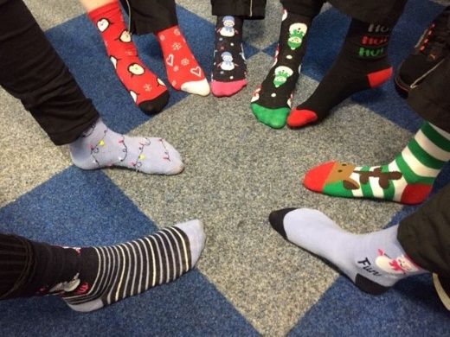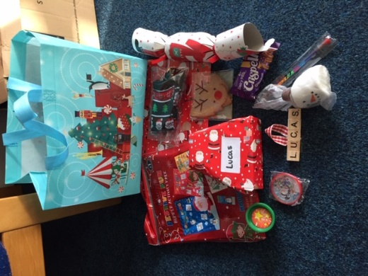We hope that the children were happy with their Christmas Bags that we gave out yesterday which were full of various items for them to enjoy over the Christmas period. The Christmas Elves who made up the bags were full of joy as they were busily filling the bags with goodies.

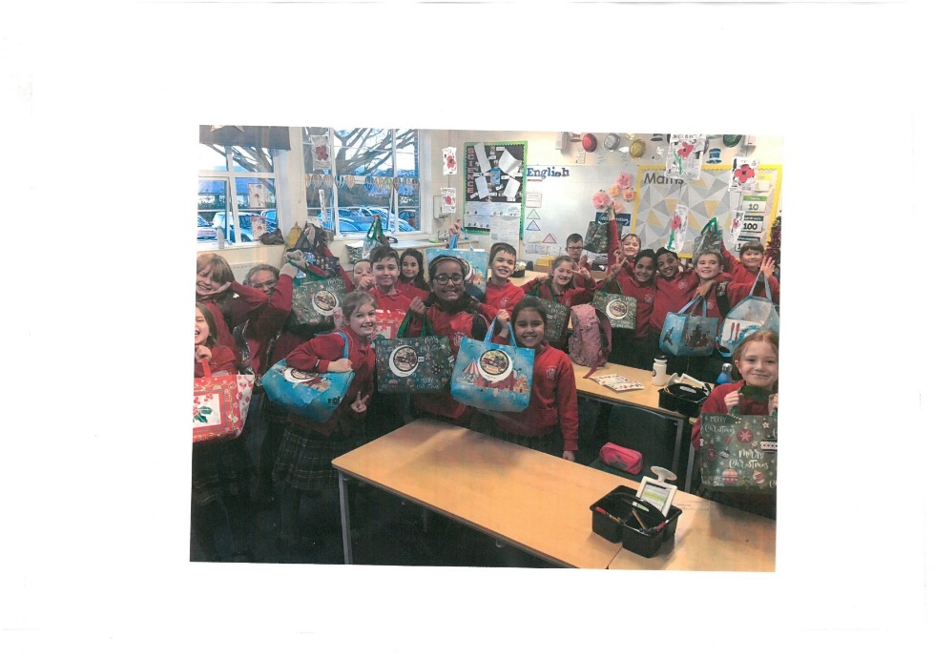Year 6 seemed to enjoy the contents of the bags; so much so that most of the class came into school today wearing their Christmas socks!

Each child, from EYFS1 to Year 6 received an age appropriate gift bag.

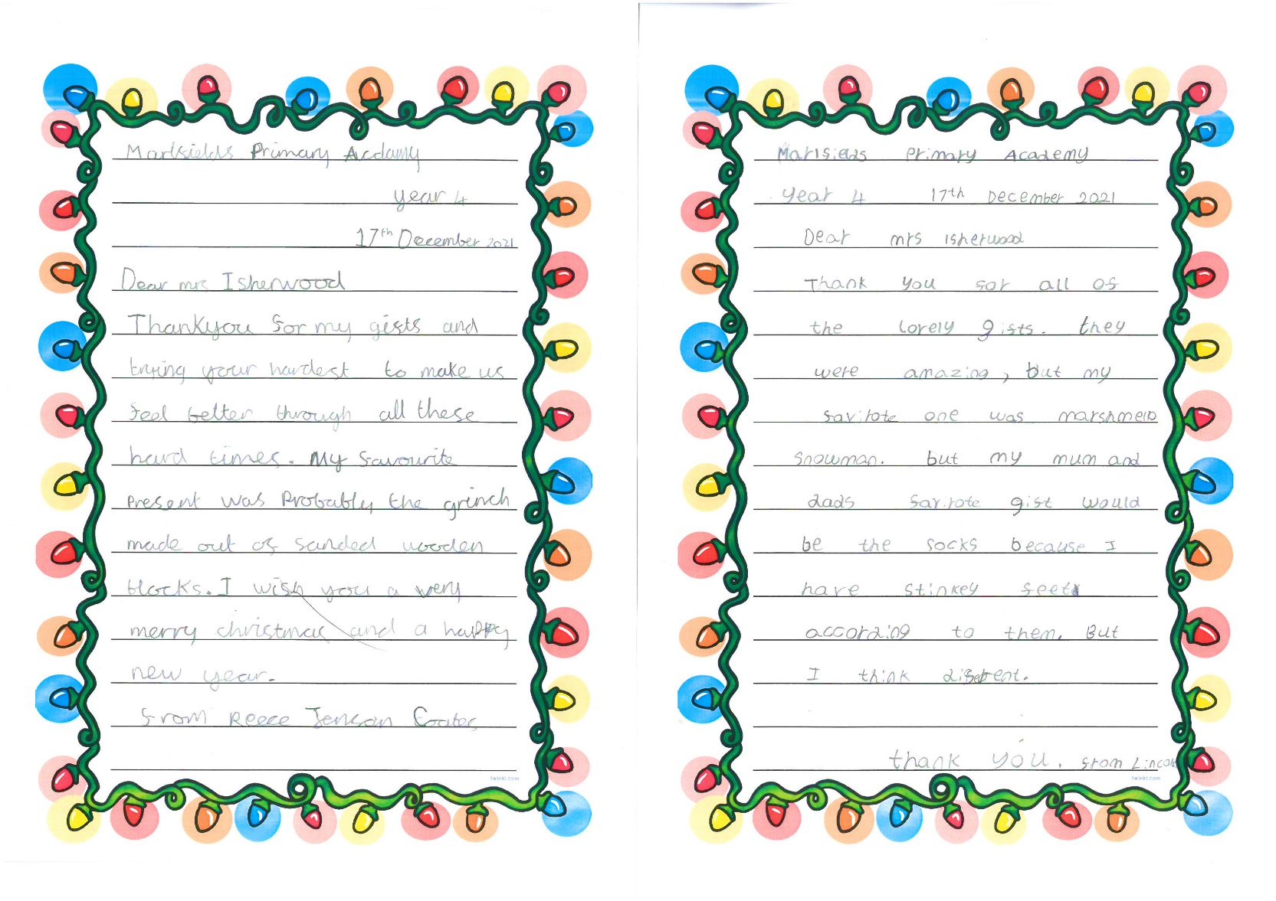

A couple of thank you letters received from the children.

The bags were made possible by a special donation from one of our parents.

We must send our thanks to them for making this possible. You know who you are –

**THANK YOU SO MUCH for your kindness, on behalf of all the children at Marlfields.**

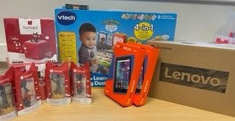Our most generous benefactor has also purchased these amazing prizes, one for each year group. Would you like to win one of these amazing prizes?

We will be holding a Christmas Family Challenge during the holiday.  Join in with the challenge and your child's name will be entered into the bag to be the one that may be pulled out in January when we return to school.

**CHRISTMAS HOLIDAY CHALLENGE**   - You need to be in it to win it!

You will need to achieve **all** these **10 challenges** during the holidays, **keep a record of them to bring into school when we return on 4th January.**

1. Get out and about! Take a tour of your local area taking 2 photos.  Write 2 sentences to say where you are and what you are sharing with us.
2. Organise a treat for your adults – take a photo.  Examples may be to get them to sit down and take a break in this busy time or maybe read them a story.  You could read your book to them without being asked!
3. Take a photo of your family Christmas Day to share with us.
4. Build a den inside or out and take a photo for us.
5. Collect 5 different leaves and draw around them and find out which tree they are from.
6. Do you have a collection of something at home – take of photo it and tell us what and why you have it.
7. Learn a new game – tell us what it is and how to play it.
8. Mrs Yoxall has sent a book list to home via email.  Show us which book you have shared with your parents.  Remember you can search on line for them or go to the library.
9. Walk through a forest and take a photo.
10. Take a photo of one present that someone in your family got.

**ROTARY CLUB COMPETITION**

Rotary-Congleton recently held a **Young Photographer Competition** which produced almost 90 entries. We are extremely happy to let you know that one of our **Year 6 children, John Thorley, is a prize winner** with his photograph of a robin. Congratulations John, well done!

The competition theme was ***“The Colours of Nature”*** and the competition was to encourage the children to experiment and to express ideas through the medium of photography.

The photographs will be exhibited at Congleton Library. Most of the entries will be on display over the Christmas holiday. The exhibition will be set up on **Friday, 17th December** and will run **until January 7th.**  The winners in each of the three age groups have been contacted and will be announced at the exhibition.

**LOCAL PAPER**

Have you had a Congleton Chronicle this week? They have done a feature on when we took some children to Bear Grills for a book launch. Here is the article in case you haven’t seen it.

|  |  |  |
| --- | --- | --- |
| **‘Wonderful’ audience heard latest Bear tale**  **cid:fa6701b5-a154-406a-849e-c7726fa57062@GBRP265.PROD.OUTLOOK.COM**  **One afternoon in Beartown: authors and audience** | | |
| The children from Marlfields After-School Club walked with head Sandie Isherwood and staff down to Bear Grills Café on the Fairground in Congleton last Wednesday, for the book launch of a book written by local author Nick Jones, illustrated by Si Clark.  The book, One Christmas in Beartown, is a sequel to his earlier book One night in Beartown and his award winning Sarah’s Shadow.  The children sat ‘beautifully’ to listen to the author reading his magical story.  An extract reads: “Before they break up for Christmas, Sandy Lane and Tommy Pickles, must team up on a school project. Tommy hasn’t slept properly since the night the bear statues came to life, and Sandy needs to find a way to help him.  “In an act of kindness, she lends Tommy her beloved teddy bear, Berisford. She hopes this will help him overcome his fear of bears, but nothing could prepare the two children for what happens on Christmas Eve …”  The children later received an email from the event organisers, thanking them for going along to support the book launch and to congratulate Mrs Isherwood on having such “wonderful, polite and well behaved children”.  Mrs Isherwood said: “This |  | One Christmas in Beartown book coveris no surprise to us, as they are all amazing ambassadors for the school and a credit to their parents.”  The school also received calls from parents thanking school for taking their children and saying how much the children enjoyed themselves.  Each child was presented with a signed copy of the book.  Mrs Isherwood added:  “Nick came to school to invite us last Friday and we took the opportunity to go down. It was fantastic and while the children have been given a book, the school will be making a donation to the Visyon charity in town as a thank you from us.”  (Photo: Marlfields). |
|  |  |  |



**Merry Christmas and a Happy,**

**Healthy New Year to you all**

**Stay Safe.**

**See you all back at school on**

**Tuesday 4th January.**