Just **one more week to go** before we break up for the Christmas holidays. The **last day in school** is **Friday 17th December**, the children will finish at the usual time.

Also happening next week within school is a **Christingle Service** for the children and **Christmas Dinner** on **Wednesday**.

On **Thursday**, the children are going to be entertained by a **Panto.** As we are currently unable go out the panto, we felt that we didn’t want the children to miss out, so we have arranged for them to see it via **Zoom**, in their classes. Not quite the same, we know, but we are sure it will get them into the Christmas spirit.

**Christmas Productions** for all the pods have now been completed, they just need a bit of editing and then you will be given a link in order for you to see them. Please also check out the **Marlfields Blog** where you will find lots of news items from each class.

**CHRISTMAS DINNER**

Don’t forget to order your child’s Christmas Dinner on Dolce’s School Grid App. If you are unsure how to do this, please ring the office (**01260 633120**) and they will order for you.

The Christmas Dinner Menu is:



|  |  |
| --- | --- |
| **Traditional**  Roast Turkey, Chipolata,  Roast Potatoes, Stuffing, Carrots, Peas,  Brussels Sprouts and Gravy  Gingerbread Christmas Tree or  Chocolate Orange Pudding or  Fresh Fruit or Yoghurt | **Vegan**  Roasted Vegetable and Stuffing Tart,  Roast Potatoes, Carrots, Peas,  Brussels Sprouts and Gravy  Gingerbread Christmas Tree or  Chocolate Orange Pudding or  Fresh Fruit or Yoghurt |
| **SANDWICH**  Hot Turkey Bap,  Gingerbread Christmas Tree or Chocolate Orange Pudding or Fresh Fruit or Yoghurt | |

**SCHOOL SNACK**

It is with sadness that we have to inform you that from 4th January 2021 school will no longer be able to provide school snacks for your child’s mid-morning break. This id due to lack of customers; we only have 9 children on our books which unfortunately makes it unviable for us to continue to off this service.

If you wish your child to have snack you will have to provide it for them on a daily basis. If you do send snack in from home, please, in line with school policy, only send in healthy snacks e.g. fruit, veg, cheese etc and certainly, **nothing containing** **NUTS**, no chocolate, crisps etc.

**NEIGHBOURS**

Please, please, please be considerate of the neighbouring properties to school on Waggs Road in particular, but also The Westlands and The Crescent/Crescent Road.

We have had a number of complaints about inconsiderate parking, foul language and people dropping litter in gardens and on driveways. We value our relationships with our neighbours, and we ask that you respect them and their property. Please note that when they have complained to us they are also contacting the police and giving them car registrations as it is becoming a Highways issue, which could result in you getting a ‘visit’ from the constabulary.

Thank you in anticipation of your co-operation.

**BOOKINGS**

Please ensure that if your child is in our Nursery or attends our Breakfast & After School Club that you have completed and returned your Booking Forms for Spring 2022. If we do not receive the forms by Monday of next week, we cannot guarantee a place for your child in the new year. If you need another copy of the form, please ask the office.

**GINGERBREAD VILLAGES**

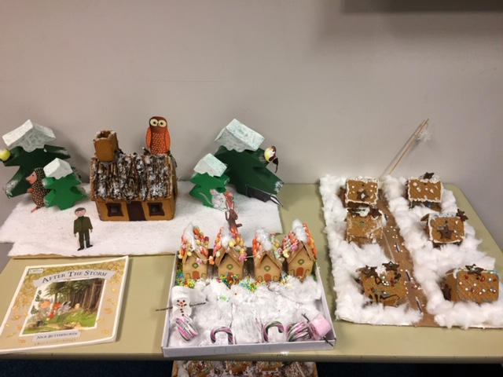 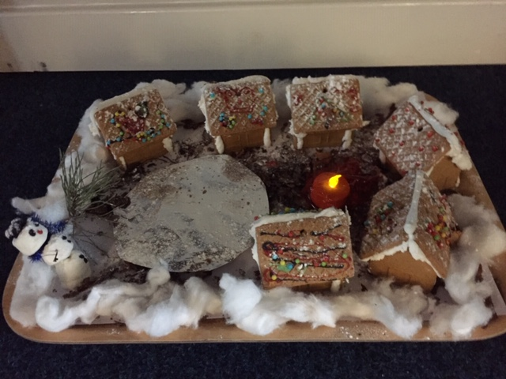 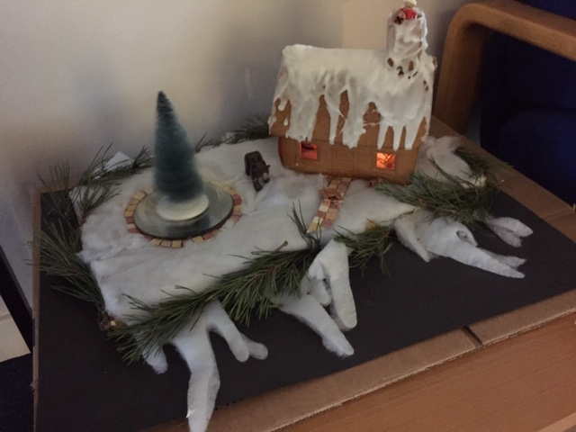 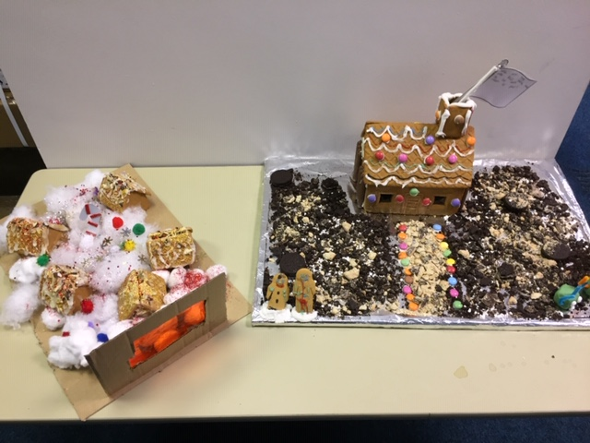

Over the past week each class, from EYFS to Year 6 has been making their own Gingerbread Village. Each one was different, there was even one with a rotating Christmas tree, one with skaters on a pond, some which lit up and a Percy the Park Keeper’s Shed. Well done everyone, you have all made a good job of your designs. Hope you like them. Which one would you pick as the winner?

**CELEBRATION TIME**



A huge **CONGRATULATIONS** to Evie-Jean for obtaining her Blue and White Belt recently at her martial arts centre.

*Does your child have any achievements like this that they would like to share with the rest of the school family? If so, please let us know by e-mailing a photo and a description of what has been achieved, and we will put it on to the Newsletter and celebrate with you.*

**SUPPORT**

Don’t forget, if you are struggling, please give us a call. We may be able to offer you some assistance. Please don’t be embarrassed to ask; any requests for help will be totally confidential and we will support you where we can.

**UNIFORM**

Don’t forget, uniform is available to buy from DP Sportswear on Bromley Road, again, if you need assistance to buy, please ask us as we may again be able to help.

**REVISED HOLIDAY LIST**

With permission from our Governor’s we have revised our Holiday List. Next year will be Queen Elizabeth II’s Platinum Jubilee, and everyone has been given an extra Bank Holiday on Friday 3rd June; however, when this takes place school is already on holiday. The Governors have therefore decided that we will take this additional Bank Holiday at the end of the school year so you can start your summer holidays a day earlier.

School will now close for the summer holidays on **THURSDAY 21st JULY\*** rather than Friday 22nd.

|  |  |  |
| --- | --- | --- |
| **NEXT Academic Year 2021 – 2022** | | |
| **School Opens School Closes** | | |
| **Autumn 1** | **01.09.2021** | **22.10.2021** |
| **Half Term** | | |
| **Autumn 2** | **02.11.2021** | **17.12.2021** |
| **Christmas Holidays** | | |
| **Spring 1** | **04.01.2022** | **17.02.2022** |
| **Half Term** | | |
| **Spring 2** | **28.02.2022** | **31.03.2022** |
| **Easter Holidays** | | |
| **Summer 1** | **19.04.2022** | **26.05.2022** |
| **Bank Holiday** | **Monday 2nd May 2022** | |
| **Half Term** | | |
| **Summer 2** | **07.06.2022** | **21.07.2022\*** |
| **INSET Days**  **01.11.21, 18.02.22, 01.04.22, 27.05.22 & 06.06.22** | | |