MARLFIELDS NEWSLETTER
19th November 2021
COVID-19
By now you must all know the precautions to take with regard to Covid-19; however, with cases still rising in Cheshire East we need to remind you of certain things.

Avoid crowds, if that isn’t possible, wear a mask. Keep all rooms that you are using well ventilated. Maintain social distancing. Regular hand washing with hot soapy water and/or use sanitiser. The latest advice from Cheshire East is, if anyone in your family has tested positive for Covid-19 all members of the family should isolate together for 5 days from the date of the positive result to ensure the rest of the family have no symptoms and to help break the transmission rates.

If, after all these precautions, someone in your family does catch Covid please see the poster below for advice. As the poster says –
“Life has to continue even where Covid-19 is spreading”. Very true words indeed.

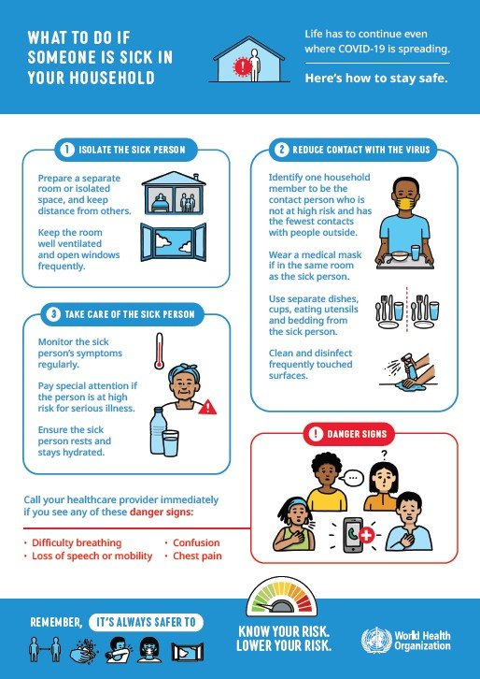

CLONTER OPERA WORKSHOP
Earlier in the week, Year 3 were lucky enough to take part in a fantastic workshop run by Clonter Opera.
During the morning, the children worked with Jess, a professional Costume Designer. The children were tasked with designing a costume for some well-known Opera and Musical Theatre characters. We all had a great time and created some wonderful costumes.

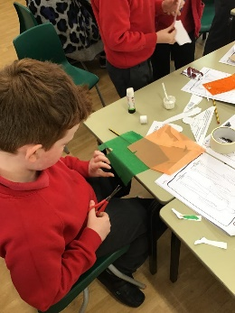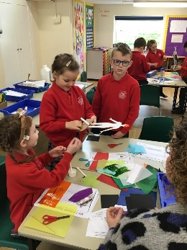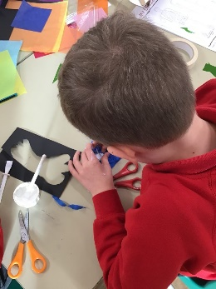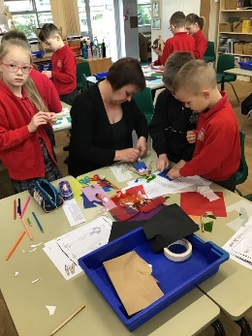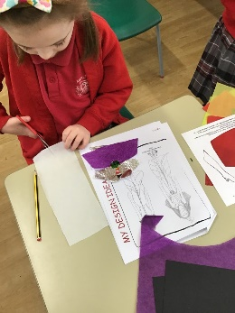
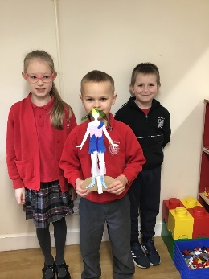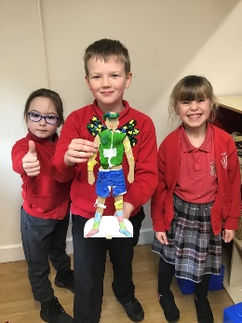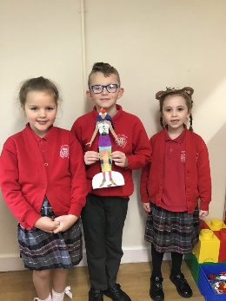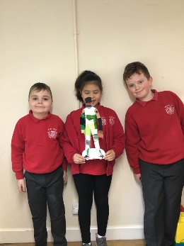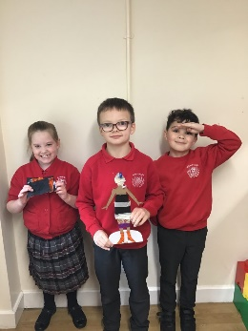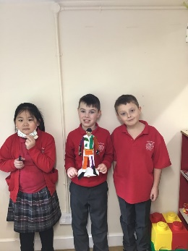
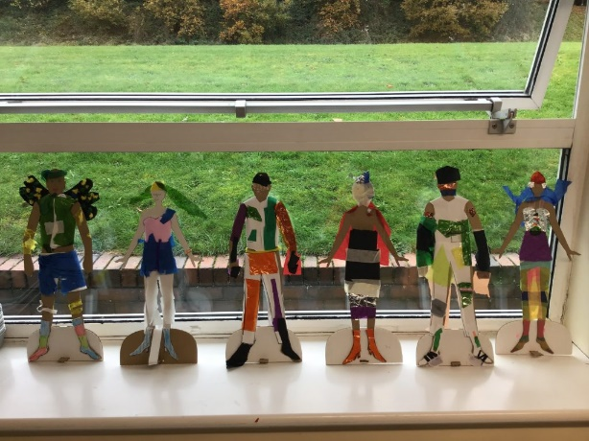
In the afternoon, Naomi joined us on-line to talk us through a Musical Workshop. Naomi is a professional singer, and we were able to ask her questions about her job and about the performance that we watched. We listened to the performers sing in other languages, such as German and Italian. We even got to join in too!
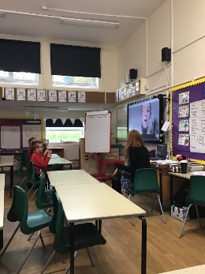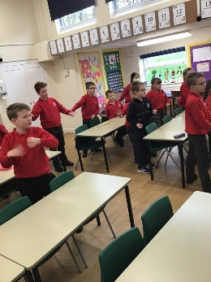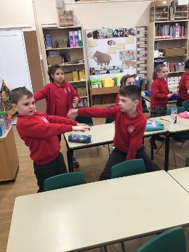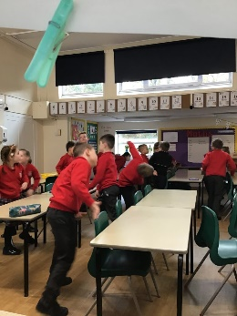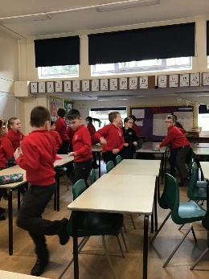
Now we have a project to complete, and then we will all achieve the Arts Award for ourselves. Thank you Clonter Opera for a wonderful experience; one that we will not forget for a long time.

SCHOOL PHOTOGRAPHS
The photographers will be in school on Tuesday 23rd November from 8:15am, photographing families (babies and siblings), school will then organise the photographing of in-school siblings, and of individual pupils.

The photographer will set up in the Studio to facilitate social distancing. If you are bringing younger children to have the ‘family photo’ please wait on the playground and you will be called in by family. Please call school on 01260 633120 if you want to book a family early morning slot.
Please remember the ‘family photo’ session is for families with children who are not in school nor at our Nursery; the photographers will be ready to take photographs for this category from 8:15am.
As stated above we will organise the photos for siblings in school and for each individual to be photographed.

FLUENZ SPRAY
School Nurses will be in school on Wednesday 24th November to administer the flu vaccine spray to the children. This can only be done if you have signed up on the new e-consent which was sent out at the end of September and again yesterday for those who may have missed the original. The site may have now closed, however, give it a try, or failing that there is a number below where the team can be contacted.
Please complete the e-consent form for your child’s flu vaccination at wchc.nhs.uk/econsent/.
Our school’s unique code number is WC140895 which you will need to complete the flu consent form.
Parents who have not submitted their e-consent form by the deadline and wish their child to be immunised will also need to contact our Immunisation Admin Team.

If you have any concerns, cannot access the link or would like to discuss immunisation further, please do not hesitate to contact a member of our immunisation team on 0300 123 4607.

We urge as many of you as possible to get your children protected from flu, especially during these still uncertain times.

CHILDREN IN NEED

Many thanks to everyone who contributed to our Children in Need collection and to the children who came into school in their chosen outfits. Some of them certainly made us smile.
This event followed on from the rest of the week, we had Odd Socks Day on Monday to kick start Anti-Bullying Week. The message for which was –
Ask if someone’s OK. Say you’re sorry. Just say hi. In other words, show a little kindness.

In a world that can sometimes feel like it’s filled with negativity, one kind word or a smile in someone’s direction can provide a moment of hope. It can be a turning point. It can change someone’s perspective. It can change their day. It can change the course of a conversation and break the cycle of bullying.
Best of all, one kind word or smile leads to another. Kindness fuels kindness, smiles fuel smiles. So from the playground to Parliament, and from our phones to our homes, together, our actions can fire a chain reaction that powers positivity.

Let’s do it, let’s carry on showing kindness to one another after this week, and hopefully we can promote a good sense of well-being amongst ourselves and others that we will meet in the future and make the world a better place to live in.

