MARLFIELDS NEWSLETTER
1st October 2021

COVID-19
There has been a significant increase in confirmed COVID-19 cases in Cheshire East.
We have been informed that a number of members of our setting community has tested positive for COVID-19.

We know that you may find this concerning, but we are continuing to monitor the situation and are working closely with Public Health and the Local Authority. Under procedures for Step 4 of the Government’s roadmap, schools are no longer involved in the contact tracing process.

Close contacts under the age of 18 years and 6 months are not required to isolate. Individuals who have had close contact with the positive case may be contacted by Test and Trace. Contacts in an educational setting will be traced if the positive case specifically identifies an individual as having close contact which will normally have occurred in a social setting e.g. sleepovers and they may be advised to book a PCR test and/or limit their social contact.

Children or staff who shared a classroom or space in school will not be counted as close contacts unless they are specifically identified and they should continue to attend the setting as normal. They can also carry out all other activities in line with national guidance and following all safety measures which have been put in place based on national and local Public Health advice.

All adults and children aged 11 plus are advised to take part in twice weekly lateral flow device (LFD) home testing, and we would strongly advise that this continues. If your child is under 11 years old, then we recommend that all adults in the house continue to test regularly using the free LFD kits. Any results should be reported to the NHS and all positive results reported to the school/setting.

If your child, or anyone else in the house develops any COVID-19 symptoms, they should isolate and book a PCR test. Please remember to let the school know about any possible cases or any other symptoms/illnesses your child develops, which should be treated like any other childhood illness.

What to do if anyone in the household develop symptoms of COVID 19
If anyone develops symptoms of COVID-19, they should remain at home for at least 10 days from the date when their symptoms appeared as advised in https://www.gov.uk/government/publications/covid-19-stay-at-home-guidance
Anyone with symptoms can request a test for via https://www.gov.uk/guidance/coronavirus-covid-19-getting-tested.

Further Information
Further information is available at https://www.nhs.uk/conditions/coronavirus-covid-19/

ABSENCE FROM SCHOOL
If your child is absent from school for whatever reason, please inform the School Office as soon as possible and certainly by 10:00am either by e-mail: admin@marlfields.cheshire.sch.uk or by calling 01260 633120. If your child has a school lunch, please ensure that you cancel it on you School Grid/Dolce app. Failure to do so will result in you being charged for the meal not taken.

HEAD LICE
As well as the other ailments that are around, we have also been informed that a number of our children have head lice (nits). Please take time over the weekend to carefully check your child’s hair and if any lice are located to treat them accordingly. If you are unsure on the best way to treat your child’s hair contact your local pharmacist for the best advice.
CHESTER ZOO
It may have been a bit cool and damp at times whilst we were at Chester Zoo on Wednesday, but my goodness, what fun we had! The children behaved impeccably and were a credit to the school and to you as parents.
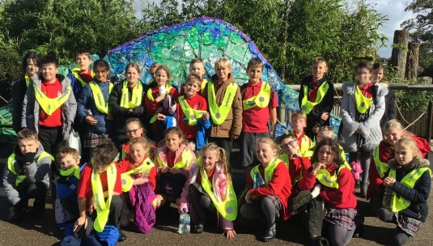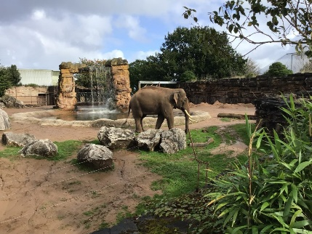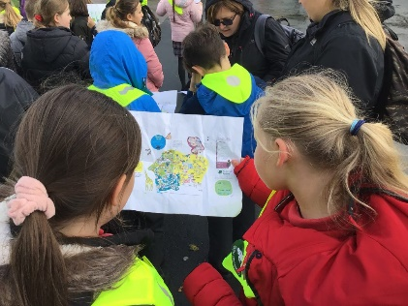

EYFS Zoo at School
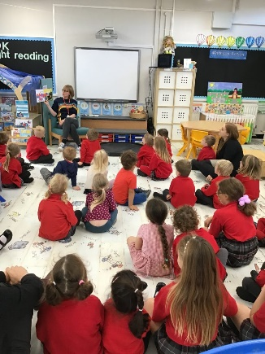
Whilst the rest of school were at Chester Zoo on Wednesday the children in EYFS had their own day learning about an animal you would find in Chester Zoo’s mini-beast house.
They started the day reading the story about Norman and his Silly Shell. They then met their animal visitor for the day – Turbo the giant African land snail. The children learnt about what he looks like, what he likes to eat and why he has a shell. They were all fascinated by him.
The children then designed snail shells for Turbo linked to the story and enjoyed continuous provision activities linked to snails.
PE KITS
We are writing to remind you of our arrangements for PE kits. Governors have agreed that if your child has a Marlfields PE tracksuit (available from DP Sports in Congleton) they are allowed to wear this on the days your child’s class do PE.
If they do not have a school tracksuit, then their kit is to be brought into school in a bag. They come to school in uniform to change here in our changing rooms.
We need to remind you that general sports clothes and themed tracksuits are not allowed to be worn on PE days regardless what your child tells you. Your support in this matter would be gratefully appreciated. Please also note that parents with children eligible for Free School Meals can get support with uniform, so just call us.

NEW ARRAGEMENTS FOR ENTRY INTO SCHOOL FROM THE TOP GATE ON WAGGS ROAD
The new system which we put in place this week seems to have alleviated most of the congestion on Waggs Road, well, that and the rain! Thank you for working with us on this as we try to get back to some resemblance of ‘normality’, although we still have many mountains to climb.

HOMEWORK & DAILY READING
Homework is important because it develops core skills in young children and further imprint in their minds what they have learned in school, which will serve them throughout their school and working life. Discipline, time management, using resources and improving communication are all vital life skills that will open the door to unique opportunities and help children find success in their careers. We have a number of children who are not doing their homework set by the teachers. We ask that you check with your child, and that they are aware of what they school be doing.

Reading to your child daily is vitally important for many reasons: We ask that you read with your child daily for 20 minutes and mark in their book as having done so. An interesting fact is that if you do this from when your child was in Nursery, they will have heard 1.8 million words per year.
By Year 6, you will have also given your child individual attention for 851 hours!

A few years ago a study was conducted and the results were astonishing. For the time commitment of just 20 minutes per day spent reading, children scored in the 90th percentile on standardized tests. However, there are lots more benefits of reading, and they go far beyond just test scores; the best being that it is enjoyable sharing books and learning new things together.

The benefits of reading 20 minutes a day are many and well worth the time. Make reading 20 minutes a day a priority to improve your child’s well-being, grow vocabulary, build empathy for others, decrease stress, and increase your sleep. That is a win-win.

OUR EXTRA CURRICULAR CLUBS
We have taken the decision to not to start our extra-curricular clubs until AFTER half term, due to staff/child illnesses. However, we will be sending out the Club List next week for you to make your child’s choice of Club. This year to avoid some children being disappointed at not getting a place at any of the clubs, we have decided to limit each child to a maximum of two clubs.

Please return your choice of clubs as soon as possible so that we can get organised to start after the Autumn half-term holiday.

Please also note that some clubs have a restricted number due to the activity. The earlier the return the better chance of getting your child’s choice.
Please return the forms to admin@marlfields.cheshire.sch.uk – forms via other ways may not get through quickly, so it would be best to use this system.

