|  |
| --- |
| **Marlfields Primary Academy**  **NEWSLETTER**  **21ST July 2021** |

**It’s finally here, the end of an extraordinarily strange school ‘year’, we did it, and we all survived, and it is all credit to you for sticking to the rules and guidelines to keep us, yourselves and your children safe.**

**We have been extremely fortunate in that we haven’t had too many positive cases of Covid, and this is due to yourselves, but most importantly due to our amazing team in keeping everywhere clean, ventilated and sanitised. We cannot thank Mr Pointon and his ‘ladies’ enough for all of their hard work over the past trying months; they have all been amazing. Thank you, each and every one of you.**

**We have all had to adapt and change the way we do even the most basic of things; but adapt and change we have, successfully. We have all had a moan about it, but we did it and we got through it, together.**

As we reach the end of this school year we bid farewell to Miss Carr and to our lovely Year 6 children.

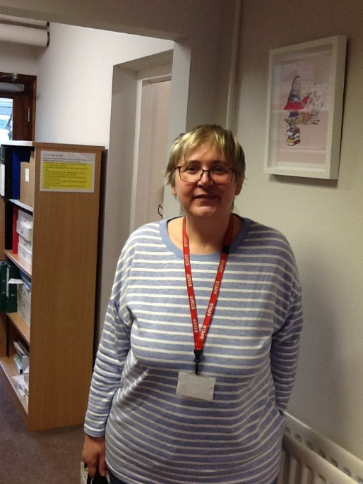

Sadly, we are saying goodbye to a much cherished long serving member of staff - **Miss Carr** who is leaving us to take early retirement.

Miss Carr joined us as a class teacher in September 2000; she has worked in most year groups from Nursery through to Year 6 which just goes to show what a good and versatile teacher she is. She is also an amazing artist, full of creativity and she leaves us with the legacy of numerous pieces of art work around the school.

Miss Carr took on the role Vice Principal of Marlfields Primary Academy in 2014, supporting Mrs Isherwood in the running of the school.

We will all miss you Miss Carr, please don’t be a stranger, we hope that you will look back on your ‘Marlfields Years’ fondly. Enjoy your retirement, and make good use of all that free time.

**Year 6**, it has been a pleasure to watch you as you have all blossomed from the shy, timid things who joined us in our Reception Class into the amazing individuals that you have all become in Year 6. We look forward to hearing how you progress at High School and beyond. We will miss you, but look forward to you shining like the stars that you are!

**Reception Class 2014** (Some of these children are no longer at Marlfields, but we thought that the children might like to see who they started their school life with)

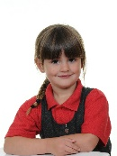 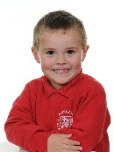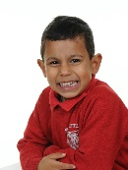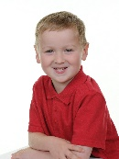 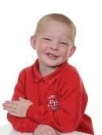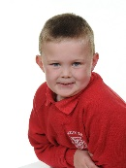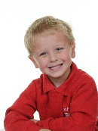  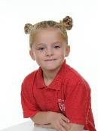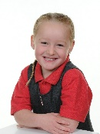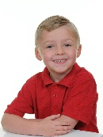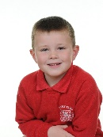 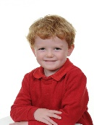

**Year 6 2021** (My, how they have grown! Some new faces too)

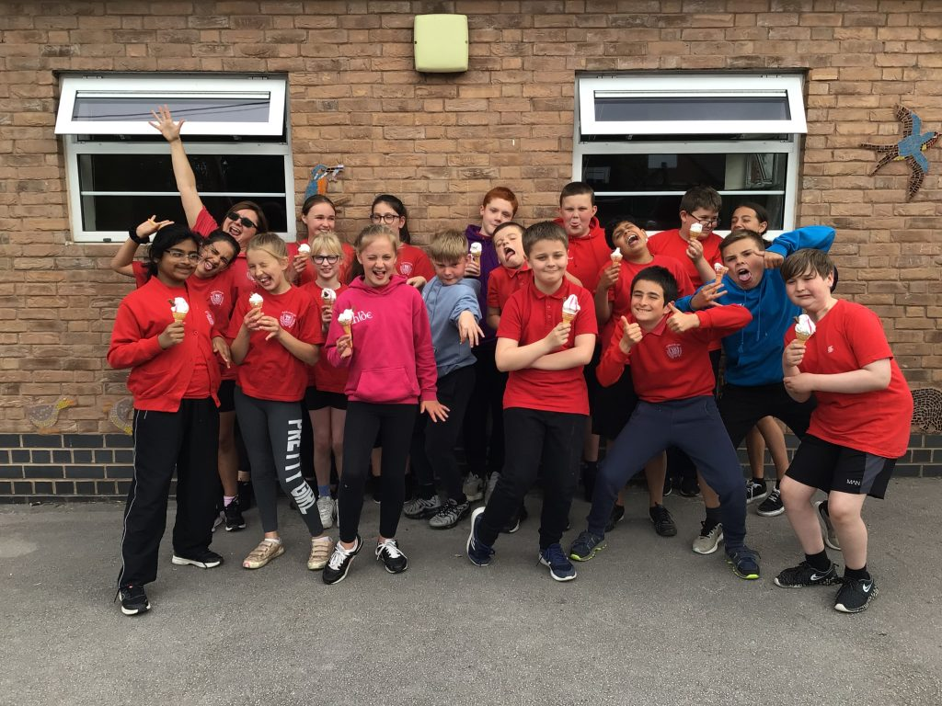

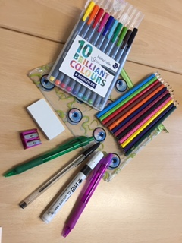**INDIVIDUAL PENCIL CASES**

Due to increased pressure from the children to be allowed their own pencil cases we are from September, allowing children to bring in their own pencil case.

Within the pencil case your child should have as pictured

***Purple and Black biro Black white-board pen Rubber***

***Pencil sharpener Set of pencil colouring crayons 3 HB pencils***

***Set of washable felt tip pens***

Please ensure that the actual pencil case is not too big as it needs to fit into children’s trays and that it is named. We are selling the filled pencil case for just £5 should you wish to purchase one from school. If you would like one, drop us an email and put £5 onto your SCOPAY account.

*Please note that school take no responsibility for items lost and, as normal, we will have these items in the school for children’s use if they do not want to bring their own.*

**CONGLETON IN BLOOM**

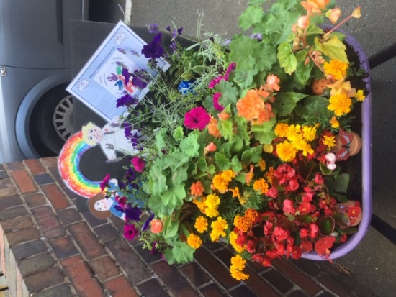We always like to support community events, and this year is no different. This week we have filled the Nursery Wheelbarrow with rainbow plants to support Congleton in Bloom giving thanks for the NHS. We were only given 24hours notice to make the wheelbarrow up. We have surprised ourselves with the outcome given such short notice. Many thanks to everyone who helped to organise it.

**PRIZE GIVING**

Prize-giving this year, like last year was rather unusual, but still very emotional. Instead of a full afternoon in the hall, singing and presentations followed by strawberries and cream we held an outdoor ceremony, sadly we were unable to invite parents along. Never the less is was, in its own way, a special time and we were still able to celebrate the children’s achievements and present them with their prizes and treats. We have attached a copy of the ‘programme’ which contains all of the recipients of the individual awards. Congratulations all of you on achieving your accolade.

**Uniform**

Don’t forget that **DP Sportswear, Bromley Road, Congleton, CW12 1PT** are now the providers for all of your uniform needs. If you need any item of uniform, just call into them in person or telephone them on **01260 274400** to check stock availability. We hope that you are finding this way of getting uniform much more convenient for yourselves.

**HAVE YOU SIGNED UP FOR THE SUMMER READING CHALLENGE**

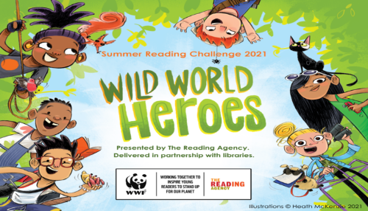Don’t forget to join The Summer Reading Challenge at Congleton Library. By encouraging the children to take part you can:

* Celebrate the joy of reading whilst ensuring that they are able to read well by the age of 11
* Continue to support their learning during the holidays
* Help to prevent the trend for children’s reading skills to dip over the holidays

For 2021, the Reading Challenge is **Wild World Heroes**, a nature-themed Challenge that will inspire the children to engage with environmental issues.

If your child reads a minimum of 6 books over the summer holidays they will receive a certificate and medal and there may be a reward from school too on production of their medal and their certificate.

**BEE ACTIVE**

If your child is in receipt of income based free school meals, there are still some places available at the afternoon sessions of the Bee Active Holiday Club. If you and your child are interested in taking up a place and are eligible to FSM contact Bee Active on [**www.beeactive.co.uk/haf or call 01782 205915**](http://www.beeactive.co.uk/haf%20or%20call%2001782%20205915)

**FREE SCHOOL MEALS**

If you are on a low family income and are in receipt of universal credit, you may be eligible to claim Free School Meals.

If you believe that you fall within this category call **0300 123 5012** to check your eligibility.

**And finally …….**

*Have a wonderful summer break and whatever you are doing, enjoy every moment.*

*We are all in need of some relaxation, and hopefully when we return on September 1st we should all be ready to face the new school year and all the challenges that this may bring. Fingers crossed for some normality!*

***Enjoy, keep safe and see you all in September****.*