Marlfields Primary Academy
NEWSLETTER
10th July 2021

If We Can’t Go To The Pool, The pool can come to us!!!!!!
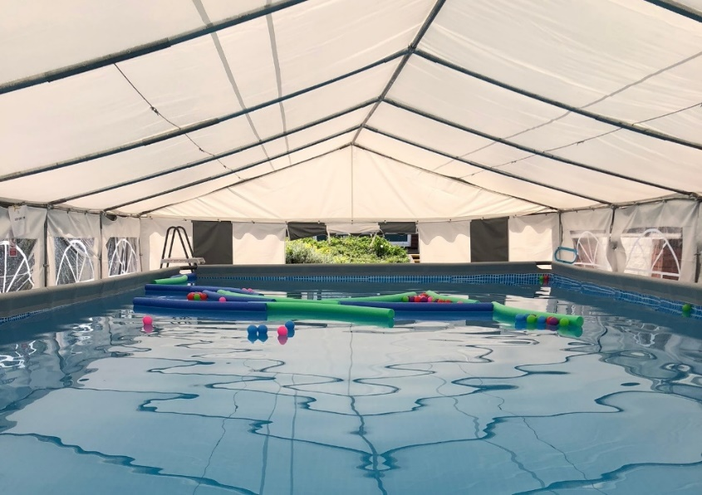
You will be aware that the swimming pool at Congleton Leisure Centre is closed for over 15 months. This means that children in Congleton will not be able to swim and our lessons, where over 100 of our pupils went each week, we have been reduced to just 36 being allowed to go and for this we have to travel to Sandbach. This has been disappointing for the children, so we have worked together to be on the case!
We are pleased to tell you that Mrs Isherwood has raised over £8000 for a pool to come to Marlfields for the first three weeks of the school year.
This will mean your children can swim each day for 3 weeks and have an intensive block of lessons to build confidence in the water and learn to swim.

We are giving you prior notice that from 7th September - 21st September your child will swim each day. We have of course got changing rooms to support this and therefore your child will need a swimming kit in school each day on return to school.
The pool will be heated to 29 degrees so it will be warm and will be placed next to the changing rooms for easy access. The pool comes with a qualified teacher and lifeguard and meets all health and safety requirements. The After School Club will also enjoy the facilities while the pool is on site and we hope you are all as excited as we are for this great start to the year for us. We thank our sponsors for this opportunity and Mrs Isherwood for her skills in gaining support for the school which means there will be no cost for you as parents for these lessons. Every class will be swimming during the week. Any questions please just ask by calling 01260 633120.

THE CHRISTIE BEAR SPELLING CHALLENGE
We are pleased to let you all know that some of our children have raised over £500 from the recent sponsored spell for The Christie Hospital, which is an amazing amount considering only 17 children raised the money. Well done to all those who took part.

HOT, SUNNY DAYS
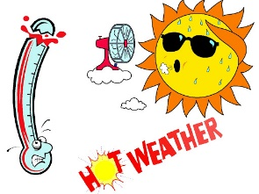
Hot weather has been forecast for the next few days; may we take this opportunity to remind you apply long acting sunblock to your child each morning, and where possible (especially Foundation Stage and Key stage 1 children) send in a named sun hat which can be kept in school until the end of term.
We will obviously limit the time that children are out on the playground on the hottest days and also ensure that they keep hydrated.

Uniform
Don’t forget that DP Sportswear, Bromley Road, Congleton, CW12 1PT are now the providers for all of your uniform needs. If you need any item of uniform, just call into them in person or telephone them on 01260 274400 to check stock availability. We hope that you are finding this way of getting uniform much more convenient for yourselves.

HAVE YOU SIGNED UP FOR THE SUMMER READING CHALLENGE
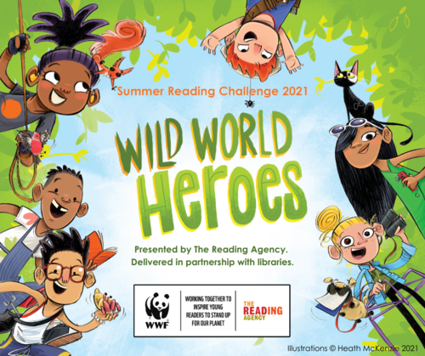
Don’t forget to join The Summer Reading Challenge at Congleton Library. By encouraging the children to take part you can:
- Celebrate the joy of reading whilst ensuring that they are able to read well by the age of 11
- Continue to support their learning during the holidays
- Help to prevent the trend for children’s reading skills to dip over the holidays
For 2021, the Reading Challenge is Wild World Heroes, a nature-themed Challenge that will inspire the children to engage with environmental issues.
If your child reads a minimum of 6 books over the summer holidays they will receive a certificate and medal and there may be a reward from school too on production of their medal and their certificate…….
SCHOOL HOLIDAYS
Including the end of this academic year (in red), and the next academic year from September 2021 to July 2022.

Summer 2021 | 08.06.2021 | 21.07.2021
NEXT Academic Year 2021 – 2022
School Opens School Closes
Autumn 1 | 01.09.2021 | 22.10.2021
Half Term
Autumn 2 | 02.11.2021 | 17.12.2021
Christmas Holidays
Spring 1 | 04.01.2022 | 17.02.2022
Half Term
Spring 2 | 28.02.2022 | 31.03.2022
Easter Holidays
Summer 1 | 19.04.2022 | 26.05.2022
Half Term
Summer 2 | 07.06.2022 | 22.07.2022
INSET DAYS
01.11.21, 18.02.22, 01.04.22, 27.05.22 & 06.06.22

COVID RESTRICTIONS AND SCHOOL
Whilst restrictions around the country finish on Monday, we will continue in the same way as we have been doing since the beginning. We may as well end the term as we began!

Changes to contact tracing in education and childcare settings
As you know, the Prime Minister announced on 12th July that Step 4 of the roadmap would go ahead on 19 July.
One of the key changes that will take place from 19 July is that education and childcare settings will no longer be asked to conduct routine contact tracing. As with positive cases in any other setting, NHS Test and Trace will work with either the positive case – or in the case of children – the parents, carers or guardian of the positive case to identify close contacts.
NHS Test and Trace already manages the contact tracing process for the rest of society – including children who have recorded a positive PCR test – and has expertise in supporting people to identify close contacts.
This letter sets out in more detail below how that process will work and what you need to do if your child tests positive for COVID-19.

Self-isolating and taking a test
- If your child has symptoms, they and other members of the household should self-isolate – and you should inform their education or childcare setting. You should immediately order a PCR test for them. If the PCR result is negative, they and other members of their household can stop self-isolating (unless instructed to self-isolate for other reasons). If the PCR result is positive, they, other members of their household and any close contacts identified by NHS Track and Trace must self-isolate until 10 days after the onset of symptoms.

- If your child has a positive result from a lateral flow device (LFD) test, they and other members of the household should self-isolate – and you should inform their education or childcare setting. You should immediately order a confirmatory PCR test. If the confirmatory test is taken within two days and the result is negative, they and other members of their household can stop self-isolating (unless instructed to self-isolate for other reasons). If the confirmatory PCR test is positive (or is taken more than two days after the LFD), other members of their household and any close contacts identified by NHS Track and Trace must self-isolate until 10 days after the LFD test.

- PCR tests can be booked online through the NHS Test & Trace website or by calling 119.

- PCR test results will be recorded with NHS Test and Trace automatically, but you should also communicate the result to the education or childcare setting during term time or summer provision.

Contact tracing
- If your child gets a positive PCR test result, NHS Test and Trace will contact you, using the details you registered when ordering the PCR test. You and/or your child will be asked a series of specific questions designed to identify who your child has been in close contact with. Being in an education or childcare setting with someone who has tested positive for COVID-19 will not necessarily mean a person is identified as a close contact.

- You will be asked to provide the contact details, if you know them, of any of the individuals – or their parents or guardians – who have been identified as close contacts. NHS Test and Trace will then get in touch with these close contacts and provide appropriate instructions or advice (see below).

Self-isolation and/or testing of close contacts
- At present, anyone identified as a close contact is legally required to self-isolate and must not attend their education or childcare setting (the only exception is if they are participating in a daily contact testing trial). Anyone identified as a non-household close contact by NHS Track and Trace must self-isolate until 10 days after the date of their most recent contact with that person. If they live in the same household, they must self-isolate until 10 days after the date of that person developing symptoms (see point 1 above) or, if that person was asymptomatic, the date of their test (see point 2 above). NHS Test and Trace will notify you of the day on which the self-isolation period ends.

- Close contacts are also advised to take a PCR test. If the test result is negative, they must still complete the full self-isolation period, as the test will not detect all positive cases. If the result is positive, they will need to self-isolate for a further 10 days – and NHS Test and Trace will contact them to identify any close contacts.

- From 16 August, if the close contact is under 18, they will not have to self-isolate (in line with the policy for fully vaccinated adults) but will be asked to take an PCR test immediately, other than for very young children identified as non-household contacts, and they will not need to self-isolate while awaiting the results of the test. If the PCR test is positive, they will be required to self-isolate for 10 days from the date of the test. NHS Test and Trace will then get in touch to identify close contacts (see points 5 and 6 above). Further guidance on these changes to self-isolation will be provided shortly.

We recognise how difficult the past 18 months have been and the sacrifices that all families, education and childcare settings have had to make. This has been an enormously challenging time for everyone and we would like to take the opportunity to thank you for everything you have done.

