**Family Well-being Service**

Lauren Cockroft is a Family and Community Worker at Visyon, which is a Charity that has been supporting the emotional health and well-being of children, young people and their families since 1994. Her role has been commissioned by the Congleton Primary Schools and she will be our local Family Wellbeing Worker.

Families can experience many challenges and her role enables her to work in partnership with families to provide **holistic** and **empowering** support. She can help you overcome whatever challenges you or your children may be facing, to enable you to achieve all that you want to achieve as a family. She can cover anything from the usual growing pains that all families can face, through to specific support around challenging behaviour and exploring additional educational needs.

Any work with her would be confidential and totally bespoke to your family’s needs. This could be a one-off chat, or a series of 1-1 or whole family sessions. Her aim is to support you to feel **confident**, **capable**, and **prepared** for moving forwards.

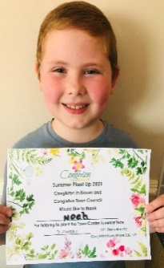The may also see her around school as she begins to deliver some workshops – the timetable for which will be sent out very soon. These are open to all and may take place at school, at the Visyon base in Congleton or via video call. These will cover a wide range of topics around challenges a family may face and will provide information, guidance and coping strategies to help improve family wellbeing.

**How do I refer?**

Referrals can be made by contacting school directly or via Visyon’s Open Access sessions as

detailed below:

**Want more information, or a quick chat or have any questions?**

Then please book an Open Access session with Lauren, which is a space to talk,

off-load, get initial tips, guidance, coping strategies and to discuss further support.

Open Access sessions are bookable through the

**Visyon Initial Contact** team on **01260 290 000**

**Tuesdays 10:00am -11:00am**

**Thursdays 5:30pm-6:30pm**

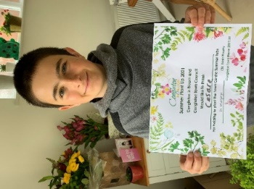 **SUMMER PLANT UP**

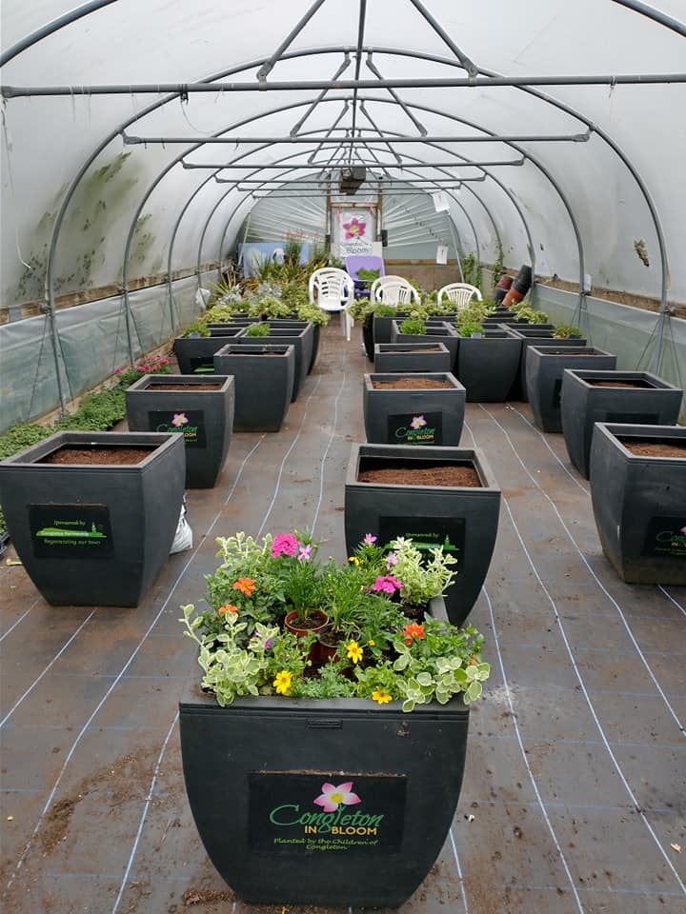Last Saturday two of our children braved the elements and went down to the poly-tunnel at Congleton Park to represent Marlfields at the Congleton in Bloom’s Summer Plant Up. The tubs will shortly be on display throughout Congleton. Five local schools sent children to take part in the Plant-Up. We would just like to say thank you Cesare and Noah for representing us, you were both a credit to us and to your families. Thanks also to your mums and dads for loaning you out for the morning.

**ABSENCE FROM SCHOOL**

**We would like to take this opportunity to remind parents that they must report any absence from school to the school office (01260 633120) before 9:30am where possible and NOT via class Dojo. Your co-operation is greatly appreciated.**

**HEAD LICE**

We have now been informed of numerous cases of head lice throughout most year groups. Please use the half term to thoroughly check your child’s hair and treat where necessary. Hopefully if everyone checks and treats we should be able to eradicate them for a while. Thank you for your co-operation.

**HALF TERM HOLIDAY**

We hope that you all have a fantastic half term, fingers crossed that the weather is favourable and we can all get out in the sunshine and have as much fun as possible whilst keeping safe at the same time.

***If anyone does get ill with Covid symptoms and need to have a test, please let us know by e-mail, both e-mail accounts are checked regularly each day, as even during the holidays our work doesn’t stop and we have to report any suspected cases (***[***admin@marlfields.cheshire.sch.uk***](mailto:admin@marlfields.cheshire.sch.uk) ***or*** [***head@marlfields.cheshire.sch.uk***](mailto:head@marlfields.cheshire.sch.uk)***).***

**THE CHRISTIE HOSPITAL FUND-RAISING PACKS HAVE ARRIVED.**

**YOUR CHILDREN SHOULD BRING THEM HOME TONIGHT.**

**As a reminder: Reception, Yrs 1 & 2 need to learn List 1; Yr 3 – List 2; Yr 4 – List 3 and Yrs 5 & 6 – List 4.**

**We hope that you will all feel able to get some sponsors to help us to raise as much money as possible for this fantastic charity which has probably helped someone who we love or know, after the past year our help is needed more than ever.**

**Monday 7th June is a school INSET day, so staff will be in school training;**

**the children are all expected back into school on Tuesday 8th June. See you all then.**