Marlfields Primary Aca

Marlfields Primary Academy

NEWSLETTER

30th April 2021

demy

**CAKES & CELEBRATIONS GALORE!**

What a lovely fun week of celebrations we have had!

First of all, we had the ‘official’ opening of our allotment, which we have achieved with the help and kindness of Graham Construction and their workers.

At the opening ceremony were two representatives from Graham’s, Mrs Gartside who is our Chair of Governors, Mrs Isherwood and our head boy and girl and their deputies.

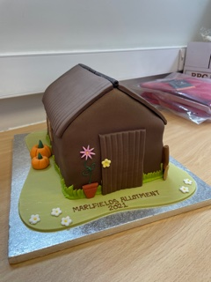 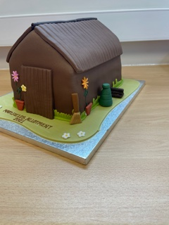

To celebrate, Mrs Isherwood bought this cake to share.

**Scrumptious!**

You may have seen the allotment on the Waggs Road side of the field.

We have a quantity of topsoil and pebbles to move; if anyone would like to give us a hand in moving them, we would be most appreciative.

If you are able to help, please call the office on (**01260 633120**) or if you prefer, email us ([admin@marlfields.cheshire.sch.uk](mailto:admin@marlfields.cheshire.sch.uk)) to offer your services.

We hope to grow lots of exciting things on it which the children can use to further enhance their education.

If you have any suggestions on what we should grow, how we should manage the allotment, please let us know; we always welcome any input.

-----------------------------------------------------

The second celebration cakes were for a special birthday for Mrs Isherwood on Tuesday.

Everyone gathered on the playground in their pods during the afternoon to sing “Happy Birthday” to her whilst she showed everyone what we had bought for her.

One of our very talented mums, Mrs Brown, made a beautiful cake for us to give her; we also had tray bake cakes so that all of the children could have a piece of cake to help her to celebrate. We hope that they all enjoyed it as much as we did! Thank you Mrs Brown for the brilliant cake.

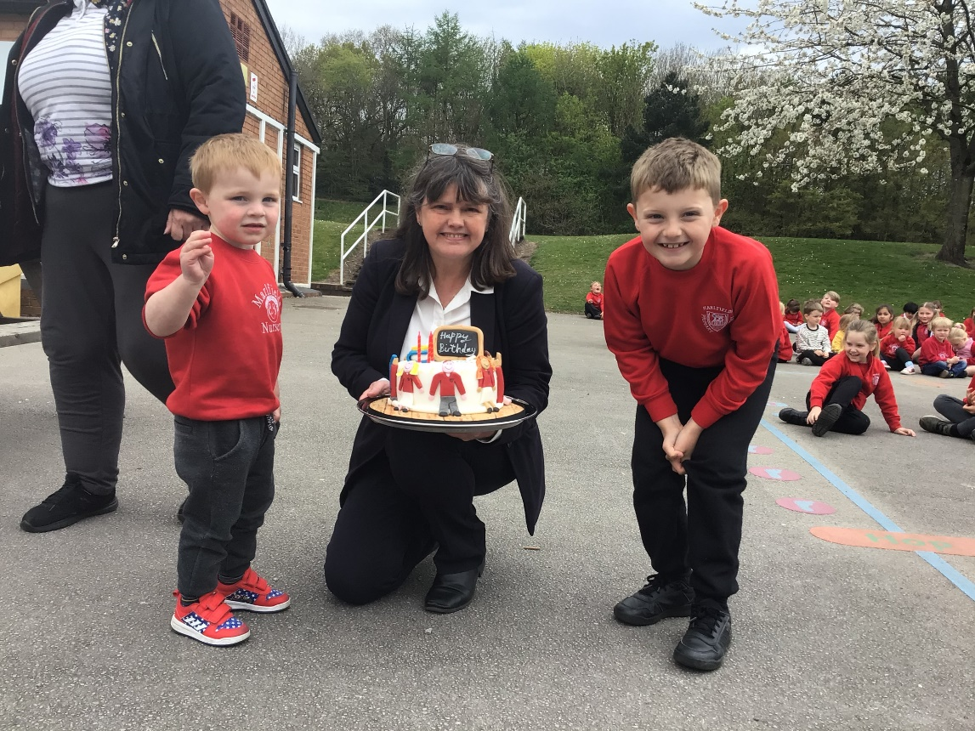

*Mrs Isherwood proudly showing off her cake with William and Ethan whose mummy made the cake.*

**UNIFORM**

We have been in consultation with DP Sportswear on Bromley Road to see if they would be able to supply and sell our uniform which they will be doing with effect from potentially, the end of the month, maybe before. This will be so much easier for you as you can call in to them to get whatever uniform you need directly from them.

In the mean time we have a limited stock on hand which may be slightly cheaper than DP should you wish to stock up. Send in your usual form requesting uniform, and we will let you know if we have it in stock.

**THE CHRISTIE FUND-RAISER**

Later in this term we will be hold a Christie Bear Spelling Challenge. The children will be given a small list of words (which will be age appropriate) to practice and learn ready for the test. All we ask that friends and family sponsor them to get as many right as possible. Everything raised will go to The Christie Hospital to support young cancer patients.

We will send the Word Lists and practice sheets with this Newsletter so you can start learning.

Reception, Year 1 and Year 2 will learn **List 1**

Year 3 will learn **List 2**

Year 4 will learn **List 3**

Years 5 and 6 will learn **List 4**

We hope that you will join in with us and get as many sponsors as possible and raise any amount, large or small to go to this amazing charity.

1. 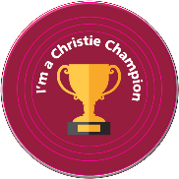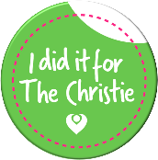 2. 3.



Everyone taking part will receive Badge No. 1, those who fill in half of their sponsor form will also receive Badge No. 2 and if anyone completely fills in the sponsor form they will also receive the Christie Champion Badge too.