We come, once again to the end of a very strange term. We can’t tell you enough how grateful we are to you all for your help and support over this term. Hopefully things will start to get back to normal for us all soon.
We should be hearing more on the Covid Roadmap on 12th April. If there are to be any changes whatsoever we will let you all know as soon as we can.
Meanwhile please have a lovely Easter break, but remember to keep yourselves as safe as possible, and we will see you back in school on Monday 19th April.

CELEBRATING EASTER THROUGH ART

As you can see from these amazing pictures, the children explored different aspects of the Easter Story and the Crucifixion and events which led up to the event and the aftermath. Perhaps they can tell you the story of what happened? Why not ask them to talk about the events in the pictures to see if they remember.

We are sure that you will agree that we certainly have some exceptionally talented children in school. Well done everyone. We hope you enjoyed taking part in the art, and learning what Easter is actually about.

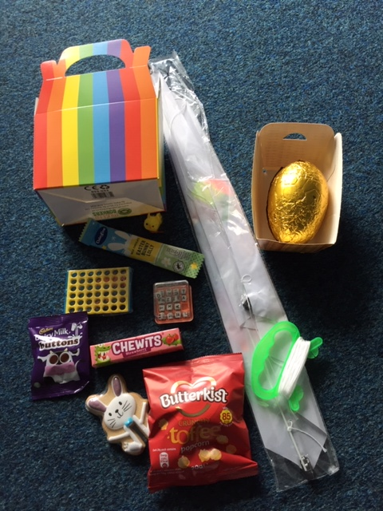
EASTER GIFT BOXES

We hope that your child enjoys their Easter gift box and its contents.
It certainly looks as if the weather is going to be rather windy, so get out there to fly them kites and burn off some of the chocolate excesses! Remember to send us a photo of your decorated kite, and maybe one of you flying it too!

EASTER LUNCH

Everyone who participated in the offered free Easter School Lunch certainly seemed to enjoy it.
We are so lucky to have school governors who allow us to be able to give these little treats to the children, and extremely lucky to have Mrs Isherwood who gives them the ideas in the first place. So thank you to all of the Governors and to Mrs Isherwood, it is most appreciated.

FREE SCHOOL MEALS

Does your child receive income based Free School Meals? You will be aware from our text message yesterday that there are various FREE Activity Clubs on offer for your child. If you and your child would like to find out more about these clubs, please feel free to email school or send us a text message and we will point you in right direction to enable you to access these activities.

SCHOOL HOLIDAYS

Please see below left a list of the school holidays for the rest of this academic year; we have also included a copy of the 2021-2022 academic year on the right for your information (just in case we are able to book any holidays next year!)
NEXT Academic Year 2021 - 2022
School Opens School Closes
Autumn 1 | 01.09.2021 | 22.10.2021
Half Term
Autumn 2 | 02.11.2021 | 17.12.2021
Christmas Holidays
Spring 1 | 04.01.2022 | 17.02.2022
Half Term
Spring 2 | 28.02.2022 | 31.03.2022
Easter Holidays
Summer 1 | 19.04.2022 | 26.05.2022
Bank Holiday | Monday 2nd May 2022
Half Term
Summer 2 | 07.06.2022 | 22.07.2022
INSET Days
01.11.21, 18.02.22, 01.04.22, 27.05.22 & 06.06.22

Academic Year 2020 – 2021
School Opens School Closes
Autumn 1 | 02.09.2020 | 23.10.2020
Half Term
Autumn 2 | 02.11.2020 | 18.12.2020
Christmas Holidays
Spring 1 | 04.01.2021 | 11.02.2021
Half Term
Spring 2 | 22.02.2021 | 31.03.2021
Easter Holidays
Summer 1 | 19.04.2021 | 28.05.2021
Bank Holiday | Monday 3rd May 2021
Half Term
Summer 2 | 08.06.2021 | 21.07.2021
INSET Days
01.09.2021, 02.11.20, 12.02.21, 01.04.21 & 07.06.21

