Marlfields Newsletter
December 4th 2020

Our Christmas Festivities are starting! It’s ALL happening on Tuesday 15th December!
Not long to go now! Have you started to get your sponsors yet?

Make any payments onto our JustGiving page
https://www.justgiving.com/fundraising/Sandra-Isherwood.
We have already had some payments onto the site, for which we sincerely thank you.
If you would prefer to collect cash and bring it in to school we are also able to accept that too.

Have you ordered your marshmallow Snowmen or mini roll Reindeer yet? Or taken part in the BAUBLE RAFFLE?
Everything is just £1, simply make your payments for these onto SCOPAY, Trips & Events then whichever item you wish to buy.
We hope you feel able to support this worthwhile charity during these difficult times.
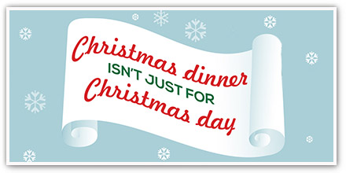

All of the children are invited to join in.
Lunches are free for children in Reception, Year 1 and 2, and for those who are in receipt of Free School Meals in Years 3-6; the cost for children who pay for their lunches is £2.20.
This year’s Christmas menu is:
Traditional Turkey Dinner or Roast Vegetable & Stuffing Tart (VG), both are served with Roast Potatoes, Garden Peas, Carrots, Sprouts, Stuffing and Gravy; dessert is a choice of Neopolitan Ice Cream or Festive Biscuit.
If you wish your child to have a school Christmas lunch, please order/pay for it on the School Grid app.

We are holding a Christmas jumper day on the 15th as well as the Reindeer Run and Christmas Dinner Day. To wear your Christmas jumper, please pay £1 onto Scopay, Trip & Events, 2020 Christmas Jumper; all money raised will be sent to the charity.

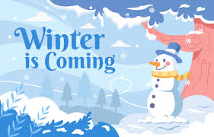

Now that the weather forecasts are changing and the ‘snow’ word is being bandied about, can we please remind you that your child should have a warm / waterproof coat with them in school at all times.
If we were to have a heavy snowfall overnight which means that staff are unable to get into school and we have to make the decision to close the school, or if we have to close early (we have only closed early once in our memory, but we re-opened the following day) we will let you all know via the text message system and we will make an announcement on the local radio stations – SILK, 106.9 FM and SIGNAL, 96.4 FM.
Please let us know if you have changed your telephone number or if you’ve not received a text message from us recently.

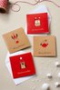

CHRISTMAS CARDS

We know that the children love to send Christmas cards to their friends around school, but as you know, this year is totally different and unfortunately, we are unable to allow the children to bring cards into school from home to give out. Most pods will be making cards in order for the children to give out taking into account all of their friends. We hope you understand the need for us to continue to keep everyone as safe as we possibly can in the run-up to Christmas. Thank you for your understanding.

