

Wow, what a day! It started off shakily when one of the coaches broke down before it got to us, however a replacement was quickly sent out and the final caoch left at 9:00am. Thank goodness it did not break down on the way there or back or our day would have been sitting eating lunch on a motorway!

Everyone was so excited as the coaches were leaving for the journey to Birmingham, our spirits were kept up knowing what was awaiting us when we got there.

We have blogs lots of great photos so please visit the school website and early indications today are that the most popular section seems to have been the 4-D Experience. Lots of screaming in there!

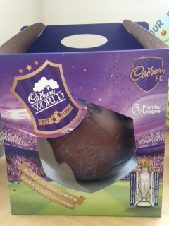

If you would like the opportunity to win this huge chocolate football (**which weighs** **1500g, 7000 calories!**) we are selling raffle tickets at £1 per strip. Tickets are available from the school office. It will be drawn on our last day before the Easter break.

**EYFS VISIT**

The children in the Reception Class and Nursery didn’t go to Cadbury World, the journey and tour would have tired them out, especially as we have some 2 year old children in Nursery; instead they have the opportunity to go on a visit next Thursday to Gruff Outdoor Learning at Marton. They will be able to pet the animals and be young farmers for the day! Let’s hope they enjoy their visit as much as the other children.

**MOTHER’S DAY AFTERNOON TEA**

Don’t forget to book your place at the Friends of Marlfields Afternoon Tea on Monday 16th March. You

**NATIONAL SCIENCE WEEK**

This week we gave out to parents our booklet sharing what we are doing for National Science Week on each of the days. Briefly this is:-

**Monday** – Robot workshop day

**Tuesday** – Science Chocolate day

**Wednesday** – Scienctific Enquiry day

**Thursday** – EYFS to Gruff Learning

**Market Place** - **Parents welcome from 2pm to come and share what we have been doing**.

As you can see there is much planned and we will be having so much fun.

**INSET DAY**

As you know there were three INSET days to be notified and these are now set as

**20th/21st and 22nd July**.

**NEW ARRIVAL**

We have some exciting news to share with you; Mrs Daley our Year 3 teacher has given us permission to share with you all that she is expecting an addition to her family in the Autumn. We are sure that you will join with us to congratulate her, her husband and Sebastian, and wish them all well.