CHRISTMAS SPECTACULAR
Thank you everyone for joining us on Monday for a fantastic day. We were all busy, busy, busy and it was the first time we have offered something like this and we had many compliments. The extra surprise of our vitual reality sleigh ride was appreciated by both the children and adults alike and the company commented on how well behaved our children were.
Following the feedback we will be running a similar event in the Spring Term so please join us.
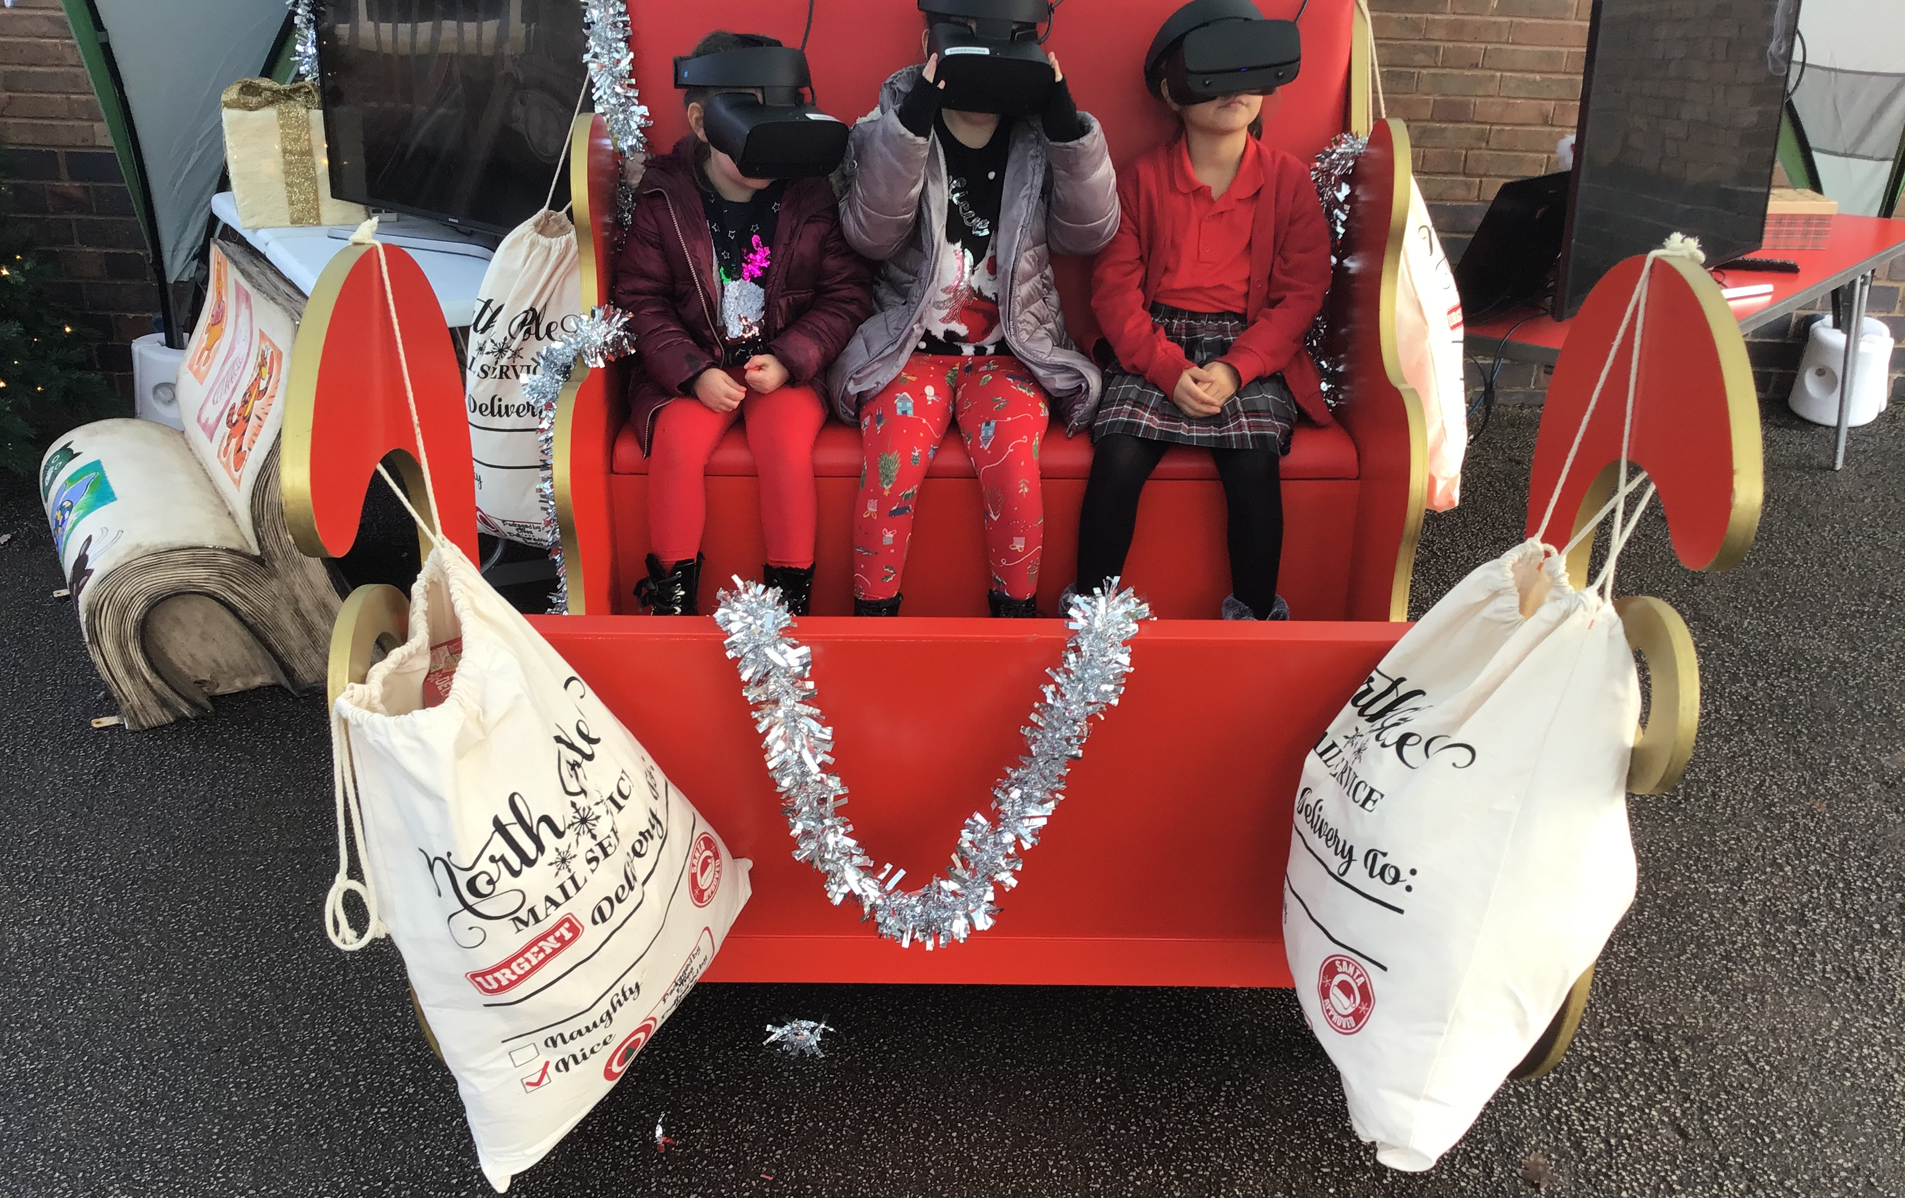

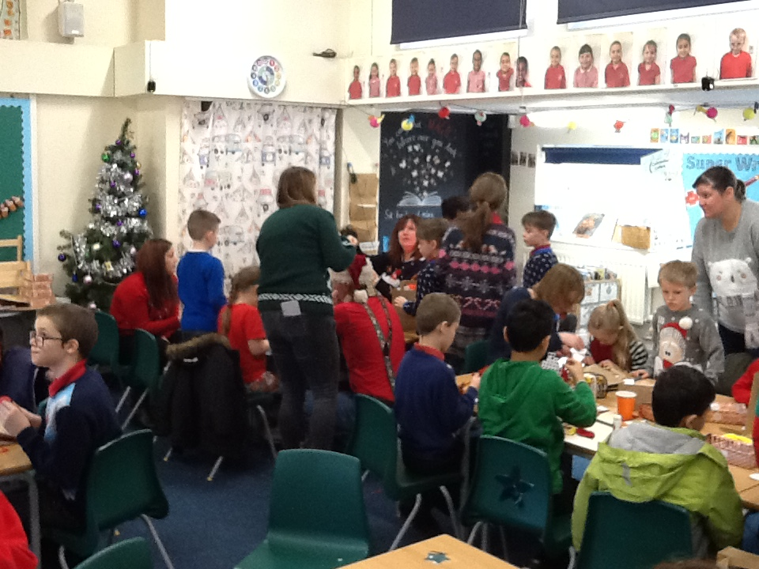

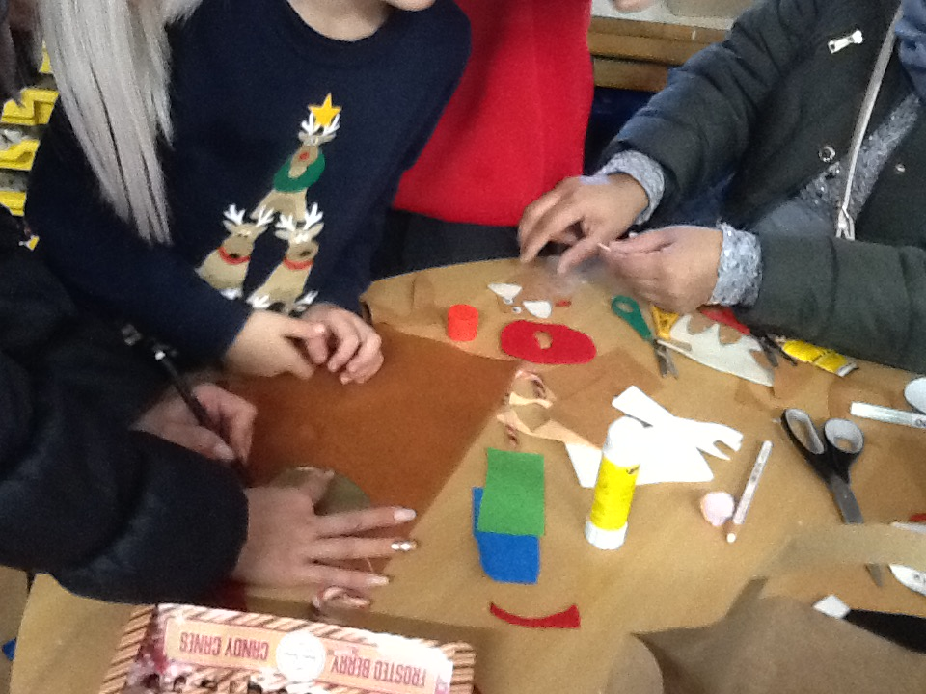

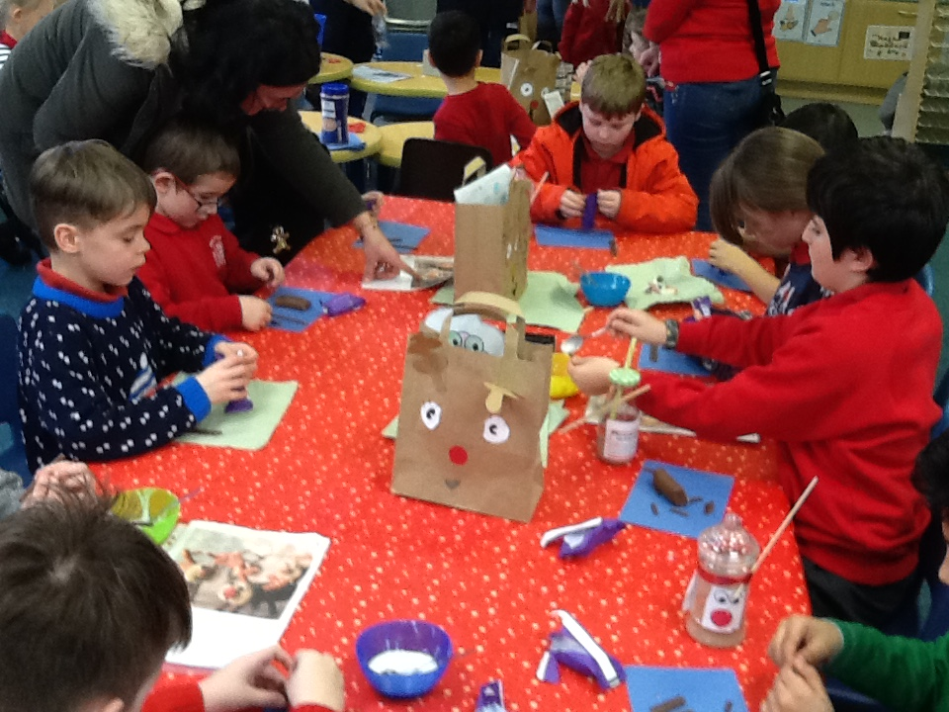

100% ATTENDANCE AUTUMN TERM
As you are aware the children are rewarded for attendane and the following have achieved 100% attendance for the Autumn Term and received their certificates today.

100% ATTENDANCE
Class | Name |  | Class | Name
R | Annisha Brough, |  | 3 | Isaac Bell,
R | Matthew Hague, |  | 3 | Jenson Blunt,
R | Alice Hamilton, |  | 3 | Thomas Davies,
R | Elliot Rosson, |  | 3 | Daisy Lawton,
R | Edith Walton, |  | 3 | Becky Oakes,
1 | Esme Bailey, |  | 3 | Haylee-Jane Porcheret,
1 | Tobias Kane, |  | 3 | Alex Wallace,
1 | Dylan Matthews, |  | 3 | Dylan Wilde,
1 | Blake Morris, |  | 3 | Julian Wilde,
1 | Ashton Mountford, |  | 3 | Libby Wood,
1 | Oliver Skellern, |  | 4 | Jasmine Ara-Nott,
1 | Kionna Valdes-Morrey, |  | 4 | James Hague,
2 | David Barbutu, |  | 4 | Toby House,
2 | Reece Coates, |  | 4 | Isaac Kane,
2 | Arthur Gruber, |  | 4 | Leo Onions,
2 | Saiful Islam, |  | 4 | Nevaeh Riley,
2 | Lincoln Marriott, |  | 5 | Charlie Barnes,
2 | Bradley Porcheret, |  | 5 | Zack Bloor,
 |  |  | 6 | Rohan Bradley,
 |  |  | 6 | George Kane,
 |  |  | 6 | Gabriella Shaw,

CELEBRATIONS OF ACHIEVEMENTS OUTSIDE OF SCHOOL
We enjoy celebrating with children their achievements outside of school so please keep your photos and news coming by emailing admin@marlfields.cheshire.sch.uk and we can add them to our newsletter.
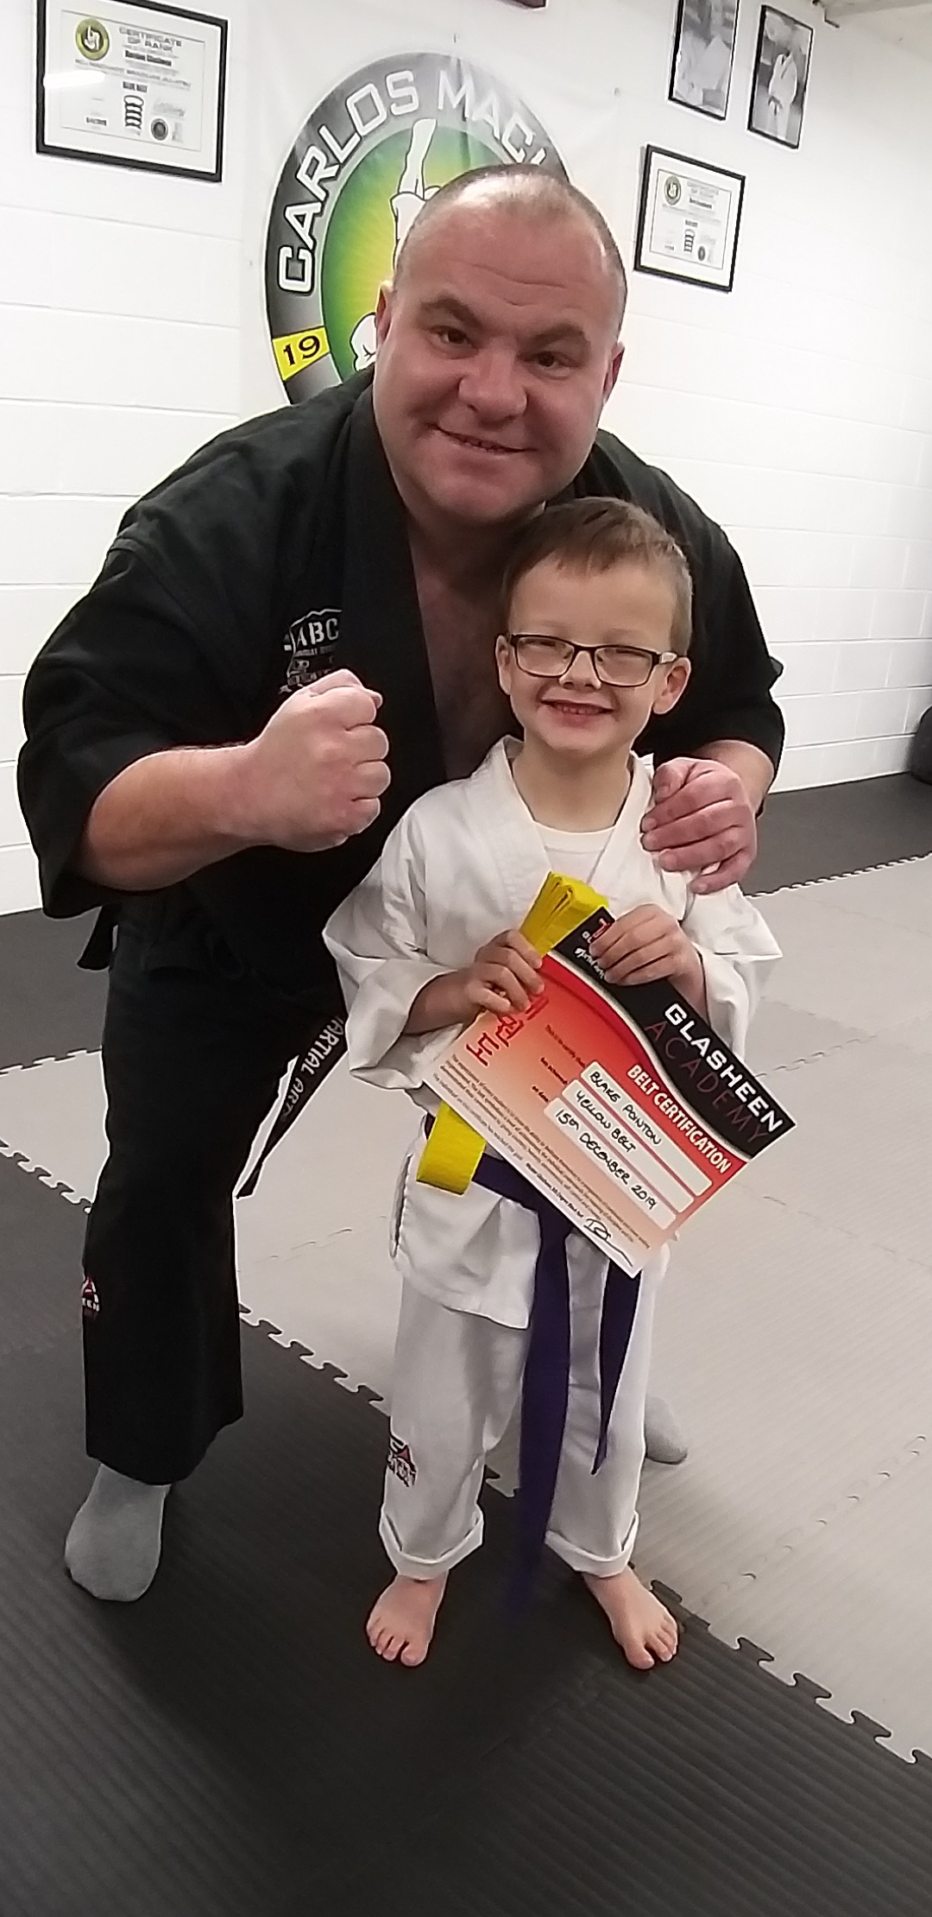
Congratulations to Blake (Year 1) in gaining your yellow belt at your Jujitsu club.
Well done. We look forward to celebrating the next belt when you get that one too.

P.T.O.
IT’S CHRISTMAS!!!
(Well, almost)
We would like to thank you all for your support this term, and hope that you will support us for the rest of the school year.

We hope that everyone who has joined the school over the past term have settled in well and have made many new friends.

We wish each and everyone of you a wonderful Christmas, and a happy and peaceful 2020.

See you all on Monday 6th January 2020.
NEW YEAR REMINDERS

UNIFORM
Our Chair of Governors was in school last week and was rather concerned about children not in the correct uniform. Please ensure that your child is in full Marlfields uniform at all times. The only exception is if it is your child’s birthday and they are allowed to come in civvies or if we have a special non-uniform day.

SCHOOL DINNER ORDERING
Please remember that you need to order and pay for your child’s dinners on the Dolce system before we come back to school. Remember you can order for the whole term but also don’t forget to pay!

CHANGES IN NUMBERS/CONTACT DETAILS
Santa can often bring new phones, so please if you have been lucky and had an upgrade please let us know your new number. You can text school or send an email to admin@marlfields.cheshire.sch.uk

WEATHER
As we are now getting nearer to that time of year when the weather suddenly changes can we please remind you to ensure that your child has a warm / waterproof coat with them in school at all times.

If we were to have a heavy snowfall that means that staff are unable to get into school and we have to make the decision to close the school, we will let you all know via the text message system and we will also make an announcement on the local radio stations –
SILK 106.9 FM and SIGNAL 96.4 FM.

ATTENDANCE MATTERS

Please remember that poor attendance is not acceptable and we have had to remind a number of families with offical letter this term. If your child’s attendance falls below the normal acceptable level that the Government sees as 94% we have to issue letter to ensure there is an improvement. Please may we remind you that poor attendance may result in a fine.
The Government also does not encourage holidays during term time so please do not ask us to approve these as refusal can often offend and we do not have the authority to do so. Please if you are intending your child to be off school for a period a time we ask you to complete a leave of absence so we know not to inform the relevant authorites of a child mising education. May we remind you that there are fines for children taking holidays during term time issued.

