CADBURY WORLD
Thank you to everyone who has returned their slips and payments for our exciting visit to Cadbury World. However, there are still a number of children who haven’t yet replied at all, some who have returned the slip but no payment, and some who have paid but not sent in a permission slip. It would be appreciated if you would complete and return the permission slip, or indeed write us a note letting us know that your child would like to go on the visit and/or make payment of £5 onto SCOPAY. We need to know who will be going on the visit by Friday 14th February in order for us to finalise our trip insurance.

CONGRATULATIONS
Well done to Gaby from Year 6 for gaining a Silver Award for Ballet. Well done Gaby, can’t wait to see your Gold Award!
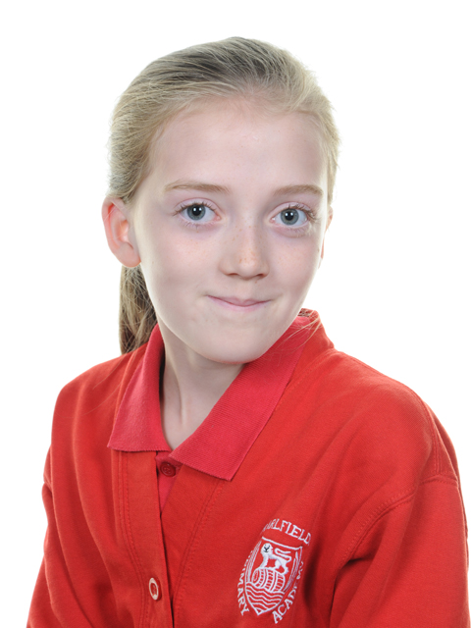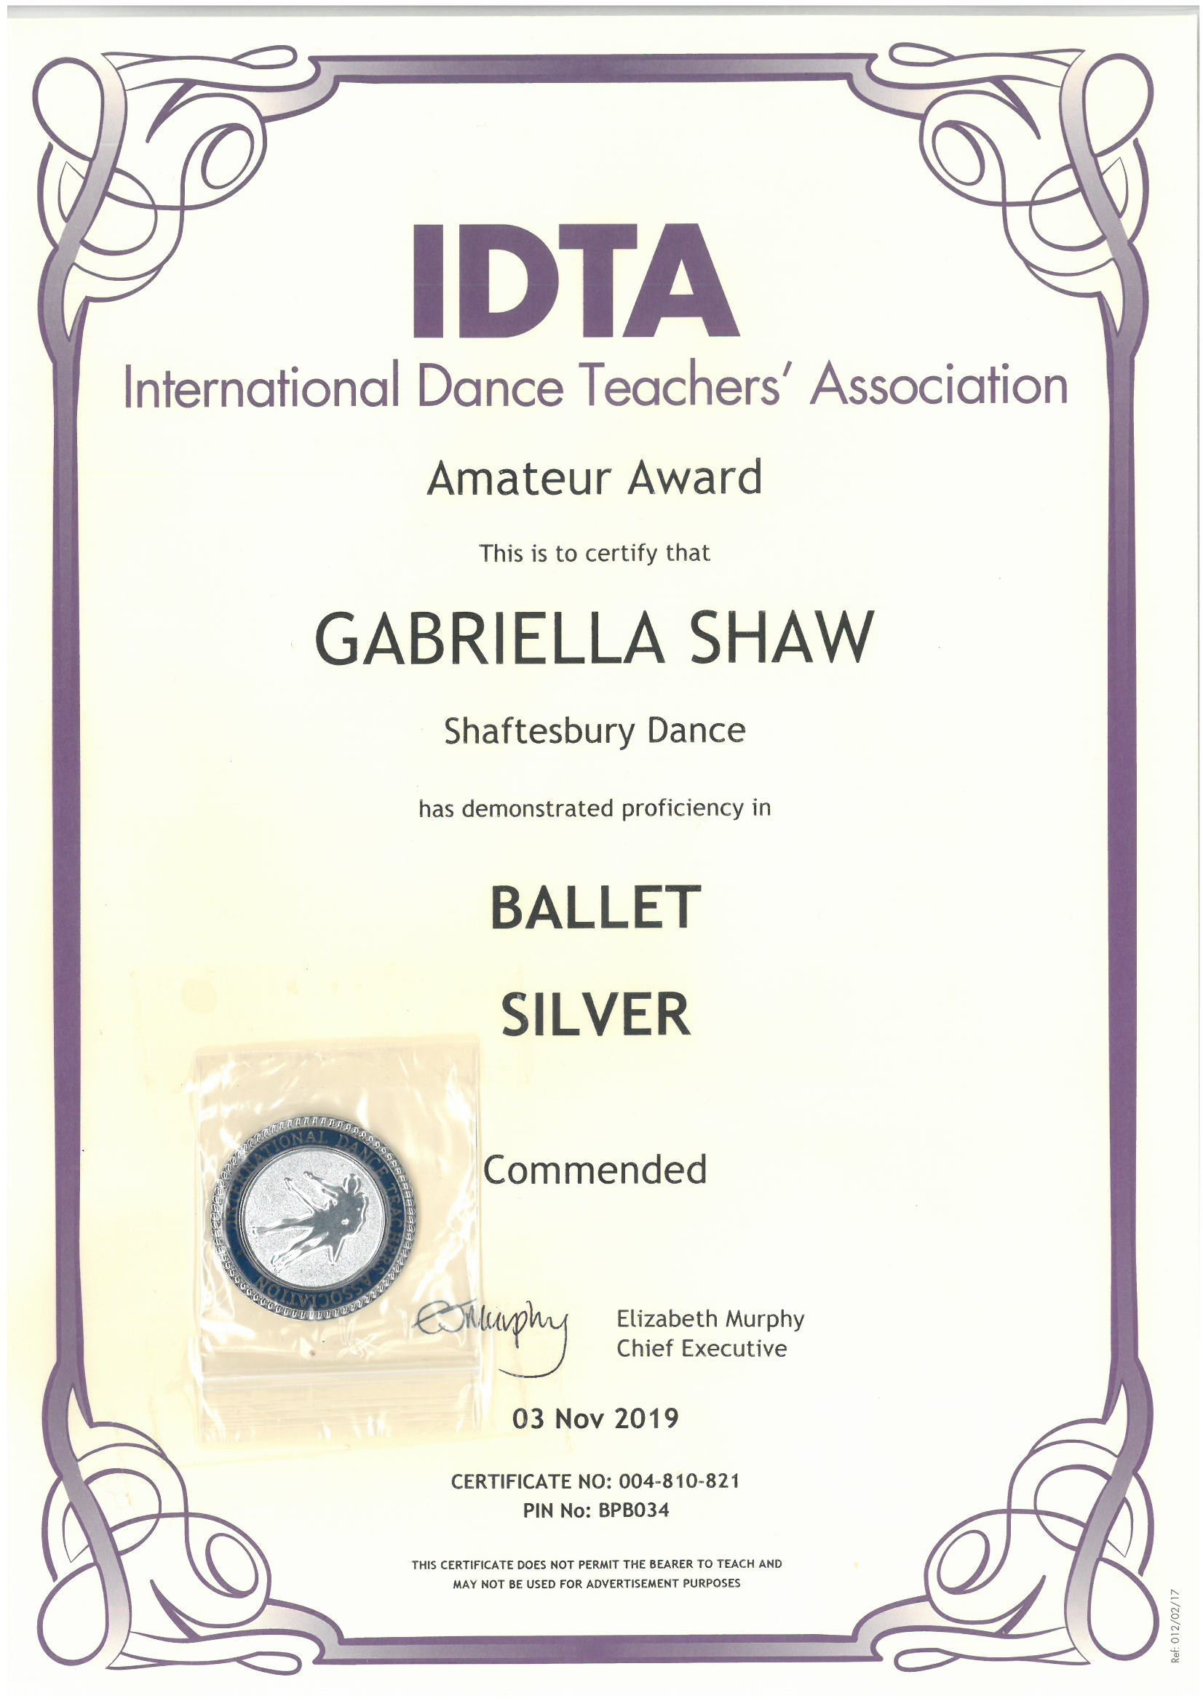

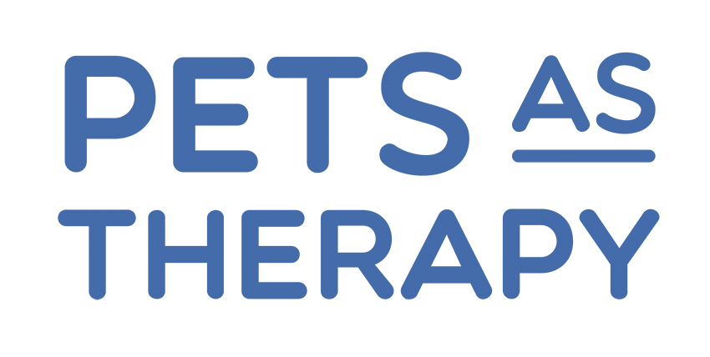
Next week the Marlfields Marlins are taking part in the Congleton Rotary Clubs annual Swimathon at Congleton Leisure Centre. The participants are being sponsored and some of all monies raised will go the the charities chosen by the Rotary Club and some will go to our chosen charity which we have decided will be Pets as Therapy.

A therapy dog is a dog that is trained to provide affection, comfort and support to people in hospitals, retirement homes, nursing homes, schools, libraries, hospices and/or disaster areas.
Research has shown therapy dogs can reduce stress and provide a sense of connection in difficult situations.
Given the impact therapy dogs can have on student well-being, schools are increasingly using therapy dogs as a way of providing social and emotional support for students. We think that this is an amazing charity and so thought it would be good to raise money to go towards training more of these dogs.
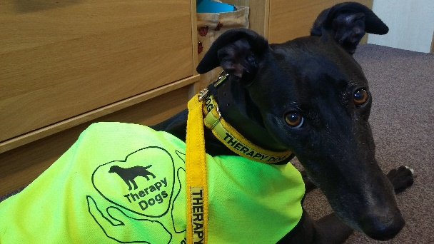
Your child may have told you about Coco, ‘our’ therapy dog, who comes in every other Friday to visit us with her owner Julie. Coco is loved by all the children who can’t wait for her visits.

P.T.O.

PARENTS EVENING

This term Parents’ Evenings will be held on:

Monday 10TH February 2020: 3:30 – 5:30pm & Wednesday 12th February 2020: 5:30 – 7:30pm

This is an opportunity for you to talk to the class teacher about your child’s work and progress. Each interview will last approximately 10 minutes. It is our intention to adhere to this time allocation wherever possible.

Parents Evening interviews are held in the School Hall; therefore to minimise disruption to the other parent/teacher interviews we ask that where possible you do not bring your child (ren) with you.

If you feel that you will need a longer interview please contact the class teacher to arrange an alternative time/date. Some classes may offer you alternate days / times due to the number of children in their particular class. If this is the case the class teacher will contact you.

Please select the day and time below which is most suitable for you and we will try our best to meet your needs.

For those of you with more than one child it would helpful if you could put all of your children’s names onto one form and return it to the teacher of your eldest child.

An appointment slip will then be returned to you giving you a specific allocated time.

……………………………………………………………………………………………………………

Please tick one box only and return to school
to your eldest child’s class teacher/by e-mail
by MONDAY 3rd FEBRUARY 2020

Children’s name/s ______________________________________ Class_______

______________________________________ Class _______

______________________________________ Class _______

Monday 10TH February 2020 Wednesday 12th February 2020
 | 3:30 – 4:00pm |  |  | 5:30 – 6:00pm
 | 4:00 – 4:30pm |  |  | 6:00 – 6:30pm
 | 4:30 – 5:00pm |  |  | 6:30 – 7:00pm
 | 5:00 – 5:30pm |  |  | 7:00 – 7:30pm

