 **REMINDER:**

School begins at **8:55am.**

The gates to the school driveway will be **locked from 9:00am and will be unlocked at 9:30am**.



**REMEMBRANCE DAY**

This week we focus on Remembrance Sunday. Remembrance Sunday and the symbol of the poppy recalls the end of the First World war, on the eleventh hour of the eleventh day of the eleventh month in 1918, the First World War ended.

Civilians wanted to remember the people who had given their lives for peace and freedom. An American War Secretary, Moina Michael, inspired by a poem by John McCrae began selling poppies to friends to raise money for the ex-Service community. And so the tradition began. With our armed forces in active service, we often see on the news the personal cost to individuals and families, it is important to take time to remember the sacrifice they have made and continue to make. As you know we are now a **‘BEACON PEACEFUL SCHOOL’** and this is our display in the Reception to mark the our success and the occasion and this years poppy appeal which reminds us of the need for peace in the world.

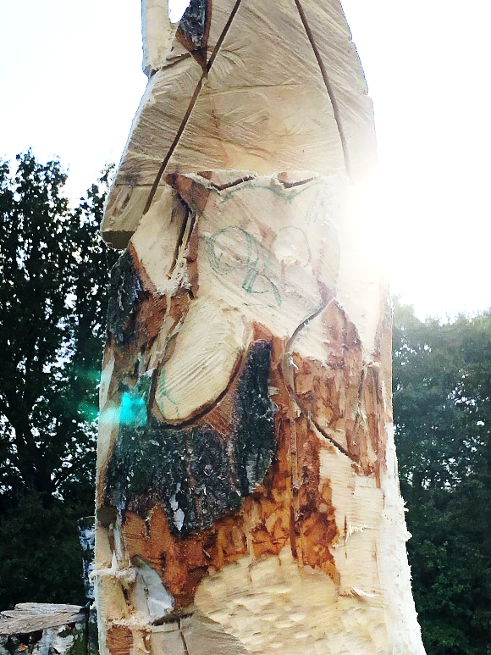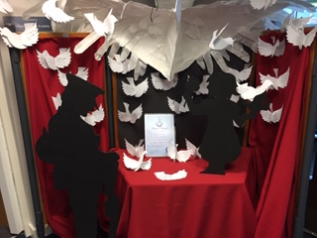

11th–15th November is National Anti-Bullying Week. The aim is for schools across England to shine a spotlight on bullying and encourage all children, teachers and parents to take action against bullying throughout the year.

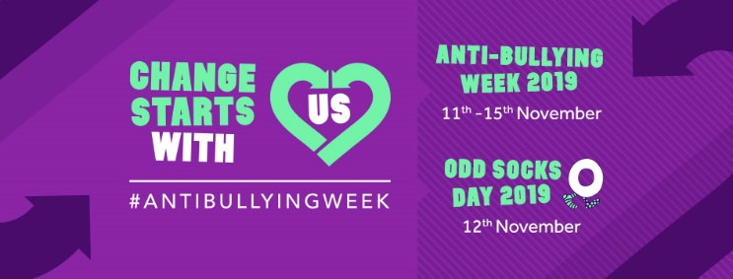This year we have decided to have a positive focus entitled **“Change starts with us”** to support our work during National Anti-Bullying week.

We will focus on ***peace*** and ***kindness*** as these are two of our school values that underpin our school rules and school ethos. During the week, the children will be taking part in a variety of activities designed to make children think about the importance of being kind and peaceful to others. We are including being kind to others on-line, on social media and on text messages. We remind you that there is a lot of useful information about E-Safety on our website and Cheshire East have also now developed an on-line resource to tackle bullying. The primary purpose of the new webpage is to provide information for parents to support their child if they are experiencing bullying at school or in the community. This includes links and advice for both children and their parents. If you are concerned about bullying or a situation at school we would encourage you to speak to your child’s class teacher in the first instance as this will be the best and most effective way of resolving any situation. Please visit:

<http://www.cheshireeast.gov.uk/livewell/staying-safe/community-safety/bullying/bully-free-cheshire-east.aspx>

**WOOD CARVING**

During our summer break you may have noticed that we had some trees removed. Now, you all know that at Marlfields we don’t like anything to go to waste, so we commissioned a wood carver to come along to create a work of art for everyone to enjoy! Please see below 3 stages of the carving.

**Stage 1: Stage 2:**

**The planning phase Nearly there**



**Stage 3:**

**Finished!**

we hope you are enjoying walking past the fantasitc tree house each day.

please contnue to watch the second tree as it will soon be transformed into something just as fantastic!

**Medicines in School**

If a doctor has prescribed medication to be administered 3 times a day, this can be completed at home without the need for it to be brought to school, administering doses before school, after school and at bedtime.

The school will only accept prescribed medication if the dose is shown as 4 times a day. We will not administer any non-prescribed medication ie Calpol, cough medicine etc. The office will look at any medications brought in on an individual basis and if the dose is able to be managed at home without the need to be in school this will not be accepted. We would draw your attention to our Medicines Policy: “Medicines are only accepted by Marlfields Primary Academy when essential: that is where it would be detrimental to a child’s health if the medicine were not administered during the school ‘day’. We only accept medicines that have been prescribed by a doctor, dentist, nurse prescriber or pharmacist prescriber”.

Medicines should always be provided in the original container as dispensed by a pharmacist and include the prescriber’s instructions for administration. This will include the child’s name, exact dosage and times to be taken. Medicines will be kept in a safe place according to the prescriber’s instructions”.

It would be preferable, where clinically appropriate, if medicines are prescribed in dose frequencies that enable them to be taken outside school hours. Parents are encouraged to ask the prescriber about this. In addition to this, if your child needs hay fever / allergy remedies, please administer these at home before bringing to school unless these are required when necessary.

**Caring for your child’s eyes**



Your child’s eyes are special. In the early years, vision helps children find out about the world around them, about their home, about you.

Later, as they go through school, their eyesight lets them learn and discover; in fact, about 80% of what is taught in schools is presented visually.

Being able to see clearly is therefore incredibly important in your child’s overall development. Most very young children have their eyesight assessed as part of their routine developmental checks. While these are very important, they are not as thorough as a complete eye test by a qualified optician.

Ensuring your child has their eyes tested as early as possible means that any problems that they may have are identified early, setting them up for a happy and fulfilling school life.

Young children may find it hard to explain the difficulties they are having with their eyesight and may not even be aware they have a problem at all.

Conditions such as squint and amblyopia (lazy eye) can be treated more effectively if they are picked up earlier and this could make a huge difference to your child. We recommend annual eye tests that are free on the NHS.

**SCHOOL CHRISTMAS TREAT – ‘THE GRINCH’**

On Friday next week, (15th), we will be enjoying our early Christmas treat where as a whole school we are off to watch ‘The Grinch’. This film will also support our work on being kind and how ‘Change starts with us’ as it was a young girl who helped The Grinch change his ways. We need to be at school for 8.30 am as the bus will leave promptly for us to be in our seats for 10am. Please note children who are late will not be waited for as the film will not wait. School lunch will be taken on return from the cinema which we estimate to be around 1pm back to school. School uniform must be worn.