THE GRINCH
As you are aware we took the children to the cinema in Altrincham for an early Christmas treat where we watched the film “The Grinch”. When we returned Mrs Isherwood received numerous Thank You letters from the children, please see a couple of samples below.
Jenson wrote:
“I am writing to you because what a good film it was we watched. We went on a coach, I sat next to Noah. I enjoyed the day because we watched The Grinch which was very funny.
My favourite part of the film was when Sindy-Lou invited the Grinch round for Christmas dinner.
Thank you again for a great day. It has made me feel super excited for Christmas.”

Oliver wrote:
“What a wonderful time we had at the cinema watching The Grinch. I enjoyed the drive down because me and Declan played Rock, Paper, Scissors and he won.
My favourite part of the film was when the Grinch took all the presents when Sindy-Lou caught the Grinch instead of Santa. Thank you again for an amazing day.”

A fantastic drawing of The Grinch by Isaac Bell, Yr 3.

VUE CINEMA VOUCHER
Please find attached to this newsletter a free voucher for the cinema for your child. They were given to us when we all went to see ‘The Grinch’ as a little extra surprise. With Frozen II and so many good films about to hit the cinema we hope you will use them as a pre-Christmas treat.

SUMMER READING CHALLENGE REWARD
“Fantastic”, “brilliant”, “awesome” were just some of the words the children used as they returned yesterday from their treat for completing the Summer Reading Challenge. Over 58 children went and Thank You to those parents who came to help as without you we would struggle to do such brilliant trips with the children.

CHRISTMAS LUNCH FORM – PAY NOW TO SECURE
We are having our Christmas lunch when we return from our Christingle Service (9:30am December 12th at St. Peter’s Church). If your child would like to join the rest of school for Christmas Dinner, please fill in the slip below for the 12th December and pay £2.20 into their Dolce School Grid payment app.

CHIRSTMAS SPECTATULAR DAY
Come and join us for a FANTASTIC & FREE Christmas Family Day on Monday 16th December!
There will be an INCREDIBLE SURPRISE for the children during the day.
There will be Bakes and Makes, Sing-a-Longs, a buffet Christmas lunch and so much more!
Even though the event is free, because we anticipate a huge volume of parents, we will be issuing tickets for people to attend which will be limited to 2 tickets per family.
Save the date in your diary!

CHRISTMAS LUNCH  CHILD’S NAME: _______________________________________  CLASS: ______  Would like to join in with the whole school Christmas Lunch.  I have paid £2.20 into his/her Dolce account.  Signed: _______________________________________  Parent/Carer |  | CHRISTMAS SPECTACULAR  CHILD’S NAME: _______________________________________  CLASS: ______  I / We would like ___________ tickets to attend the Christmas Spectacular day on Monday 16th December, and stay for a Buffet Lunch.  Signed: _______________________________________  Parent/Carer

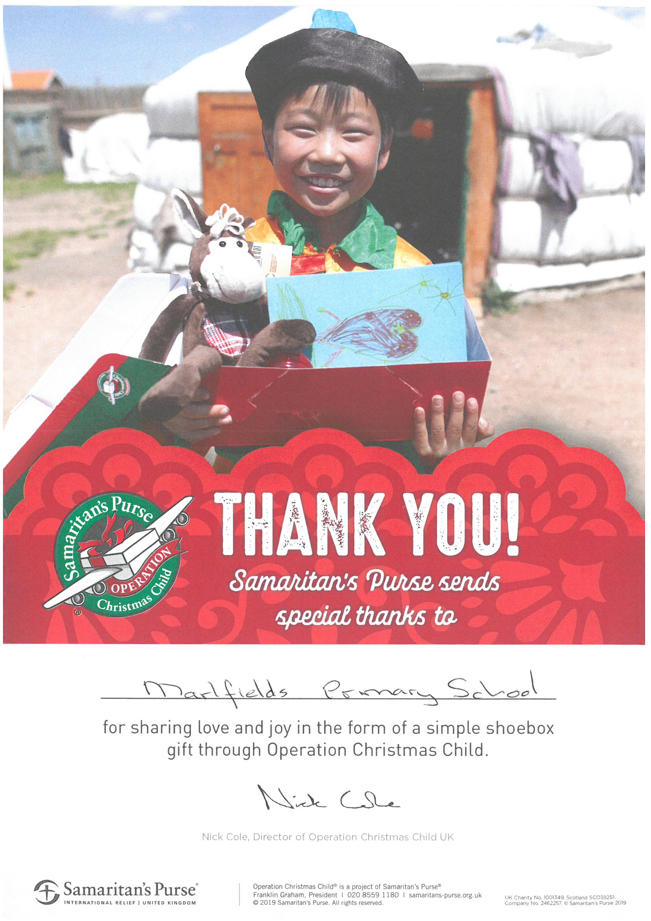

School have received this certificate in thanks for our contribution to the collection. Congleton has filled 1027 boxes for children in other countries which is a sign of Congleton being known as ‘The Little Town with the Big Heart!’

Thank you for helping us to fill the 22 boxes that we sent.

ATTENDANCE
The number of absences and late marks has become very concerning during this term. There have been a total of 4830 minutes lost due to lateness, which is 80.5 hours, or the equivalent of nearly 3 weeks’ of schooling. We are sure that you find this figure as shocking as we do and realise that we must all work together to ensure that your children have the best opportunities to learn.

We will be contacting all parents whose children’s absence or lateness is a cause for concern, to establish a way of improving their arrival time in school. Despite several nasty bugs that have hit across the school, a high number of absences are due to unauthorised holidays, or parents not informing us of illness. It is so important for your children to be in school as regularly as possible so that they can access their learning to their full potential. To those of you who have excellent attendance please remember that this will be rewarded! Please keep working hard at getting up and getting in now the cold weather is upon us!

HOME TASKS
Home tasks are an essential part of being a successful learner in life.
At Marlfields Primary Academy, we value Home Task work as it helps our children to practise and perfect their skills; as well as deepen their knowledge, understanding and skills through regular short bursts of repetitive tasks.
So, rather than completing all of a spelling or times table activity during one session (e.g. on a Saturday afternoon), doing a little task every day will help to retain learning better. Home tasks also gives parents/carers an idea of what your child is learning in school. We expect every child to:
- Read most nights for at least 10 minutes in Reception, up to 30 minutes in Year 6
- Practise spellings daily
- Learn ‘Maths Facts’ until they are known by heart
- Take advantage of learning internet-based app activities (IDL, TT Rockstars, etc.) for a short activity that can be daily or a few sessions over the week
- Complete additional Maths, English or topic-based activities over the half-term to contribute to class topic books
- Finish work that has not been completed due to choice in behaviour.

KS1 should be practising phonic sounds and key words at least three times a week
Year 6 pupils should be consolidating learning through their own English and Maths Revision Books.

We expect every parent to:
- Promote a love of reading: reading to your child, listening to your child read and talking about books that are read
- Sign the Home-School Planner to confirm what reading has taken place
- Check bags for letters and messages sent home
- Talk to your child about their learning in school and support them when necessary
- Check that any work not finished in school due to choice in behaviour has been completed and returned to school the following morning.

In creating this home task timetable, we have followed the Government’s guidelines of:
- Reception, Years 1 & 2 - 1 hour a week
- Years 3 & 4 - 1½ hours per week
- Years 5 & 6 – ½ an hour a day.

Please encourage and help your child to do their home tasks, you will be helping them to practise and extend the skills and knowledge learnt in school, whilst encouraging them to be an independent learner. Children whose parents get involved with their education will do better at school.

Top Tips
- Know how much home task your child should be doing at each stage of their education and make sure that they are doing this
- Be interested: ask your child what tasks they have been set and what they have learned
- Encourage your child to complete their home task sooner rather than leaving it to the last minute
- Encourage your child to improve on their home tasks; are there any ways they could make their work better?
- Provide a quiet space for them to do their home task, where there is no television
- It is very important to attend Parent Evenings, where teachers will show you how you can help your child succeed. The school will advise you when Parent Evenings are happening.
- If your child needed lots of support, or more challenge, please record this in their Home-School Planner
- Refer to our school website's class pages for further information and guidance.

SPORTING EVENTS
We hope to enter as many events as possible, but we may not always be able to due to lack of support from the children who commit and then do not turn up. Please, if your child is chosen to play for school, encourage them to do so as it important for the whole team. If you have a concern please can you let us know and we can then support improvements. Thank you.

Uniform/Lost Property
We already have a rising mountain of lost property which is not named. Please ensure that over the weekend all your child’s school clothes have their name in - this makes it possible for us to return it to them if they mislay it. This includes all PE kit as well as polo shirts, sweatshirts, trousers, skirts, coats etc. We understand how frustrating it is for parents when children lose their uniform, but if it isn’t named, it makes it very difficult to return it. Thank you for help in this!

Smoking
Can we please remind you that the whole of the school grounds is a no smoking zone - this applies to vapes as well as cigarettes. Thank you for your co-operation.

DATES FOR YOUR CHRISTMAS DIARY 2019

Wednesday 11th December  at 6:00pm | Years  1 & 2 | The Wriggly Nativity
Thursday 12th December  at 9:30am | ALL | Christingle Service at St. Peter’s Church  ---oOo---  Christmas Dinner Day
Friday 13th December  at 9:30pm | Nursery  &  Reception | Christmas Extravaganza
Monday 16th December  from 9:15am | WHOLE SCHOOL  ALL DAY  EVENT | CHRISTMAS SPECTATULAR  DAY IN SCHOOL  Parents invited to join us
Tuesday 17th December  9:00am | Nursery  & Reception | EYFS  CHRISTMAS SPECIAL
Wednesday 18th December  at 3:20pm | School breaks for CHRISTMAS!

Marlfields’ Holiday Dates
2019 -2020
School Closes School re-opens
Christmas | 18.12.19 | 06.01.20
Half Term | 14.02.20 | 24.02.20
Summer Term | 03.04.20 | 20.04.20
Early May Bank Holiday | Friday 8th May 2020
Half Term | 22.05.20 | 01.06.20
End of Term | 22.07.20 INSET DAY | 2 further INSET Days  to be alloctated

