SCHOOL GATES
We would like to remind you that the gates to the school driveway will be locked from 9:00am and will be unlocked at 9:30am.

Please do not block our neighbour’s access by parking in the slip road between school and the road.

Entrance onto school grounds/parking is restricted to staff and permit holders only.

SCHOOL DINNERS
Please do not to make payments onto the old payment system of Scopay for dinners, this is now only for snacks, uniform and trips, all dinner money must now be paid to Dolce.

If you have not received an email asking you to set up your Dolce account (check your junk folder) please call the office on 01260 633120 to ask for a password reset.

SCHOOL PHOTOGRAPHS
With this Newsletter you should receive your child’s individual/sibling photograph proof. The final date for you to return your order is 23rd October.

If putting cash in the envelope please ensure you include the correct amount as we are unable to give change, all payments should be made to Academy Photographers.

FILM replies
Thank you to everyone who has returned their slip and made payment on-line for your child to join us on the visit to the cinema to see The Grinch as a festive treat. However, we still need a great many more returned! Please send the completed form and pay your contribution of £3 towards the cost of the coach as soon as possible, and certainly before the end of next week so that we will be able to complete all the necessary paperwork involved with the insurance and the trip as a whole.

head lice
At the moment there seems to be quite a problem in school with head lice and we feel that the only way to deal with the issue is if everyone has their hair checked and then if necessary, treated at the same time. The weekend or even the forthcoming half term holiday would be the ideal time to do this. Please ensure that you check everyone in the family, grandparents included, and not just your school age child.

Please find overleaf a leaflet from the NHS on the recommended methods of prevention and treatment of head lice. The leaflet contains the current guidelines on the detection and treatment of head lice. Please try to follow the advice given, and check hair regularly. If we all work together on this problem, we might just win the war!

Head lice and nits
Head lice and nits are very common in young children and their families. They do not have anything to do with dirty hair and are picked up by head-to-head contact.

Check if it's head lice
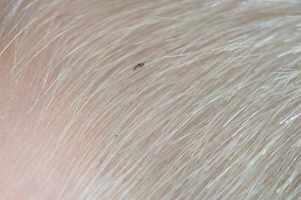  Head lice are small insects, up to 3mm long. | 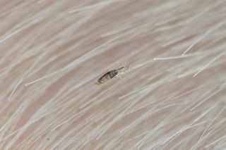  They can be difficult to spot in your hair. | 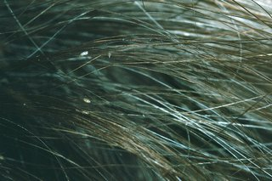  Head lice eggs (nits) are brown or white (empty shells) and attached to the hair.
Head lice can make your head feel itchy or like something is moving in your hair
The only way to be sure someone has head lice is by finding live lice. You can do this by combing their hair with a special fine-toothed comb (detection comb).

How to get rid of head lice

Important
You can treat head lice without seeing a GP.
- Treat head lice as soon as you spot them.
- You should check everyone in the house and start treating anyone who has head lice on the same day.
- There's no need to keep your child off school if they have head lice.

Wet combing
Lice and nits can be removed by wet combing. You should try this method first.
You can buy a special fine-toothed comb (detection comb) online or from pharmacies to remove head lice and nits.
There may be instructions on the pack, but usually you:
- wash hair with ordinary shampoo
- apply lots of conditioner (any conditioner will do)
- comb the whole head of hair, from the roots to the ends
It usually takes about 10 minutes to thoroughly comb short hair, and 20 to 30 minutes for long, frizzy or curly hair.
Do wet combing on days 1, 5, 9 and 13 to catch any newly hatched head lice.
Check again that everyone's hair is free of lice on day 17.

Medicated lotions and sprays
Ask a pharmacist for advice if you have tried wet combing for 17 days, but your child still has live head lice.
They may recommend using medicated lotions and sprays. These kill head lice in all types of hair, and you can buy them from pharmacies, supermarkets or online.
Head lice should die within a day. Some lotions and sprays come with a comb to remove dead lice and eggs.
Some treatments need to be repeated after a week to kill any newly hatched lice.
Check the pack to see if they're OK for you or your child and how to use them.
If lotions or sprays do not work, speak to a pharmacist about other treatments.
Some treatments are not recommended because they're unlikely to work.
For example: products containing permethrin or head lice "repellents", electric combs for head lice, tree and plant oil treatments, such as tea tree oil, eucalyptus oil and lavender oil herbal remedies.

You cannot prevent head lice
There's nothing you can do to prevent head lice. You can help stop them spreading by wet or dry combing regularly to catch them early.

