**HALF TERM HOLIDAY**

Don’t forget that we break for the Autumn half term holiday this week. We return on **TUESDAY 5th NOVEMBER.**

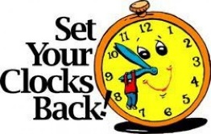The clocks go back an hour this weekend which means lighter mornings and darker nights.

If you are out and about either playing or ‘Trick or Treating’ please keep safe, and we will see you all on the 5th.

When we return to school please ensure that your child has with them a warm coat for playtimes.

**MORNINGS**

We have noticed that a few children are arriving at school as early as 8:10am!

May we just remind you that if your child comes to school super early the school playground is **NOT** supervised until **8:45am** and as such school cannot be held responsible should an accident/incident occur.

On the subject of children coming to school; if your child comes to school on a bike they **MUST** wear a helmet.

**REMINDER:**

School begins at **8:55am.**

The gates to the school driveway will be **locked from 9:00am and will be unlocked at**

**9:30am**.

Children arriving between these times should enter school using either of the two pedestrian walkways – up the road from the driveway or the path by the back of the Football Club from The Crescent / The Westlands.

**Entrance onto school grounds/parking is restricted to staff and permit holders only.**

**Parents should not use the staff car park for their own convenience.**

**SCHOOL DINNERS**

There are still a handful of parents who are making payments onto the old system of Scopay for their child’s dinners.

**PLEASE ONLY PAY FOR DINNERS ON THE DOLCE APP**.

May we also remind you that if you have pre-ordered a lunch for your child who is subsequently absent you will need to go on-line to cancel the order or you will be charged for that meal.

**Scopay** is only now to be used for snacks, trips, uniform orders or special events; this ensures that payments are allocated instantly to your child’s account and for the specific item, thus avoiding any confusion.

Please remember that Marlfields is now a **‘cashless school’**.

**CHRISTMAS SHOE BOX APPEAL**

Sincere thanks to everyone who donated items for us to include into our shoe boxes for those children less fortunate than our own. We have managed to fill 20 boxes which will now go off to New Life Church for distribution. Thank you all once again.

**CELEBRATION!**

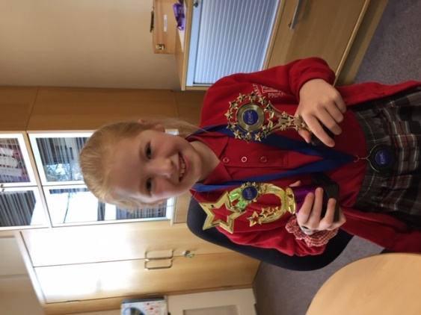This week we celebrate with Emily Campbell-Wood who proudly came in on Monday to show us the wonderful trophies recently won in dance competitions in Preston and Blackpool.

Her next competition is in December in Liverpool.

**Good luck Emily! “Keeeeep Dancing!”**

**PLANT UP DAY**

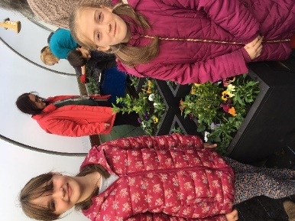Last Saturday, Mia Wilde and Gaby Shaw very kindly gave up part of their morning to represent Marlfields at the Congleton In Bloom annual ‘Winter Plant Up’ of the tubs which adorn the town centre. Thank you girls (and parents) for giving up your free time. You’ve done us proud, as always!

**New Child and Adolescent Mental Health website for young people, parents/carers and teachers across Cheshire and Wirral**

Cheshire and Wirral Partnership NHS Foundation Trust’s (CWP) nationally recognised Child and Adolescent Mental Health website **MyMind** has been refreshed and relaunched!

[**Visit www.MyMind.org.uk**](bit.ly/35g7c1F)

MyMind is our dedicated website for young people across Cheshire and Wirral experiencing mental health difficulties. With support from local young people from our Child and Adolescent Mental Health Services (CAMHS), MyMind has now been given a modern makeover!

MyMind 2.0 provides advice and guidance around the key topics identified as most important to young people and their families: how to cope with mental health challenges, how to get help and what to do in a crisis.

The site includes a host of interactive self-help resources for young people, parents/carers and anyone who works with young people around the topics of Mood, Lifestyle and Relationships, as well as details on local mental health services in your area.

Originally launched in 2011, MyMind has won a litany of accolades over the years (including Health Service Journal Value in Healthcare and Positive Practice in Mental Health Awards) and been accessed by hundreds of thousands of people across the region and beyond.

