Marlfields’ Newsletter

16th February 2024

ROTARY CLUB PHOTOGRAPHY COMPETITION

Earlier in the year all schools in Congleton were challenged to capture a photograph based on the theme ‘buildings in harmony with nature’, as always, the children at Marlfields rose to the challenge.

On Monday of this week, two representatives from Congleton’s Rotary Club came in to award the children who took part for their amazing effort and every child who participated was given a certificate.

The best three pieces were chosen, and they won amazing gift vouchers to spend! Thank you again to the Rotary club for organising such a wonderful competition and we look forward to welcoming you back to our school. Here is a picture of the three ’winners’, and one of everyone who took part. You are all winners to us!

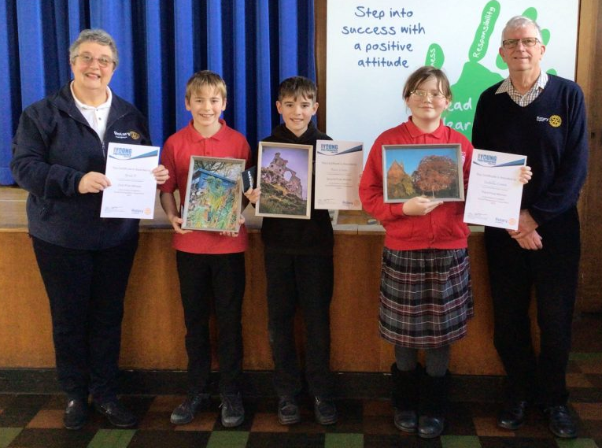
Well done all of you and thank you for taking part and representing Marlfields.
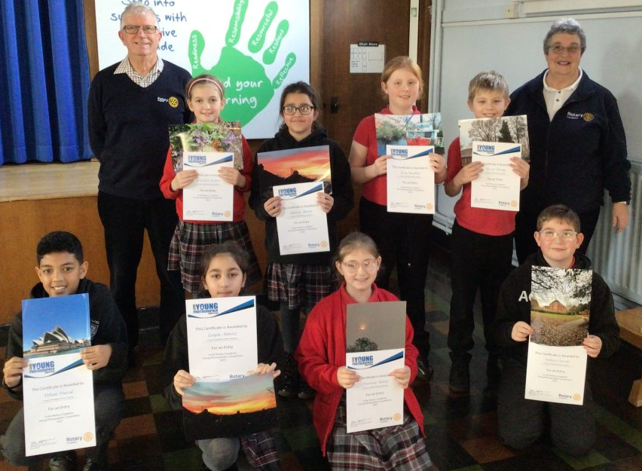

DINNERS

Please find below the menu for lunches week beginning 4th March.

Please return your choices via e-mail by 5:00pm on Monday 26th February.

MONDAY |  | TUESDAY |  | WEDNESDAY |  | THURSDAY |  | FRIDAY
Fish &  Chips | Macaroni Cheese | Roast Beef | Potato, Cheese & Leek Bake | Chicken Goujons | Meat Free Mushroom & ‘Chicken’ Style Pie | Steak Pie | Vegetarian Sausage Casserole | Beef Chilli | Bean Chilli
Vegetables, bread and a dessert are served each day

Around the classes

EARLY YEARS - I wonder what moves?…. Dinosaurs!

This half term the children in Early Years have been using Dinosaurs as a theme for their learning.
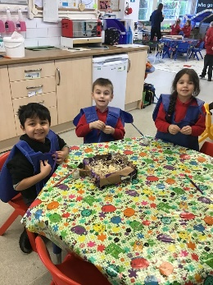
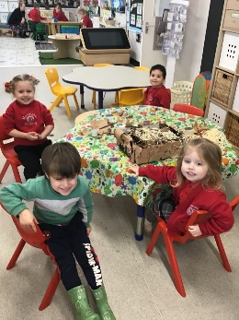
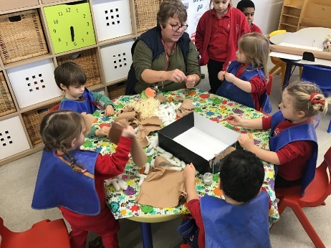
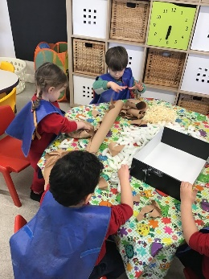
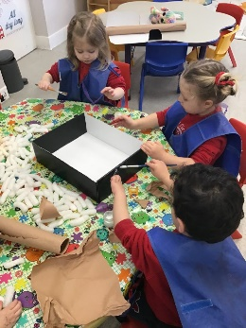
The children started their topic by discovering a dinosaur egg in our sand pit. The children worked together to make nests for the dinosaur egg.
The children have learnt about the different types of dinosaurs and what environments they liked to live in. The children created representations of different dinosaurs using their colour mixing skills to create the colours they wanted.

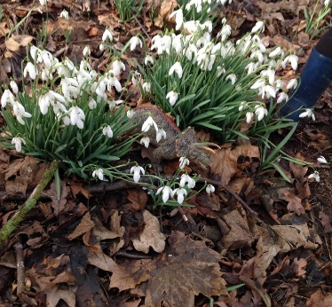
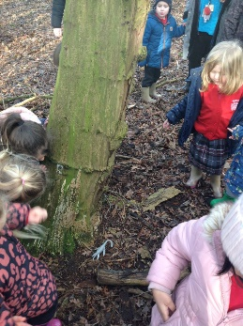
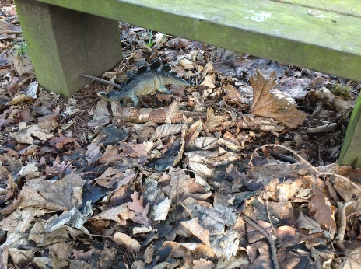
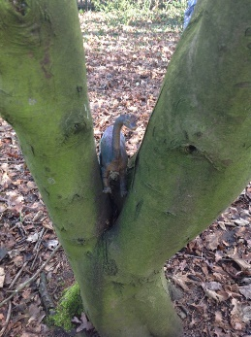
The children finished the topic with a Dinosaur Hunt in our school woods. The Dinosaurs were hiding in a variety of different places, in the tree, behind the tree, under the bench, next to the tree, in the flowers.

The children have really enjoyed the learning through Dinosaurs! It has really captured their imagination.

Year 1 - Science
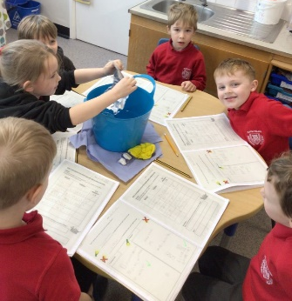
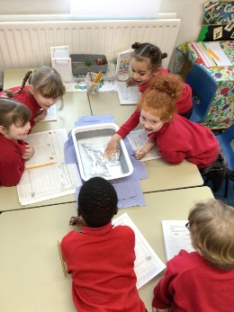
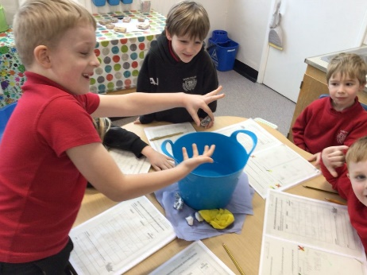
This week the children conducted an experiment looking at which material was the most absorbent. The children decided that fabric is the best material to soak up any spillages!

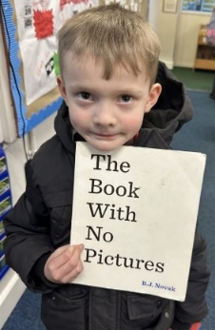
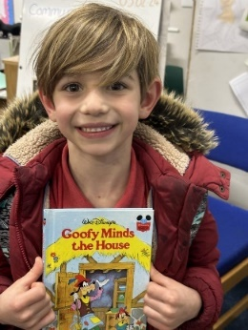
YEAR 2 - Reading
In Year 2 they all love books. Any book. The children have been bringing in their favourite books from home for everyone to share. ‘The Book with No Pictures’ was very, very funny!
They all enjoyed showing their favourite reads to their friends and couldn’t wait to have a look at what made them so interesting. Do you like to read? What is your favourite book?

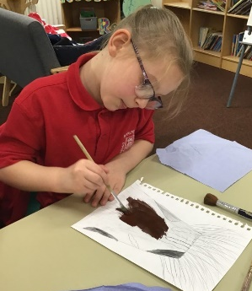
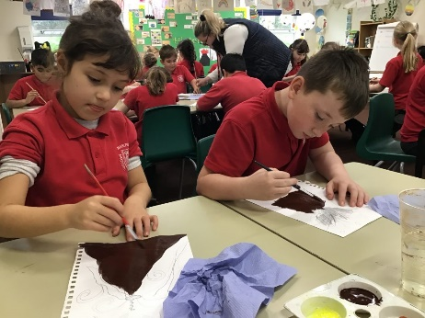
YEAR 3 - Volcano Eruptions
Year 3 have been learning about volcanoes as part of our topic and as part of Art we have painted a background and painted a volcano which we will cut out and mount on the background. This is a process called layering.

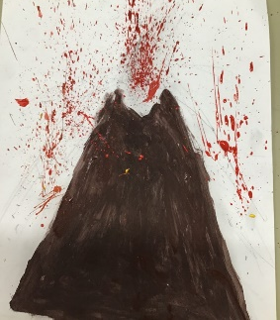
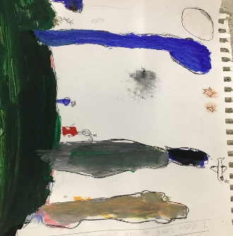
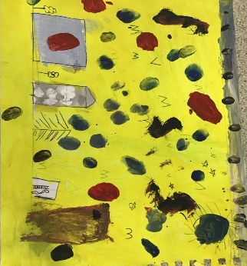
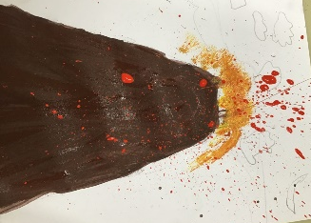

YEAR 4 - Chinese New Year Celebrations
In Year 4 the children have been learning all about China and with last Saturday being Chinese New Year, on Friday, they enjoyed a small festivity during the afternoon and had an artistic style Chinese New Year celebration.
The children read about the origins of the Chinese New Year, where the 12 animals of the zodiac had a race to see who would lead which years. They then looked at the celebration for the end of the Year of the Rabbit and welcomed in this year, the Year of the Dragon.

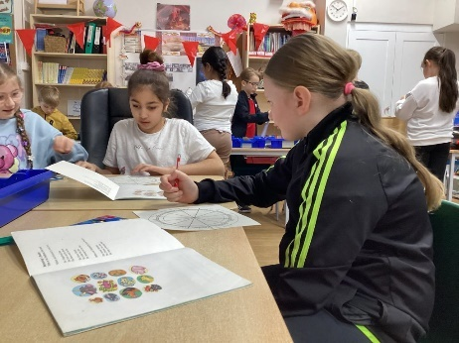
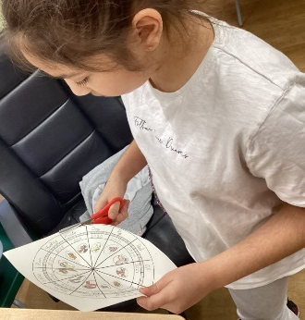
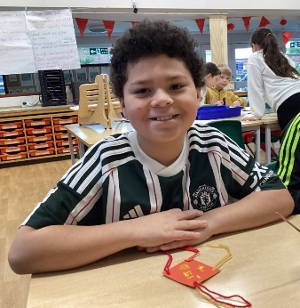
To celebrate the children then created their own Chinese dragons as well as creating a zodiac wheel (they found out some of them are the Year of the Horse and some are the Year of the Ram).
They then created their own good luck charms using their calligraphy skills to create the word ‘luck’ in Chinese. To finish off the activities, they had their usual Friday Celebration and had a fortune cookie.

YEAR 5 / 6 - Football
Report by Reece Coates

On Wednesday 14th February our team took part in some Year 5 & 6 School League matches.
We won one game out of three. In the first game, against St. Mary’s we battled well, but unfortunately lost the match 2 – 1. Next, we played Buglawton, the first half was very intense, with both teams having countless shots but not scoring any goals. In the second half we played excellently, with me, Reece, playing a pass through to Jayden from which he then got onto the score sheet. After the goal, we played on, and Jayden scored once more.

We then got to play our hardest match yet, versus The Quinta.
Straight after kick-off they got through our defence and scored. I (Reece) changed position and got moved back to midfield after the opposition scored again.

At half time, Harry gave us a team talk, the second half began, and we got through their defence, but their keeper pulled off a fabulous save. Quinta scored yet again to make the score 3 - 0. We kept on working hard, Blake used some brilliant skill to slip the ball through the legs of the opposition, he took a shot, the ball hit their keeper on the leg, resulting in an own goal.
Harry congratulated us on playing so well; we are all excited and looking forward to the next fixtures, which will be on 14th March.

HALF TERM HOLIDAY
School breaks up today for the February Half Term Holiday.
Children return to school on Tuesday 27th February, (Monday 26th being a staff training day),

We hope you all have a good break and that the weather stays fine to enable you to be able to get out and about. Enjoy yourselves!

HOLIDAY DATES
Academic Year 2023 - 2024
 | SCHOOL OPENS  FOR CHILDREN | SCHOOL CLOSES  FOR CHILDREN
Autumn 1 | 05.09.2023 | 20.10.2023
Half Term
Autumn 2 | 31.10.2023 | 21.12.2023
Christmas Holidays
Spring 1 2024 | 08.01.2024 | 16.02.2024
Half Term
Spring 2 | 27.02.2024 | 28.03.2024
Easter Holidays
Summer 1 | 15.04.2024 | 24.05.2024
May Day Bank Holiday – 06.05.2024
Half Term
Summer 2 | 04.06.2024 | 23.07.2024
INSET DAYS
04.09.2023 30.10.2023 22.12.2023
26.02.2024 03.06.2024

HOLIDAY DATES
Academic Year 2024 - 2025
2025 | SCHOOL OPENS  FOR CHILDREN | SCHOOL CLOSES  FOR CHILDREN
Autumn 1 | 03.09.24 | 25.10.24
Half Term
Autumn 2 | 04.11.24 | 20.12.24
CHRISTMAS HOLIDAY
Spring 1 | 06.01.25 | 14.02.25
Half Term
Spring 2 | 25.02.25 | 04.04.25
EASTER HOLIDAY
Summer 1 | 22.04.25 | 23.05.25
May Day Bank Holiday – 05.05.2024
Half Term
Summer 2 | 03.06.25 | 22.07.25
INSET DAYS
02.09.24 04.11.24 06.01.25 24.02.25
02.06.25

