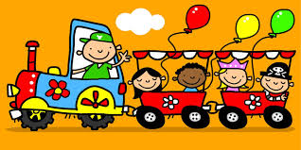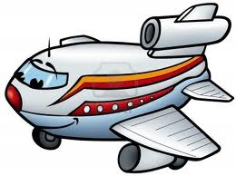

***Wheels, Wings, and Other Things***



***I wonder what can***

**Physical Development**

Transport mimes – getting on a train/into a boat/in a car

Movements based on vehicles

Follow my leader

Stop/go games using traffic light colours

Positional games

Fast/slow games based on modes of transport

Construction kits

Make tracks with footprints

Set up an obstacle course to travel along

Action songs

**Communication & Language**

**Literacy**

Photographs of different types of transport

Role play- garage/carwash/train station/travel agents/airport check in

Small world road and track layouts

Collection of holiday postcards

Story making – a magic carpet ride/a hot air balloon ride/ a ride on a broomstick

Circle time

Memory and list games – ‘I packed my bag and in it I put…’

Audio resources of traffic sounds

Songs and rhymes

Books – fiction and non-fiction

Play writing opportunities –lists/letters/postcards/passports/tickets

Make tickets for train/plane/bus journeys

**Personal, Social & Emotional Development**

Road safety

Small world road and track activities

Discuss personal journeys the children have been on

Use chairs to be an impromptu bus/plane/car/train

Healthy and eco ways of travelling – walking, biking, public transport

Act out unusual ways to travel, e.g. Magic carpet/hot air balloon

Circle time

Role play- garage/carwash/train station/travel agents/airport check in

Large cardboard boxes/packing crates can be transformed into any vehicle

Rescue vehicles – ambulance/fire engine/helicopter/life boat

**Transport Books**

Cars, Boats, Trains and Planes, published by Collin. Rosie’s Walk, by Pat Hutchin. Mr Gumpy’s Motor Car & Mr Grumpy’s Outing, by John Burningham. Please Don’t Chat to the Bus Driver, by Shem Reddie. The Train Ride, by June Grebbin. Whatever Next, by Jill Murphy. The Naughty Bus by Jan Oke.

**Expressive Arts & Design**

Tyre prints/rubbings

Painting with wheels

3D models of vehicles

Floating music and hot air balloons

Songs and rhymes

Book collections about single types of transport e.g. stories about cars

Selection of large cardboard boxes for imaginative play

Imitate vehicle sounds with musical instruments

Collection of audio resources – vehicle sounds

Making postcards

Dressing up in uniforms

Make paper aeroplanes

Body sounds and rhythms

**Mathematics**

Data handling – how do we come to school?

Data handling – monitor traffic – record as bar charts/pictograms

Positional words and games

Maths trails – follow the tracks

Sorting vehicles

Songs and rhymes

Role play- garage/carwash/train station/travel agents/airport check in

Making 3D models of vehicles

Count down for a rocket launch

Using money in role play – e.g. buying tickets

Make paper aeroplanes

**Understanding the World**

Map making – which way do you come to school?

Collection of maps to investigate

Compare past and present transport

Collection of tickets from different modes of transport

Directions games and stop-go games

Outdoor play – homemade water ways with sections of plastic guttering

Outdoor play – old car tyres to roll around

Wet sand tray – tracks

Water tray – boats

Road safety

Visit from lorry company/local garage Visit airport / Science & Industry Museum

Take a bike apart using spanners, screwdrivers etc.