**Marlfields Newsletter**

**9th February 2024**

# [**Terracotta Army**](https://blog.marlfieldsprimary.co.uk/year-4-art-terracotta-army/)

Mr. Price and his Class have continued into their journey into the past of ancient China by exploring the tomb of the first Emperor of China and his Terracotta Army.

[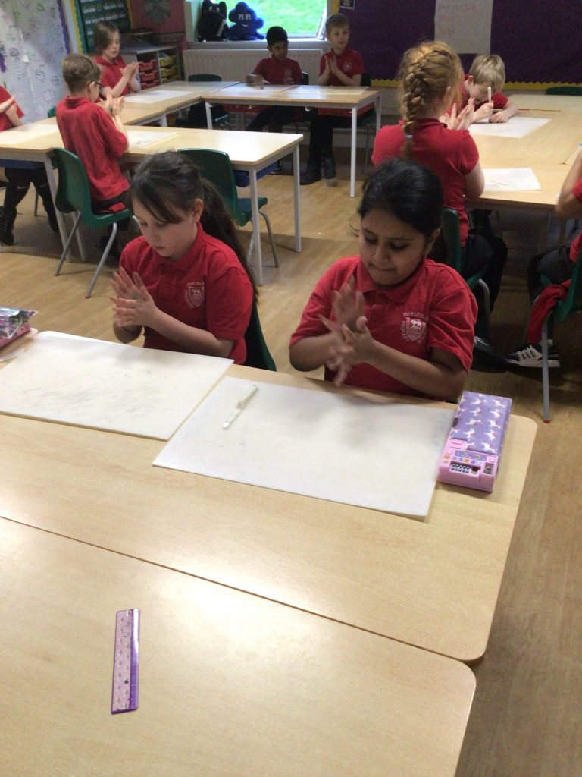](https://blog.marlfieldsprimary.co.uk/wp-content/uploads/2024/02/F7E86D02-E2E1-4978-B889-E1B68A54EB2C-scaled.jpeg)After exploring the 8000 soldiers and nearly 1000 horses and chariots the children then spent some time making their own replica terracotta soldiers.

They began by practicing the art of manipulating clay to make smaller designs and intricate makings on a smaller piece before creating our soldier.

](https://blog.marlfieldsprimary.co.uk/wp-content/uploads/2024/02/C5ED2A05-2835-4697-92A2-04D89BB47612-scaled.jpeg)Once they had practiced using different tools and techniques to model and manipulate the clay, the children were then given a larger piece of clay which they would use to begin moulding into their terracotta soldier.

Once the children had created and added details to their soldiers, they then left them to dry and become the Year 4 Terracotta Army.

](https://blog.marlfieldsprimary.co.uk/wp-content/uploads/2024/02/1AD0B26D-65CE-4F83-8604-6E1D6E33C8DA-scaled.jpeg)

](https://blog.marlfieldsprimary.co.uk/wp-content/uploads/2024/02/7DAEDB1A-B6B4-4313-8B99-E6D032758F99-scaled.jpeg)

**BLUE PETER BADGE**

Here we have two very happy boys receiving their Reading Badge from Blue Peter; Aiden in Yr 6 and his brother  
Arthur in Yr 3.  
It is the first badge for Arthur and as you can see, he is **very** proud of his award, as is Aiden!

# [**World Religions – Passover Meal**](https://blog.marlfieldsprimary.co.uk/year-4-world-religions-passover-meal/)

](https://blog.marlfieldsprimary.co.uk/wp-content/uploads/2024/02/IMG_5792-scaled.jpg)The children in Year 4 have been learning about the festival of Passover which the Jewish community celebrate each year - they sit down and eat from the Seder plate which represents the story of Exodus and the 10 plagues of Egypt.

](https://blog.marlfieldsprimary.co.uk/wp-content/uploads/2024/02/IMG_5796-scaled.jpg)Each of the food represents different parts of the story of Exodus:  
**Egg**: New birth and new start for the Hebrews future.  
**Charoset**: The bricks and mortar which the Hebrews had to build for Pharaoh.

**Bitter Herbs:** Represent the tears of the slaves.  
**Lamb Shank Bone:** The blood put above the doors to save the first born.  
**Horseradish:** The suffering and the pain of the Hebrews.  
**Unleavened bread:** The bread cooked under

the heat of the sun as the Jews escaped Egypt.

Each child was given their own Seder plate to try the different foods

in their own Passover festival.

**CURRENT ILLNESSES**

**HEADLICE** still remain prevalent. Treatment can take up to three weeks to be effective, as lice/eggs are at different stages. In between using the proprietary lotions, you also need to use a fine-toothed comb at least once a day to help with the removal of these annoying creatures.

**SICKNESS & DIARRHOEA** has been the reason for several children not being in school this week. If your child is unfortunate enough to get this, please remember that you MUST keep them at home for 48 hours after the last bout of sickness/stool.

**CHICKENPOX** is still around, though fortunately not as many cases. Again, stay off school until all the blisters have crusted over.

**HALF TERM HOLIDAY**

Don’t forget that school breaks up for the February half term holiday next Friday, at the usual time of 3:20pm.

We will re-open for the children on **Tuesday 27th February,** Monday 26th being an INSET Day for staff training.

|  |  |  |  |  |  |  |
| --- | --- | --- | --- | --- | --- | --- |
| **HOLIDAY DATES**  **Academic Year 2023 - 2024** | | |  | **HOLIDAY DATES**  **Academic Year 2024 - 2025** | | |
| **2024** | **SCHOOL OPENS**  **FOR CHILDREN** | **SCHOOL CLOSES**  **FOR CHILDREN** |  | **2025** | **SCHOOL OPENS**  **FOR CHILDREN** | **SCHOOL CLOSES**  **FOR CHILDREN** |
| **Spring 1** | **08.01.2024** | **16.02.2024** |  | **Autumn 1** | **03.09.24** | **25.10.24** |
| **Half Term** | | |  | **Half Term** | | |
| **Spring 2** | **27.02.24** | **28.03.24** |  | **Autumn 2** | **04.11.24** | **20.12.24** |
| **EASTER HOLIDAY** | | |  | **CHRISTMAS HOLIDAY** | | |
| **Summer 1** | **15.04.24** | **24.05.24** |  | **Spring 1** | **06.01.25** | **14.02.25** |
| **Half Term Half Term** | | |  | **Half Term** | | |
| **Summer 2** | **04.06.24** | **23.07.24** |  | **Spring 2** | **25.02.25** | **04.04.25** |
| **Holiday list for this Academic**  **Year and the NEXT Academic**  **Year for your information.** | | |  | **EASTER HOLIDAY** | | |
|  | **Summer 1** | **22.04.25** | **23.05.25** |
|  | **Half Term** | | |
|  | **Summer 2** | **03.06.25** | **22.06.07.25** |
| **INSET DAYS**  **02.09.24 04.11.24 06.01.25 24.02.25**  **02.06.25** | | |

**DINNERS**

Please find below the menu for lunches **week beginning 26th February**.

Please return your choices via e-mail by **5:00pm on Monday 12th February.**

**Dinners W/B  26.02.24**

**Child’s Name:                                                                    Class:**

|  |  |  |  |  |  |  |  |  |
| --- | --- | --- | --- | --- | --- | --- | --- | --- |
| **MON** | **TUES** | | **WEDNES** | | **THURS** | | **FRI** | |
| **INSET DAY** | **Beef Bolognaise** | **Penne Pasta with tomato and basil sauce** | **Cottage**  **Pie** | **Vegetarian**  **Cottage Pie** | **Chicken**  **Korma** | **Vegetarian Tikka Masala** | **Fish &**  **Chips** | **Vegetable Lasagna** |
| **Vegetables and Dessert are served each day** | | | | | | | | |

**GATES TO THE STAFF CAR PARK**

Just to remind you, that in the next few weeks we will be having automatic gates at the entrance to the staff car park.

This is due to new regulations regarding school security.

This will mean that other than staff cars, children in the Resource Provision, deliveries etc there will be no other vehicular or pedestrian access this way.

As we are aware this is scheduled, weather permitting to start week beginning 4th March.

**HARRY POTTER STUDIO TOUR**

This year we have challenged our child to go above and beyond without being asked by us or yourselves in their learning behaviour. They have had a challenge to read fifty of the one hundred recommended reads for their year group, keeping their passport up to date. Two children have already read thirty – keep going everyone! One of the rewards for this will be a trip to Harry Potter Studio. We have 50 seats and at yesterday’s assembly some were given out. As the time draws near, if you child has secured one of the seats, we will be sending further information. Please encourage your child to take responsibility for their own learning at home and in school. Remember you must be in it to win it, and we are watching all week!

**WORLD BOOK DAY**

SAVE THE DATE - World Book Day is March 7th. Each child will receive a free book token to enable them to choose a book from this years’ list.

