**Marlfields’ Newsletter**

**12th January 2024**

Is it really already the 12th? Where has the time gone?

Christmas seems so far away; however, we hope that you all had a great time and kept well over Christmas and the New Year and are looking forward to the joys (and trials and tribulations) that 2024 probably has in store for us all!

**CONGRATULATIONS**

Please join us in congratulating Valentina from Year 3, and Jacob and Ryan from Year 2, who received notification in the school holidays that they had won the Blue Peter Book Badge.

Well done, all of you, we are so proud of you. Keep up the good work. Please remember we are asking all children to work to get this badge by World Book day in March, where those children who do can be celebrated and rewarded. If you still want to do this and join in please visit the Blue Peter website to complete the form, it is easy to do.

If your child has anything to celebrate and would like to share with the whole school community, please send us a picture and details of what is being celebrated and we will include it on the next Newsletter.

**INCLEMENT WEATHER**

Snow has been forecast for next week, in the event that it does, as always, we will do our utmost to keep school open. Should we need to **close** during the school day **we will text/e-mail/send Dojo messages** out asking you to collect your child(ren) early. *(Please ensure that all of your contact details are up to date, especially if you have changed your phone number*).

If there is a heavy snowfall during the night and we are unable to open because staff are unable to get into school safely, we will **text/e-mail/send Dojo messages** and make an announcement on local radio - ***SIGNAL RADIO 96.4 FM / SILK RADIO 106.9FM / RADIO STOKE 94.6FM.***

Please ensure that your child has a **warm, waterproof coat with them each day** for outdoor play. The children should also wear **sturdy sensible shoes** to keep feet dry and to provide a decent grip on potentially icy pathways to and from school. We also urge you all to **keep to the Gritting Plan** when on school grounds, a copy of which is on each gate. This shows you the routes around school that have been gritted and are safer to use.

**NEW LOOK**

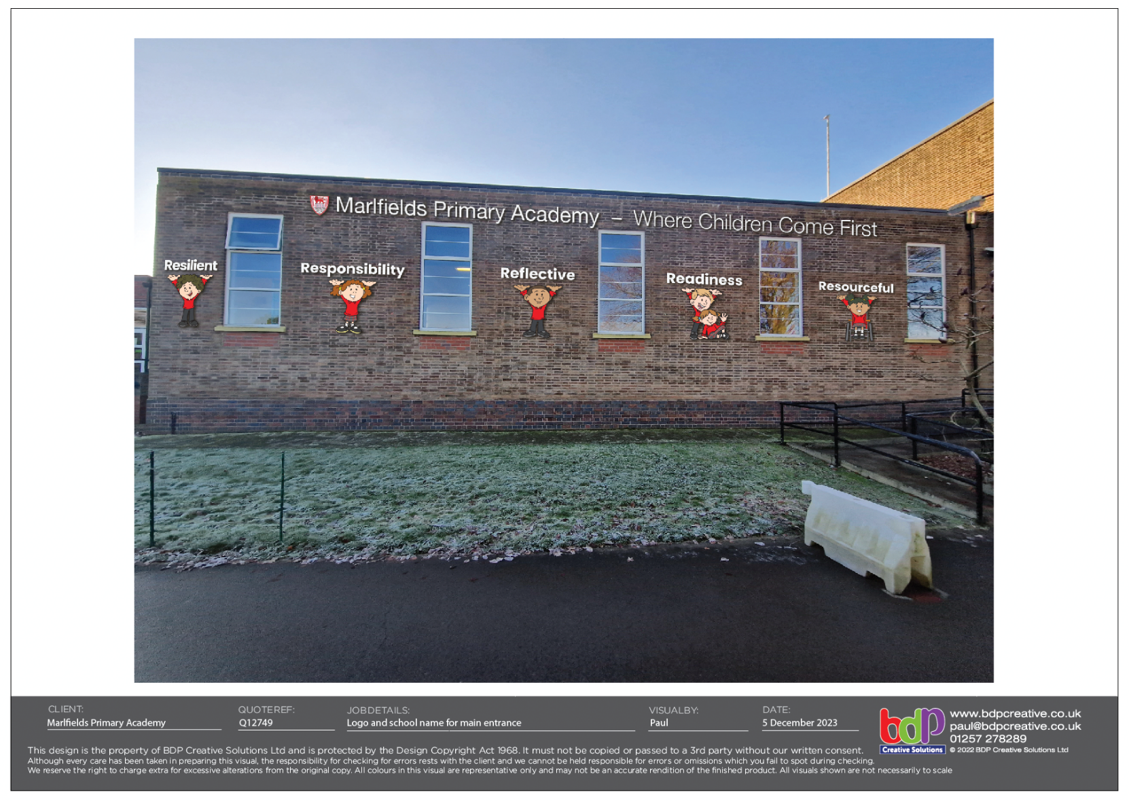This week, the front of the building has had a bit of a makeover.

As you can see from the photograph, it looks much brighter – better than just drab brickwork! We think that it makes us look more like a school and not just a building.

Keep your eyes open for more ‘brightening up’ around the building over the next few weeks.

**RECYCLING SPECTACLES**

You know how we always like to help other people and charities. Our latest project is collecting old glasses.

We have been asked by the local branch of Lions International (Congleton Branch) to collect spectacles which are no longer needed. They will be taken to be recycled and sent to other countries to improve the eyesight of children and adults in other countries.

If you have any glasses lurking around in the back of a drawer that you no longer need, please consider bringing them in to the office at school, where there is a collection bin.

Thank you in anticipation.

**DINNERS**

Many, many thanks for your co-operation and understanding during this week’s dinner situation. Hopefully the new catering situation will be in place in time for next week

Children in Reception Class, Year 1 and Year 2 will still be eligible to Universal Infant Free School Meals, children in receipt of income-related Free School Meals will continue to receive these, which means that there will be nothing to pay.

Everyone else will have to pay **£3.00** **per day / £15 per week** which will be payable on **SCOPAY**. You will be able to order lunches in advance as before, also on SCOPAY.

With the new system meals **MUST** be pre-ordered. We will only be preparing food that is pre-ordered and no extras.

On Monday we e-mailed out an allergy sheet to everyone. Even if your child doesn’t have any food allergies/intolerances, it is important that your return the form for our records. Especially if you are going to take up the offer below. If you are struggling to complete the Food Allergy Form please call the office who will be happy to help.

To thank you for your support, and to enable the children to see for themselves what the food is like we are offering the children a **FREE** lunch on Monday. We will send home a form today with your child to enable them to choose what they would like to try. Please return the slip on Monday morning or e-mail the office with their choice of a **FREE LUNCH**.

**P.E. KITS**

Please remember to always have P.E. kits in school from Mondays, only taking them home on a Friday to be freshened up.

**CURRENT HEALTH ISSUES**

**Chicken Pox**: We are still receiving notification of a number of children with Chicken Pox.

If your child contracts the virus, you should keep them off school until each spot has scabbed. Once this is the case, they can return to school.

**Head Lice:** We have not yet had any cases reported, but please stay vigilant, and check your child’s hair regularly for any signs of live lice of their egg cases (nits).

**PARKING**

We have received a complaint from one of our neighbours on Waggs Road about parents parking inconsiderately over their driveways. One of the neighbours is disabled and NEEDS access to her drive. Please park considerately when parking on the road and do not park over driveways or block the homeowner in any way. We do have a photo of one car that blocked the drive of the disabled lady which may be forwarded to the Highways Traffic Enforcement Team if the situation doesn’t improve.

**Important information regarding children’s Nasal Flu Vaccine – FLUENZ**

If your child missed their vaccination when the School Aged Immunisation team visited school and you would still like your child to have their vaccination at a community clinic, please complete the booking form below.

If you missed the deadline to fill in a consent form before the School Aged Immunisation Team visited your child’s school and you would still like your child to have their nasal flu vaccination, please complete the booking form below. You will be required to fill in an e-consent form.

**Fluenz booking form.**

**If you would like an appointment at a community immunisation clinic for your child to receive the fluenz nasal spray, please complete the following form and identify your preferred clinic. Please return completed forms to** [**wcnt.immunisation@nhs.net**](mailto:wcnt.immunisation@nhs.net)**. Please ensure you have completed a consent form online before returning this booking form. Once your child’s details have been checked the Immunisations Team will email you with an appointment.**

|  |  |
| --- | --- |
| **Child’s Name** |  |
| **Child’s DOB** |  |
| **Child’s School** |  |
| **Parents Contact Number** |  |
| **Parent’s Email** |  |

|  |  |  |
| --- | --- | --- |
| **Date** | **Venue** | **Preferred clinic (please X)** |
| Wednesday 17th January 2024 | Middlewich |  |
| Saturday 20th January 2024 | Macclesfield |  |
| Wednesday 24th January 2024 | Middlewich |  |
| Saturday 27th January 2024 | Crewe |  |

**If you have already completed a consent form, you DO NOT need to do another.**

|  |  |  |
| --- | --- | --- |
| **HOLIDAY DATES**  **Academic Year 2023 - 2024** | | |
|  | **SCHOOL OPENS**  **FOR CHILDREN** | **SCHOOL CLOSES**  **FOR CHILDREN** |
| **Autumn 1** | **05.09.2023** | **20.10.2023** |
| **Half Term** | | |
| **Autumn 2** | **31.10.2023** | **21.12.2023** |
| **Christmas Holidays** | | |
| **Spring 1 2024** | **08.01.2024** | **16.02.2024** |
| **Half Term** | | |
| **Spring 2** | **27.02.2024** | **28.03.2024** |
| **Easter Holidays** | | |
| **Summer 1** | **15.04.2024** | **24.05.2024** |
| **Half Term** | | |
| **Summer 2** | **04.06.2024** | **23.07.2024** |
| **INSET DAYS**  **04.09.2023 30.10.2023 22.12.2023**  **26.02.2024 03.06.2024** | | |

**If you have not yet completed a consent form, you will be required to fill one in prior to receiving an appointment.**