Marlfields Newsletter
8th December 2023
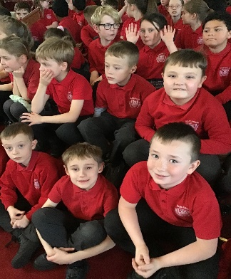
SING THE CHRISTMAS STORY

Many thanks to everyone who came to The United Reformed Church on Wednesday for the Key Stage 2 production of “Sing the Christmas Story”. It was lovely to see so many faces in the audience enjoying themselves.
What can we say about the children? Each and every one of them were amazing. We hope that you enjoyed as much as we did.
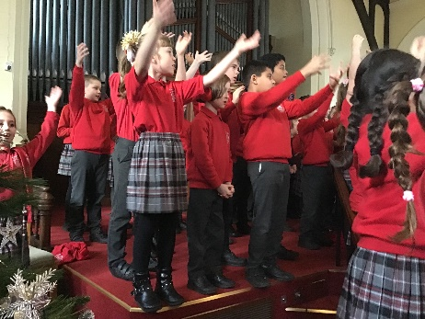
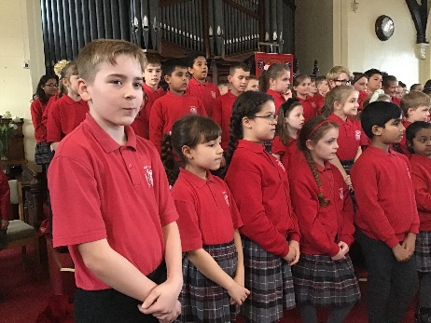
We are sure that next week’s performances will be just as good, we are really looking forward to them.
DATE | TIME | EVENT / VENUE
Wednesday 13th December | 1:30pm | Years 1 & 2 Christmas Production - School
Thursday 14th December | 9:30am | Christingle – St. Peter’s Church, Chapel Street, Congleton
 | Lunchtime | Children’s Christmas Dinner in school
Monday 18th December | 9:30am | Santa Run - School
Tuesday 19th December | 1:45 – 5:00pm | EYFS/Year 1/Year 2 Polar Express Trip – Froghall Station
Wednesday 20th December | 9:30am | EYFS Christmas Production - School
 | 10:00am | Castaway Visit – Castaway, Moss Road, Congleton
Thursday 21st December | 1:00 – 5:30pm | Years 3 – 6 Christmas Panto visit – Buxton Opera House
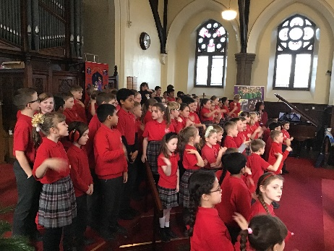
CHRISTMAS DINNER
As you will be aware Christmas dinner day is next Thursday. We ask that you order your child’s lunch by Monday 11th December at 12 noon at the latest to ensure that the cook can place an order to ensure there is enough food for everyone and that there is minimal waste. We will be unable to accept late orders due to the food ordering system.

CHRISTMAS JUMPER DAY/SANTA RUN
We have been asked if we are having a Christmas Jumper Day in school. We aren’t hosting the Jumper Day this year, instead we are organising a SANTA RUN, with monies raised by sponsorship/donation going to the East Cheshire Hospice.
Please find a sponsorship form at the end of the Newsletter for you to use. Any donation, small or large will be most welcome for this amazing charity to put to good use.

HEALTH SECTION

CURRENT ILLNESSES – we have a number of different illnesses doing the rounds.

Chicken Pox – Be in school if child has been in contact with someone with them. If the spots come, then stay off school until ALL of the spots have scabbed over.

Norovirus – sickness and diarrhoea bug. Stay off school until 48 hours AFTER the last bout of sickness or diarrhoea.

Temperature/Headache – usually viral. Treat with paracetamol suspension until symptoms subside. Seek medical advice if the temperature doesn’t go down/headache doesn’t subside.

Headlice - Not an illness, but they are proving to be a problem in most classes throughout the school. Please be vigilant in thorough and regularly check your child’s hair, and indeed your own for any evidence of live lice or the empty eggshells (nits) and treat accordingly. If you are unsure on how to treat your child, please seek the advice of your local community pharmacist who will be more than happy to point you in the right direction for treatment.

Fluenz: If your child didn’t get to have the Fluenz Nasal Spray on Wednesday of this week and you would like your child to have the spray, please see below what you need to do to get it.
If you would like an appointment at a community immunisation clinic for your child to receive the fluenz nasal spray, please complete the following form and identify your preferred clinic. Please return completed forms to wcnt.immunisation@nhs.net . Please ensure you have completed a consent form online before returning this booking form. Once your child’s details have been checked the Immunisations Team will e-mail you an appointment.
Child’s Name
Child’s DOB
Child’s School
Parents Contact Number
Parent’s Email
Date |  | Venue | Preferred clinic (please X)
Wednesday 8th November |  | Middlewich
Wednesday 22nd November |  | Middlewich
Saturday 9th December |  | Crewe
Wednesday 13th December |  | Middlewich
Monday 18th December |  | Macclesfield
Wednesday 20th December |  | Middlewich
Thursday 21st December |  | Wilmslow
If you have already completed a consent form, you DO NOT need to do another.
If you have not yet completed a consent form, you will be required to fill one in prior to receiving an appointment.
MARLFIELDS
SANTA RUN
for the
EAST CHESHIRE HOSPICE

Please try to raise as much money as you can for this worthwhile cause.
Any amount of money would be gratefully received.
If each child manages to raise just £1 would mean almost £200 for the charity,
however, more would be wonderful!
Please bring in the form and monies raised into
school on the date of the SANTA RUN to enable us to get the funds
over to the hospice before the Christmas holidays.
THE RUN WILL TAKE PLACE ON MONDAY 18th DECEMBER after the children are registered.

NAME | AMOUNT PLEDGED | AMOUNT RECEIVED

