Marlfields Newsletter
22nd September 2023
ONE WEEK TO GO! ………

Put Thursday 28th September 8:00am – 10:00am into your diary for our Breakfast/Coffee Morning to support Macmillan. This year we thought we would change it up a little, and have a Breakfast theme – for example, croissants, pastries, bacon or sausage butties.
However, we know that the children love to have a cake, so we will sell cakes to the children later in the day.

To keep with the Breakfast theme we are asking that the children come into school on that day wearing PYJAMAS for a £1 donation which will also go to Macmillan.

Donations of cakes for us to sell to the children throughout the day would be gratefully received.
Donations can be brought in from Monday of next week.

Please let us know if you will be joining us for breakfast
by e-mail, text message or in person at the office.

SCHOOL DINNER PARTNER UPDATE
Our current school dinner partner Dolce has informed us that they are not renewing our contract due to the rising costs of food and labour and that we do not have enough children taking hot dinners.
We have requested to Cheshire East Dinner service who also have refused to quote for our service due to the low number of uptakes.
Dolce also say they have several bad debts, which continue to be unpaid when chased and that they cannot sustain and therefore cannot continue to work with us.

We are searching for a new partner now and have a new company APETITO who are coming to do a tasting session on Tuesday 26th September between 2:45pm and 3:30pm – please come along and taste the new food to see if your child will either continue to use the service or may be interested in tasting the new food.

So, we do not waste food please can you indicate that you will pop into the session next week to taste and give us your thoughts.
We need to work together to find a service for our children moving forward and so please do join us.

ORDERING DINNERS
May we please remind parents to order your child’s lunches at home, especially if your child has any dietary requirements i.e. no pork / fish etc. if you do not personally order their food, they may be served with food which they cannot have. If they are served with forbidden food and you haven’t ordered the food yourself school cannot be held responsible.

If your child is off school and you have ordered a lunch, you must ensure that you cancel the order or you will be charged for it.

CHAMPION FUNDRAISER
We would like to share with you this week’s Champion Fundraiser – Harvey Porter from Year 6.

Last weekend Harvey took part in the Alzheimer’s Society Memory Walk at Tatton Park.
He completed the course of almost 6 miles and raised an amazing £165 for the charity.
Well done Harvey, and thank you for supporting such an amazing charity! We are all so proud of you.

LATENESS
We continue to have several children who are consistently late in getting to school. This is unacceptable as they cause disruption going into a lesson that has already started which has to be halted while what has already been explained, must be repeated for the late comer. It is vitally important that your child is in school and ready to work by 8:55am.

Similarly, some families are late being collected at the end of the day – some as late as 3:45pm and later, when school finishes at 3:20pm. We appreciate that sometimes the children can be late coming out to you on the playground at the end of the day, but sometimes this is unavoidable, especially when children are dragging their feet! Realistically you should be ready to receive them on the playground at 3:20pm. Any children NOT collected by 3:30pm will automatically by placed in the After School Club for which you will be charged.

COATS
As the weather is so changeable, please send your child in with a waterproof coat so that they can go outside at break/lunch time. If they don’t have a coat they will be unable to go out to play.

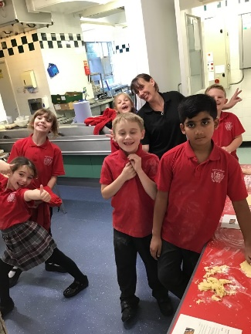
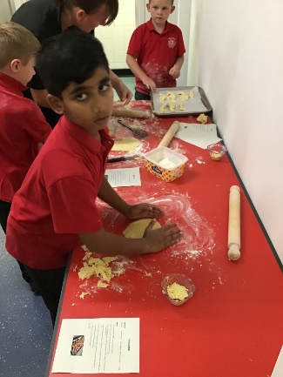
Cooking in School
This week, Year 3 have been going in groups to work with Kelly the Cook. This week the groups have been following recipes to make their own cheese straws. They looked and smelled delicious! We can’t wait to see what they will cook next.

