Marlfields Newsletter
15th September 2023

Put Thursday 28th September 8:00am – 10:00am in your diary for our Breakfast/Coffee Morning to support Macmillan. This year we thought we would change it up a little, and have a Breakfast theme – for example, croissants, pastries, bacon or sausage butties.
However, we know that the children love to have a cake, so we will sell cakes to the children later in the day.

CLASS ELECTIONS
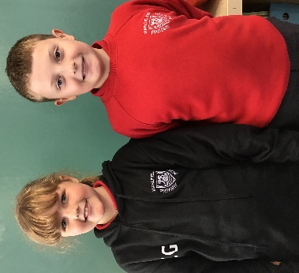
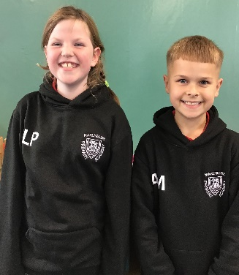

Luna and Ashton Callie and Ethan Jeremiah and Isabella Ismail and Annisha

Yr. 5 ECO Councillors Yr. 5 School Councillors Yr. 4 ECO Councillors Yr. 4 School Councillors

Matthew Cara Ryan Chrissie

Yr. 2 ECO Councillors Yr. 2 School Councillors

HEADLICE

Once again, we are having numerous reports of headlice throughout each year group. Please use the weekend to thoroughly check your child’s hair and your own to should you find evidence of lice in your child’s hair. If you do see any, please treat everyone’s hair accordingly, and repeat treatment after the recommended time. The more people check their child’s hair, the quicker we can hopefully halt the spread of these unpleasant creatures. Thank in anticipation of your co-operation.

BOYS TROUSERS

Mis Barber and Mrs Bennett have a request for you all – do you have any boys’ trousers age 2 – 5 years for EYFS to have in their spare clothes box. Any style of trouser would be most gratefully received.

P.E. KITS & UNIFORM

Please remember to send in your child’s P.E. kit each Monday morning and leave it in school, only taking it home to be washed at the end of the week. P.E. is an important part of the school curriculum, and we like to get the children outdoors or in the hall as often as possible, which we sometimes can’t do as many children don’t have their kit with them.

Please ensure that ALL items of uniform, P.E. kit included are clearly named. If they are named, they can easily be returned to your child, without a name the job is impossible.

We have lots of items of Pre-loved Uniform in the Entrance. Call in to have a look, all we ask for it, is a small donation, whatever you can afford, which will be given to the Friends of Marlfields.

SUMMER READING CHALLENGE
If your child took part in the Reading challenge at the Library don’t forget to send in their certificate so that we can photocopy it or e-mail a copy of it to us.
There will be a reward for all those children who completed the challenge. Well done to everyone who took part.

DINNERS
Please ensure that you order your child’s lunches in advance on the Dolce SchoolGrid site. For those new to the system we will shortly be sending you log-in details. If lunches are not pre-ordered your child may not get their preferred choice of what is on offer on any given day.
If your child’s meals are paid for, i.e. from Year 3 – Year 6 or Nursery, meals MUST be paid for in advance.

Please note that we are a ‘nut free’ school, due to some of our children having serious nut allergies. Please ensure that you do not include any nuts or nut-based products e.g. Nutella, when preparing your child’s packed lunch or snack. Chocolate/crisps are not a healthy snack for you to send in for break times but are just about acceptable as part of their lunch. Thank you for your support on this.

ILLNESS
Please call 01260 633120 before 10:00am to report your child’s absence.
School will contact you via text message or phone if a message has not been received by that time. Failure to inform school of a valid reason for your child’s absence may result in you being contacted by the Educational Welfare Officer, with the possibility of a Fixed Penalty Notice being served.
Following their illness, should your child be well enough to return to school, but still require antibiotics, please try to space the doses so that the medication can be given at home wherever possible.

We are only 2 weeks into the term, and already many parents have not informed us that their child is off ill, this results in your child’s absence being logged as unauthorised, which can trigger contact from the Education Welfare Officer.

TULIP BULBS
If you receive a voucher in the post from Astbury Garden Centre for a free pack of tulips, but won’t be using it, please consider sending it in to school so that we can use them to enhance the school grounds in Spring.

